Candidate analysis of WSR8,9,10 – ‘standard’ Hough

We are analyzing data of WSR 8,9,10 using the standard Hough transform. We have used a threshold 3.8 on the CR for the selection of candidates. The peakmaps have been cleaned with the new procedure. Excess of candidates can be seen in the plots below. It is particularly clear in the CR distribution with a large tail deviating from the theoretical curve.

WSR8
T_obs~2.34days
Input of Hough: 530 peakmap files each covering ~1.9Hz
N_FFT=386
N_sd=7

Candidate database:
499,229,600 candidates (~7.5GB)

Distribution of candidates in frequency and CR (0 spin-down):

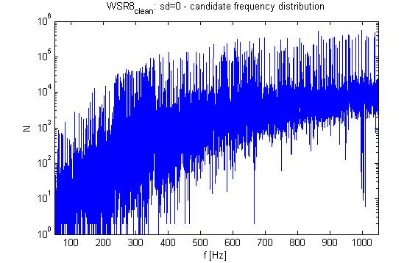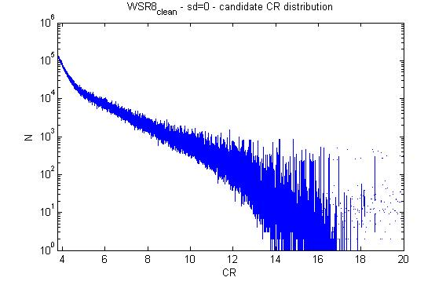

WSR9
T_obs~1.66days
Input of Hough: 350 peakmap files each covering ~2.86Hz
N_FFT=274
N_sd=5

Candidate database:
305,672,558 candidates (~4.6GB)

Distribution of candidates in frequency and CR (0 spin-down):

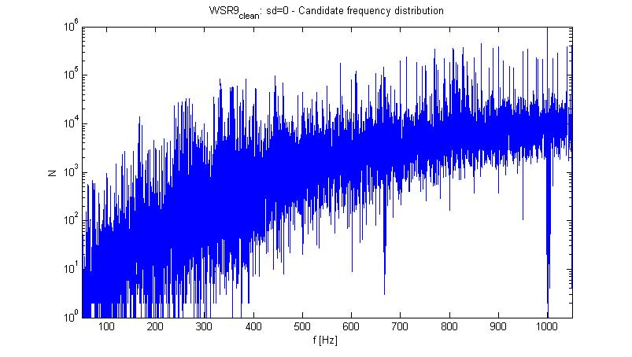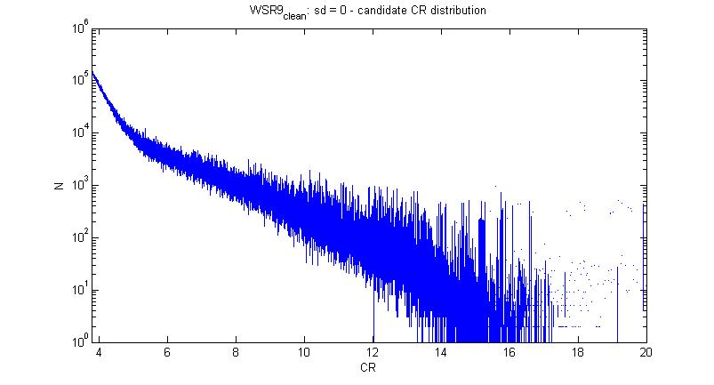

WSR10
T_obs~1.06days
Input of Hough: 210 files each covering ~4.77Hz
N_FFT=174
N_sd=4

Candidate database:
310,579,966 candidates (~4.6GB)

Distribution of candidates in frequency and CR (0 spin-down):

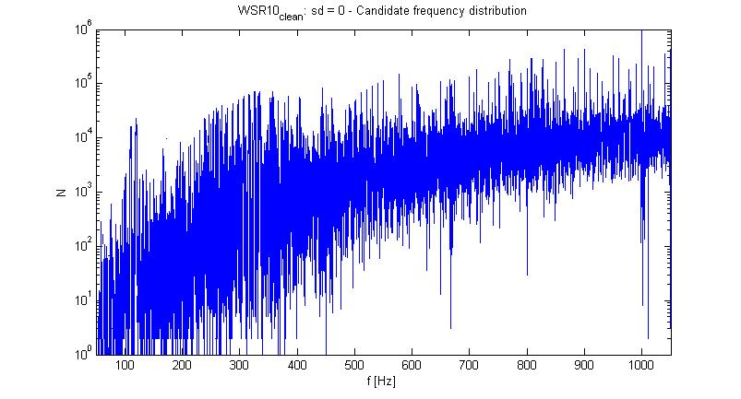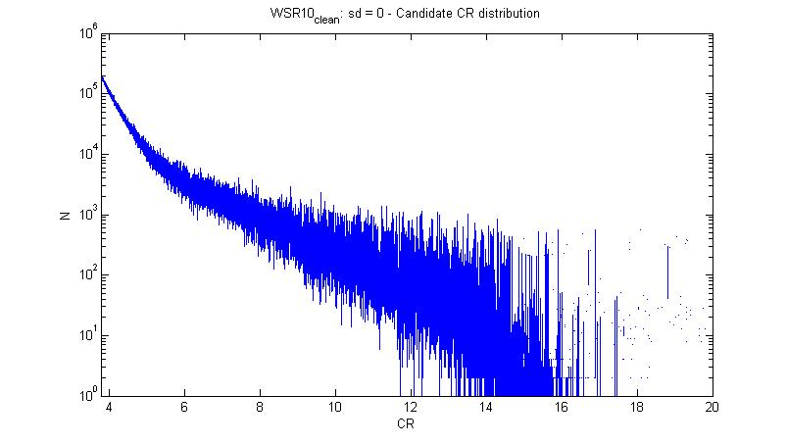
The effective sensitivity, i.e. approximately the minimum signal amplitude that would produce a candidate with 95% confidence level, is shown here (C7 for reference):

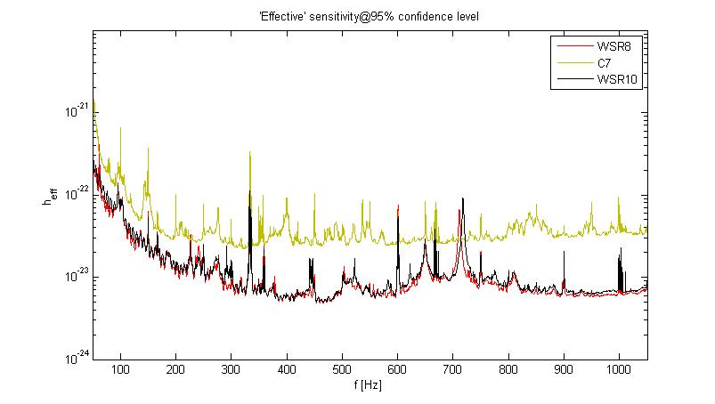

The detection efficiency has been ‘measured’ injecting simulated signals in C7 data.
244 signals with various spin-down values and uniformly covering frequency and source position. The following plot shows the injected sources in the band [50,500]Hz (blu circles) and the detection (red dots). We have a detection when a candidate is coincident with a given source. A coincidence means that the candidate and the source have parameters within a given coincidence window. Here we have used the following coincidence windows (in number of bins): Df=2, Dfdot=1, Dlambda=3, Dbeta=6. The green line is the ‘effective’ sensitivity of C7 at 95% confidence level. All the missed sources are due to the short observation time (they are detected using ‘dilated’ data).

The next step of the current analysis will be to analyze WSR data as a single set, using the adaptive Hough transform. In this way we have a better sensitivity (more data) and data cover a larger observation time (better accuracy).

