C.N.R.S | I.N.F.N.
Centre National de la Recherche Scientifique | Instituto Nazionale di Fisica Nucleare



Noise Monitor
Application Programming Interface
For Advanced Detectors Network

A.Colla, E.Cuoco, G.Hemming + LIGO+GEO

VIR-XXXXX

14 Ottobre 2011

Change Record

Version | Date | Section Affected | Reason / Remarks
VIR-XXX-XX | 14/10/2011 | All | First version.

Table of Contents

- Introduction
The idea is to have a common web interface for the Advanced Detectors for the Noise Monitors applications.
The Data Analysis for Gravitational Waves detectors is essentially a network or coincident analysis among the data produced by the different detectors.
One of the advantages to have a common interface to detector characterization monitor tools for each detector is to exchange results with a common tool and common “language”.
It has been requested to run one of the Noise Monitor developed at Virgo for Lines identification (NoEMI, see reference) also on data produced by other detectors.
As explained in the references here reported NoEMI, as other noise analysis algorithm (Coherence, WDF,…) produces results which are archived into a mysql database.
NMAPI interface to this database to retrieve info, to launch scripts and execute queries, produce plot which are showed on the web for the users.
- Purpose
This documents details the software, hardware and man power requirements to carry on the development of this project.
In Figure 1 we showed a simplified description of the usage of NMAPI on the database for a noise monitor (NoEMI in this example) for different experiments.
The noise tool run locally on data produced on detector site and produce results which can be stored locally to a mysql database or sent to a centralized database in Cascina.
NMAPI can interface to one or more database of LIGO, Virgo or GEO.
The User can follow the noise monitors via web interface for each detector, simply selecting the detector he/she wants to monitor.
The client makes a request for data, NMAPI decides how to manage the request, launching a related script locally or sending to computational nodes in the process, which then deal with data retrieval from source databases and with the production of required outputs.

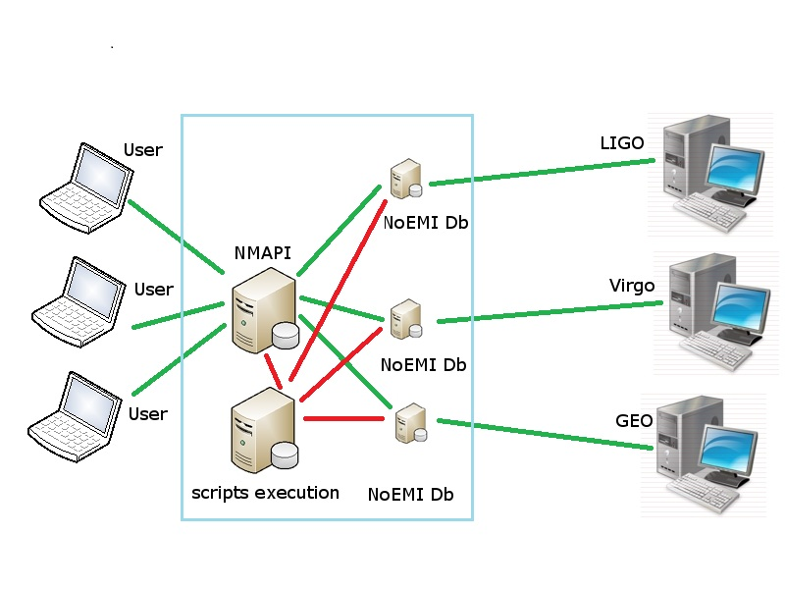
Figure 1 –Simplified example of the NMAPI architecture
for Advanced Detectors network.

- Scope
This document is limited to the describing the project of application of NMAPI to a detectors networks. For each details regarding NMAPI, refer to VIR-0226B-11 and VIR-0448A-11.

- Related documents
- A.Colla, E.Cuoco, G.Hemming, Noise Monitor Application Programming Interface (NMAPI) Software Requirements (VIR-0226B-11), https://tds.ego-gw.it/ql/?c=8280 , 2011
- A.Colla, E.Cuoco, G.Hemming, Noise Monitor Application Programming Interface User Guide (VIR-0448A-11), https://tds.ego-gw.it/ql/?c=8503, 2011
- P. Astone, A. Colla, E. Cuoco, S. D’antonio, S. Frasca, C. Palomba, Update on NoEMi and the Lines Database (VIR-0091A-11), https://tds.ego-gw.it/ql/?c=8145, 2011.
- F.Carbognani, A.Colla E.Cuoco, G.Hemming Lines Database Web Interface Software Requirements (VIR-0227A-11), https://tds.ego-gw.it/ql/?c=8281, 2011.
- Alberto Colla, Elena Cuoco, Pia Astone, Sabrina D'Antonio, Sergio Frasca, Cristiano Palomba, Status of the Noise Event Miner Framework (VIR-0456A-10), https://tds.ego-gw.it/ql/?c=7743, 2010.
- E.Cuoco, A new wavelet-based method for transients detection. Efficiency with respect the whitening algorithms (VIR-NOT-EGO-1390-308), https://tds.ego-gw.it/ql/?c=1611, 2005.
- E.Cuoco, Wavelet de-noising strategy for transient waveforms identification (VIR-NOT-EGO-1390-305), https://tds.ego-gw.it/ql/?c=1602, 2005.
- G. Hemming, Connections Database Project Proposal (VIR-0225A-11), https://tds.ego-gw.it/ql/?c=8279, 2011.
- G. Hemming, D. Verkindt, Virgo Channels List Data Base (VIR-0079A-08), https://tds.ego-gw.it/ql/?c=2093, 2008.
- D.Verkindt, G.Hemming, Channels Data Base (VIR-0684A-06), https://tds.ego-gw.it/ql/?c=5061, 2006.

- Abbreviations and Acronyms
Abbreviation/  Acronym | Description
AJAX | Asynchronous JavaScript and XML
CDB | Connections DataBase
CSS | Cascading Style Sheets
EVF | EVent Finder
GPL | GNU General Public Licence
GPS | Global Positioning System
HTML | HyperText Markup Language
HTTP | HyperText Transfer Protocol
HTTPS | HyperText Transfer Protocol Secure
IIS | Internet Information Services
LDAP | Lightweight Directory Access Protocol
LGPL | GNU Lesser General Public Licence
MIT | Massachusetts Institute of Technology
MPL | Mozilla Public Licence
NM | Noise Monitors
NMAPI | Noise Monitor Application Programming Interface
NoEMi | Noise Event Miner framework
PHP | Pre-Hypertext Processor
SQL | Structured Query Language
UI | User Interface
W3C | WorldWide Web Council
WaSP | Web Standards Project
WDF | Wavelet Detection Filter
WDFfollowup | Wavelet Detection Filter follow-up
WYSIWYG | What You See Is What You Get
XHTML | eXtensible HyperText Markup Language

- Glossary
Term | Description
Apache | Web server (http://httpd.apache.org/)
CKEditor | WYSIWYG editor (http://ckeditor.com/)
Epoch | DHTML Javascript calendar  (http://www.meanfreepath.com/javascript_calendar/)
GPL | Open source licence (http://www.gnu.org/licenses/gpl.html)
Javascript | Browser-side scripting language (http://en.wikipedia.org/wiki/JavaScript)
Jquery | Javascript library (http://jquery.com/)
LGPL | Open source licence (http://www.gnu.org/licenses/lgpl.html)
MIT | Open source licence (http://en.wikipedia.org/wiki/MIT_License)
MPL | Open source licence (http://www.mozilla.org/MPL/MPL-1.1.html)
MySQL | Open source database software (http://dev.mysql.com/)
Python | Programming language (http://www.python.org/)
WaSP | Web standardisation information project (http://www.webstandards.org/)

- Functional requirements
- User-related information
This section provides information relating to: use cases involved in the system.

- Use cases
This section contains use cases for each of the interactions that may be undertaken within the system; classes of users; user groups at the interface level; and user authentication.

- Operating environment
- Operating system
NMAPI will be able to operate using the standard Linux operating systems common to the Virgo public host machines (see ref VIR-226B-11).

- Web server
NMAPI will require the use of a standard web-server, i.e. Apache, IIS (see ref VIR-226B-11).

- Hardware (DA MODIFICARE…forse ci serve Hardware diverso...per gli scripts)
Richiesta dei Dabase centralizzato o cluster per gestire I NM e gli scripts

- Non-functional Requirements
- Performance Requirements
This section provides details in order to help determine the physical solutions that will need to be implemented in order to ensure the proper functioning of the software. Inevitably, much of the details in this section will be based upon hypothesis, but it is important that it is as detailed and informed as possible.

        - Storage, traffic and load expectations
NMAPI should, in itself, be very light-weight, serving as little more than an interface through which external applications may be activated.

        - Criticality and responsiveness
NMAPI will be used by scientists and operators on shift in the Control Room of the different LABS.

        - Estimated number of users
??

- Security Requirements
Firewall??
Of significance here is the fact that a registry of script-launches will be maintained within the database. This will record the time and date on which a script was launched and the user that launched it.

- Software Quality Attributes
This section provides details on those additional elements of the software that are considered of importance to potential end-users and developers.

        - Extensibility
The application has been designed to be completely extensible and modular. This means that new NM can be added to it directly via the NM Co-ordinator interface, regardless of their location, without the need to modify any code.

        - Flexibility
The fact that individual NM host or database information is not stored at NMAPI level, rather at the level of the individual NM scripts, means that it is entirely flexible.

        - Maintainability
Maintenance of the application should be possible for any programmer with more than a cursory knowledge of PHP classes and CSS. JavaScript and AJAX knowledge will also be required.

        - Portability
While NMAPI is designed to be an interface to which NM applications can essentially plug themselves, in itself it will also be designed to be portable, in that it may be called an attached to any website in which it is required. Effectively, it is practically platform independent, in terms of end usage.

- FTE
Man power full time on the projects

- Appendix 1. Software & hardware requirements to run NoEMi at Cascina
NoEMi workflow
NoEMi is a tool for the in-time discovery and follow-up of frequency noise lines and disturbances in the Virgo data. It exploits some of the algorithms implemented for the CW search to analyse the Virgo data and extract the frequency lines.
NoEMi runs every night on the data collected in the previous day; it analyses the h(t) channel, the raw Dark Fringe (DF) channel and the 32 auxiliary channels of the Reduced Dataset (RDS). The main steps of the analysis are listed below.

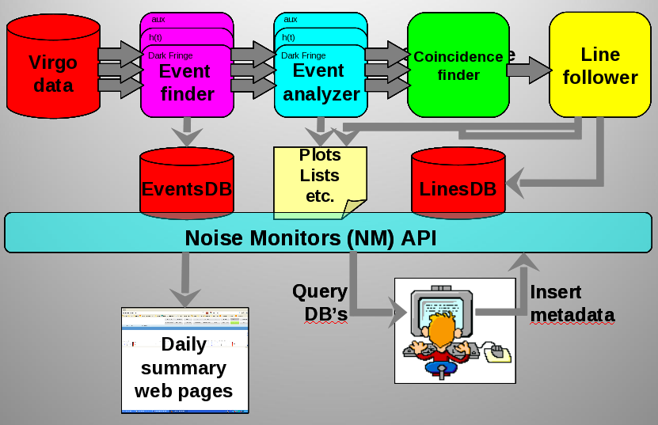
Figure 1. The NoEMi workflow.

The Event Finder performs a series of Fast Fourier Transforms (FFTs) on the data, after a cleaning procedure that removes the fast transients from the data. For each FFT the program identifies the peaks (a.k.a Frequency Events or EVF) which stand above the average spectrum, estimated by means of an auto-regressive (AR) technique, and registers their parameters (frequency, Critical Ratio / CR, width, amplitude) in a MySQL database (EventsDB).
- The Event analyzer makes a statistical analysis of the events collected in some tens of FFTs. In particular, two distributions are computed: persistency (frequency distribution of the events, divided by the number of FFTs in the collection) and CR (average CR of the events) vs frequency. The program identifies the peaks of the two histograms, which provide a “projection” of the noise lines in the period covered by the collection.
- The Coincidence Finder compares the peaks found in the Dark Fringe or h(t) with those of the auxiliary channels, flagging them as coincident if their frequencies overlap.
The Line Follower reconstructs the noise lines comparing the frequency of the latest peaks with those found in the previous iterations. NoEMi stores the line parameters and the list of coincident auxiliary channels in a second database (Lines DB).

During VSR4 NoEMi operated in two different configurations:
1 mHz frequency resolution, DF, h(t) and 27 auxiliary channels, daily updates;
10 mHz frequency resolutions, DF and 27 aux channels, 2 hours updates.

NoEMi publishes the latest results (time-frequency plots of the frequency events, persistency and CR histograms, lists of lines and coincidences) in the daily summary NMAPI web pages. In particular, it raises an alarm if noise lines are detected at or near the Doppler band of the most “promising” pulsars for the CW search.

  - Software dependencies

NoEMi requires Python 2.5.2 with the following external modules:

- matplotlib
- numpy
- mySQLdb
- markup

The Event finder is composed of a C standalone executable written in the framework of the CW analysis package, and does not require any local libraries.

  - Hardware/network access requirements

- 4 GB (minimal) / 8 GB (ideal) RAM machines; According to the number of CPUs and memory, more than one channel can be analyzed in parallel.
  - In the past Virgo runs 8 worker nodes at Cascina (olnodes) have been dedicated to NoEMi for the analysis of the Virgo data.
- POSIX accessible frame files (for NoEMi's Event Finder).
- MySQL server, web server for the summary pages and the database query results (as a component of the Noise Monitors' infrastructure).
- An important point to be solved in view of the Advanced Detector era is to have a fast and reliable access to the data repositories by the worker nodes. During the past Virgo runs the concurrent access to the data disks (mounted via NFS) by the noise monitors caused severe slow-downs and, from time to time, “Stale NFS” problems. For this reason we were forced to run only one channel in parallel on each machine, which slowed down the daily analysis. This issue is even more critical in view of monitor also the LIGO and GEO data on the Cascina cluster.

  - Storage requirements

The storage expectations are summarized in Table 1.

What | Disk size /  1 day | Disk size /  1 year
Log Files - DF and auxiliary channels (1) (2) | 100 MB | 40 GB
Log Files – h(t) (3) | 700 MB | 260 GB
Log files - DF + h(t) + 27 auxiliary channels (1) | 3.5 GB | 1.3 TB
Events database - DF and auxiliary channels | 50 MB | 20 GB
Events database - h(t) | 200 MB | 70 GB
EVF database - DF+h(t)+27 auxiliary channels | 1.6 GB | 600 GB
Lists of lines & plots for the daily pages | 0.4 GB | 150 GB
Lines database | 2 MB | 0.7 GB
Plots for Lines table web page (4) | 100 MB | 100 MB
Total |  | 2 TB
(1) Log files can be deleted/zipped after the analysis
(2) the sizes refer to the 20 KHz sampled channels; the channels sampled at lower frequencies are smaller.
(3) h(t) analysis is done with a lower CR thresholds, therefore its size is bigger
(4) Lines table is rewritten everyday and its size is practically constant
Table 1. NoEMi storage requirements for the analysis of the Virgo data.

Note that the numbers listed in the table refer to the analysis of the Virgo data in one single configuration (1 mHz frequency resolution, 1 daily updates).
For instance, in case we want to monitor also the LIGO-H, LIGO-L and GEO detectors, using 2 different configurations as it was for the recent VSR4, the above numbers must be multiplied by 8.

  - Traffic expectations from the WN to the database

From Table 1 we can also estimate the network traffic to and from the NM framework. The heaviest traffic is due to the transfer of the peakmaps to the Events database (1.6 GB/day). The list of lines and plots for the summary web pages amounts to 0.4 GB/day.
NoEMi's line tracker algorithm requires downloading the full line database. Assuming this is done once a day we expect ~1 GB/day of incoming traffic (to the client) and 2 MB/day outgoing (to the server) with the information of the “new” lines for the Lines database.

