New control and DAQ electronic
Architecture and cost estimate

T. Bouedo, A. Masserot, B. Mours, J.M. Nappa, E. Pacaud, S. Vilalte,

VIR-xxxx
November 29th 2006

…
.
Summary
1 Introduction 3
2 Architecture 3
2.1 Photodiode readout and Global Control (Pr+Gc): 3
2.2 ISYS control 4
2.3 Suspension control 4
2.4 Local readout (or fast frame builder) 5
2.5 Test facility to be installed in Annecy 5
2.6 DSP Test facility to be installed in Cascina 5
3 Budget estimate 7
3.1 Summary 7
3.2 TDBox 8
3.3 ADC board 8
3.4 TOLM 8
3.5 MUX/DeMUX 8

Introduction
This document describes the proposed architecture of the control and DAQ electronic for Virgo+, focusing on the modules developed in Annecy in the framework of the ongoing Annecy-EGO-Pise R&D. This document includes also a preliminary cost estimate for the board production.

Architecture
This is a summary of the proposed deployment for Virgo+ electronic. It should be noticed that this is a first version. Details of the implementation may change in the future. However, the overall number of components should remain almost unchanged.

Usually, the timing distribution scheme is not describes in the following drawing. However, the principle is to have one centralized generation system feeding one TDBox per rack (on top of each rack). The connections between all the racks are made by optical fibers.

Photodiode readout and Global Control (Pr+Gc):
The first tests indicate that the main longitudinal control loop could run in 20 to 40 kHz range.

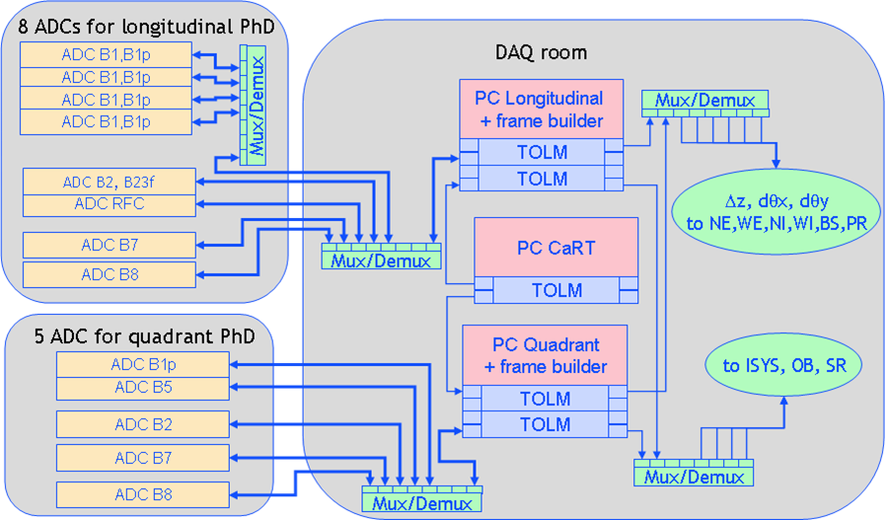

ISYS control
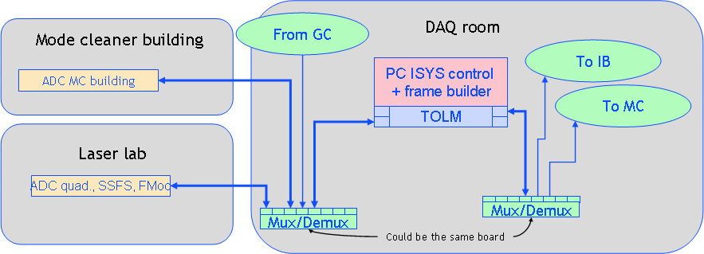

The ISYS system should be able to run even if the global control is stopped.

Suspension control
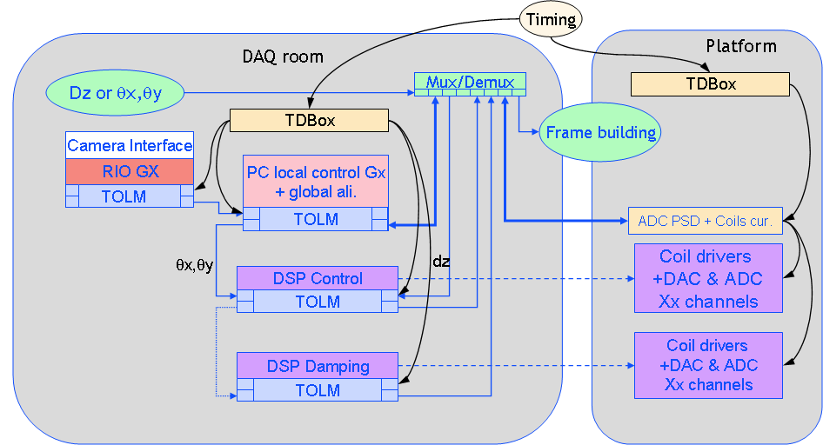

The interface with the existing camera will be made using the RIO and a TOLM board. However, the Gx code will be moved to the external PC, in order to have to possibility to remove later on the old camera interface and RIO.

Local readout (or fast frame builder)
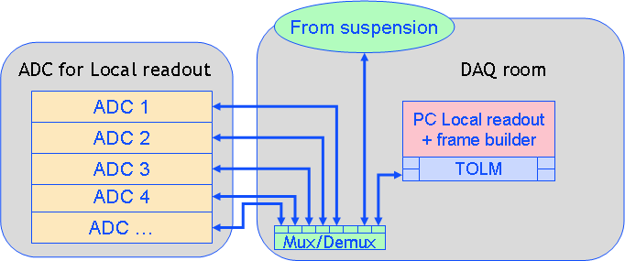

Test facility to be installed in Annecy
The purpose of this facility is to check the integration of the system, develop the required software and test it. It includes most of the critical part of the overall configuration.

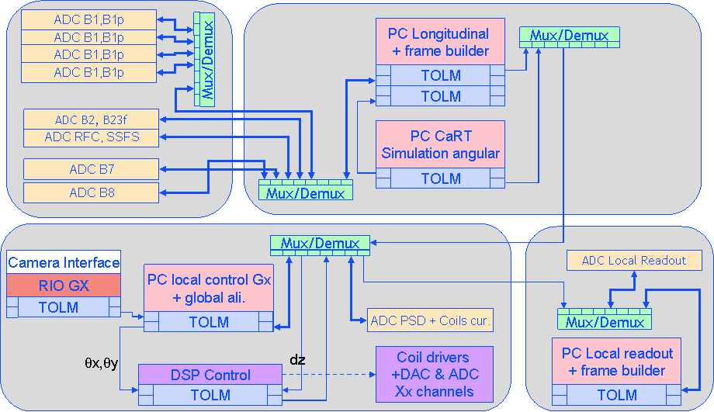

DSP Test facility to be installed in Cascina
The purpose of this facility is to provide the regular Virgo environment for the DSP development.
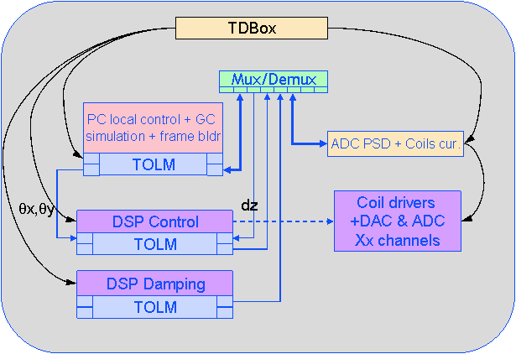

Budget estimate
This is a very first estimate of the production cost.

Summary
 | ADC | TOLM | TOLM-PC | Mux/Dmux | TDBox A | TDBox B | PC | DAC
Pr+GC+Ali | 13 | 0 | 5 | 5 | 4 | 0 | 3 | 0
Local readout
Central bldg A | 6 | 0 | 1 | 1 | 1 | 0 | 1 | 0
Central bldg B+MC | 6 | 0 | 1 | 1 | 1 | 0 | 1 | 0
Central suspensions | 0 | 0 | 1 | 1 | 0 | 0 | 1 | 0
West bldg | 2 | 0 | 1 | 1 | 1 | 0 | 1 | 0
North Bldg | 2 | 0 | 1 | 1 | 1 | 0 | 1 | 0
Suspension
WE | 1 | 3 | 1 | 1 | 2 | 0 | 1 | 0
WI | 1 | 3 | 1 | 1 | 2 | 0 | 1 | 0
NE | 1 | 3 | 1 | 1 | 2 | 0 | 1 | 0
NI | 1 | 3 | 1 | 1 | 2 | 0 | 1 | 0
BS | 1 | 3 | 1 | 1 | 2 | 0 | 1 | 0
PR | 1 | 3 | 1 | 1 | 2 | 0 | 1 | 0
SR | 1 | 3 | 1 | 1 | 2 | 0 | 1 | 0
OB | 1 | 3 | 1 | 1 | 2 | 0 | 1 | 0
MC | 1 | 3 | 1 | 1 | 2 | 0 | 1 | 0
IB | 1 | 3 | 1 | 1 | 2 | 0 | 1 | 0
Timing distribution | 0 | 0 | 1 | 0 | 0 | 6 | 1 | 0
ISYS | 3 | 0 | 1 | 1 | 2 | 0 | 1 | 0
Slow control benches
Central bldg | 6 | 1 | 1 | 1 | 1 | 0 | 1 | 2
West bldg | 2 | 1 | 1 | 0 | 1 | 0 | 1 | 1
North Bldg | 2 | 1 | 1 | 0 | 1 | 0 | 1 | 1
Total Virgo | 52 | 33 | 25 | 22 | 33 | 6 | 23 | 4
Annecy Tests | 10 | 2 | 5 | 5 | 3 | 1 | 3 | 1
DSP Tests | 1 | 2 | 1 | 1 | 1 | 0 | 1 | 0
CALVA?
Spares | 5 | 4 | 4 | 4 | 3 | 2
Total | 68 | 41 | 35 | 32 | 40 | 9 | 27 | 5
Price/unit (kEuros) | 1,8 | 0,9 | 0,9 | 1,6 | 0,8 | 1,2 | 1,5 | 0
Price (kEuros) | 122,4 | 36,9 | 31,5 | 51,2 | 32 | 10,8 | 40,5 | 0
Grand total |  |  |  |  |  |  |  | 325,3

This list does not include
- The price of all cables, especially fibers
- The price of 2 GPS receiver
However, there is some hope that part these items could be purchase using the end of the R&D budget line

This estimate is a guess based on list of components. The real offer may differ.

TDBox
The TDBox is based on an exhaustive list of components provided by JM Nappa.

ADC board
ADC Board (16 channels)
ADC chip | 400
FPGA | 300
Optic | 100
AA Filters (mezannines) | 300
Various components | 100
PCB | 200
Front pannels/connectors | 250
Cabling | 150
Total | 1800

TOLM
TOLM
Optic | 200
FPGA | 300
Various components | 100
PCB | 100
Cabling | 200
Total | 900

MUX/DeMUX
MUX/DeMUX
Optic (6x70) | 400
FPGA | 700
PCB | 200
Front panel | 100
Cabling | 200
Total | 1600

