Visit to LIGO Hanford site 16-17Nov09
-------------------------------------

Minutes of the visit to vacuum installation, cryotraps equipment in particular
Presents: GG, AC, GP, AP, JvdB, MD, John Worden, Kyle Rian, Robert Schofield, Ski

Cryotraps level control system
Method to control and maintain the level: the pressurized nitrogen storage vessel is connected directly to the trap through a superinsulated pipe and a needle valve, located near the vessel itself. The valve is driven by a simple pid controller taking the level signal from a differential pressure gauge installed on the trap. The Pid control is not done locally with a dedicated module but from VME pc.
The level is maintained at 90% of the available range.
Equipment employed: chosen by PSI, see p&I sketch (copy given to Gianluca and Martin)
They tested some different sizes of needle valves to optimize the control (reducing excursions of valve aperture...)
Safety installations and procedures: only a few, simple things:
burst disks (vacuum and cryostat) driven to outside (with big size stainless pipe)

Details about the LN2 storage vessel and supply system
LN2 tanks are owned by LIGO
Tanks are pressurized, above the atmospheric pressure.
The LN2 lines are vacuum insulated.
Signals monitored by remote are the LN2 storage level(?), needle valve opening status, LN2 level in the trap.
At the staorage tank bottom, there is a piping section insulated by foam which is much contributing to thermal losses.
One tank per trap, approx 50000liter capacity.
Maintenance needed: low, change of the outer insulation every some years (its humid). Eventually pump the vacuum jacket.
Hints about the contract for the LN2 supply: the trucks can stop for different reasons, foresee a large capacity of tanks.
They last for more than 2 months.
During the weekly break there is time to refill 2 tanks out of 8 existing; each tank is refilled once per month. 2 trucks on site during the maintenance break. 7000 gallons per refill (‘Our’ trucks capacity is normally 20000liters, tbc).
Global consumption is about 1% of the reservoir capacity per day.

Cryotraps special procedures (regeneration, emergency evacuation):
regeneration shall be achieved with N2 produced locally and heated. LN2 evacuation is not foreseen.
Traps have been never regenerated or maybe they did once. The consumption of the trap affects the total consumption not that much. One spy of the need of regeneration is the CO2 release. When the ice thickness becomes high (and surface temp is high too) the CO2 is no more pumped.

Cryotrap typical operation during a tower intervention
Until now, benches at LIGO are located in air, so the vacuum chamber does not need to be vented very often. However, in the future (Adv LIGO), benches will be moved in vacuum so venting operations will need to be performed more often.

Last intervention (tower venting) in vertex (central) area:
_ 18 hours opened, flushed with dry! air
_ 4 days of turbopumping (in the past more than 1 2 week).
_ Ion pumps are then started and the LV opened (total pressure=7E-7 torr)
The total pressure near the trap fall down at 3E-8. At the tube side the pressure rise up to this figure . At this point the main gas is hydrogen on both trap sides (thanks to the high pumping speed for water). Some air is also present. It takes 1.5 months to get back at 5E-9 torr. RGA is used for diagnostic, like us.

Cryotraps environemental noise: never experienced apart the glitches from the external LN2 storage tanks.
4-5 glitches per day around 20Hz were originated from the mechanical cracks of the storage tank vessel when changing temperature due to the daily variations. It was solved by thermally isolating the tank.
The storage tanks are installed 10m to 60m far from traps. Putting it on a different ground foundation could be not effective, ‘disturbance wavelenght is long, can go across this interface easily’. The influence of distance: surface waves energy decrease only as sqrt of distance, double distance = 1.4 gain factor.
our proposal: isolate the tanks with dampers (for insance classical ones made out of rubber and/or springs, like the ones used for big motors). An horizontal or more compact design could be maybe better, less exposed to windage and maybe also to temp gradients and mechanical settlement.

Cryotraps are located about 30m away from the more sensitive devices .

Concerning the bubble-like noise, here are some points (from email of Mike Zucker):

1) Trap design
_The cold surface is baffled out
_The form and finish of the liquid reservoir walls minimizes the "attachment" of GN2 bubbles, such that they form at numerous places, detach and rise while they are still small rather than growing in place.
_The reservoir seeks to maximize the free surface so that gas evolves at the top without forming bubbles.
_The liquid reservoir hangs from a set of SS support rods, about 15mm dia. x0.5m long; the cold ends are terminated in sets of SS coil springs, and the warm ends are mounted in compliant Viton or Flourel bushings. The suspension reduces transmission of reservoir noise to the outer shell (and presumably, vice-versa).
2) LN2 supply system
_The superinsulated LN2 supply line is maintained absolutely level, such that both gas and liquid phases are maintained in the tube everywhere between the control valve (located near the storage dewar) and the liquid reservoir. This prevents "slug flow," intermittent gas/liquid spurts.
_ LN2 enters the reservoir via a sloping half-tube or "chute," which
intersects the free liquid surface at a shallow angle. This prevents "dripping."
_The exhaust tubing is oversized to insure laminar or near-laminar flow at the expected gas evolution rate.
_ Gas and liquid connections use corrugated flex sections to bridge from outer to inner shells.
###

Vacuum controls: based on VME standards. Interlocks just for turbo pumps. No problem with other equipment even if mains power go away . The valve in front of the traps close automatically when pressure in tube is 1E-7 (driven by air). Normally it is disabled because could give false alarms.
The idea is 'to keep the system simple'. It monitors: Gauges, Ions currents, the levels of LN2, the opening status of needle valves, the LN2 level in the trap.

The HVAC system is also monitored

GNB valves, remarks after years of use: ok, with initial difficulties.
outgassing data NOT available. anyway they stand in a good vacuum, range of 1E-8. metal bellows, double orings bonnet.
they had problems at beginning (actuators bellows), which GNB solved in guarantee.

Procedures to maintain the towers cleanliness: dry air purging in mirror chambers, no mirrors pre-heating at present, maybe foreseen for AdV.
Chambers are vented with dry air (produced by an oil free compressor) and flush the ‘towers’ with this one. Currently there have dust problems on mirrors, thought coming mostly from the oxide layer of the tower (not electropolished).
Maybe improvement for AdV.

Ion pumps experience: big ones (varian) always kept under vacuum, valved off during ventings (manual valves).
No expected replacement, since always working at 1E-8 or less. No problem of bursts seen. Automatic HV change are left ON.
Small ions are to pump the gaps between double orings (maybe 50!). they can work more than 2 years, they are used also as a monitor of the leakage of the sealing. They are installed in a far point, and with small pipes 5-10m long reaching the orings, sometimes more than one per pump.

HVAC (xAndrea)
At present Ligo requirements are less demanding: room air within 0.7°C instead of 0.1°C.
Inside the experimental hall, the acoustic noise feeling is much less than in virgo one.
This system produces cold water relatively far from the experimental building. Water pumps, located in this ‘far’ place, send the water to the experimental building, where the air heat exchanger and the air fans are located.
Air fans are like 'axial plane turbines', with variable pitch blades.
All machines (air fans, water pumps) are seismically damped (springs, rubber). The direct acoustic emissions have a low coupling and in general are less important.
Env. noise (mainly around 10Hz) comes from: air turbulence, water turbulence.

Hence it is not much important to displace pumps and machines but it is to mitigate the flow turbulence:
Water = reduce flow speed, reducing pump rotating speed or enlarging pipe size (the pumps rotating speed is adjustable, for instance 40Hz instead of 60Hz, with inverters).
Air = reduce the speed by changing the blade pitch and improve the air flow distribution.
Env. noise was coming from a ‘column of air going up and down’, originated in the pre-distribution chamber. The fans push the whole air in this ‘room’ (pre-distribution chamber) which distributes the air to the different pipes. The entrances are sharp and cause flow instabilities and increase turbulences. A system consisting of placing a ‘silencer’ in front of the aperture has been adopted in order to change the flow pattern (forming little swirls instead of a big moving column of air).

Mirror contamination
Basis is similar to us: in-vacuum components and materials are baked, measuring the HC conventional pressure at the end of the bake; the situation of the Ligo chambers is extrapolated by the ratio of pumping.
The optical losses given by some specific materials are tested in an ‘optical test’ chamber located in another site.
A new vacuum oven has been installed for the advLigo parts, similar to our ones; Rgas and instruments are valved off during the baking process.
A new large ultrasonic machine has been installed and also some air ovens to dry at high temp large metal parts.

‘brewster’: Output bench in vacuum separated by a wedged viewport

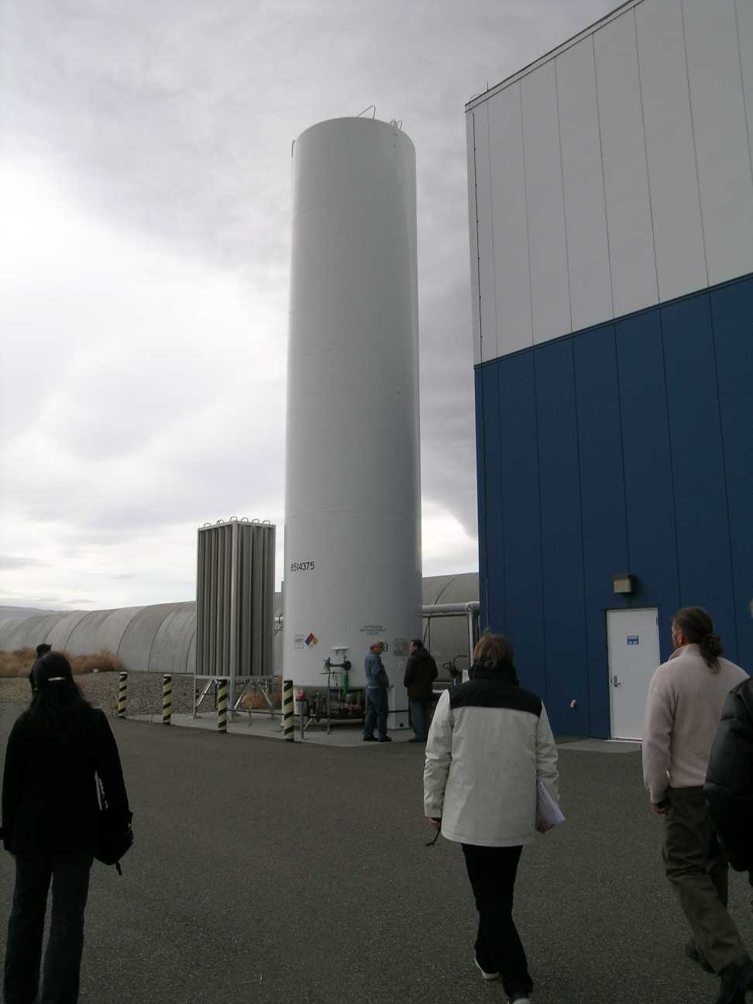
End station LN2 tank
1)External surface here is not thermally isolated
2)The ‘evaporator’ is used to produce GN2 for regeneration
3) 3 pipes for GN2, 1 for LN2
4) needle valve position. Not clear in this picture, after the valve the liquid supply pipe rise up vertically up to the level of the other pipes (1m or so) and then the outer isolation is not more present
(1)
(2)
(3)
(4)

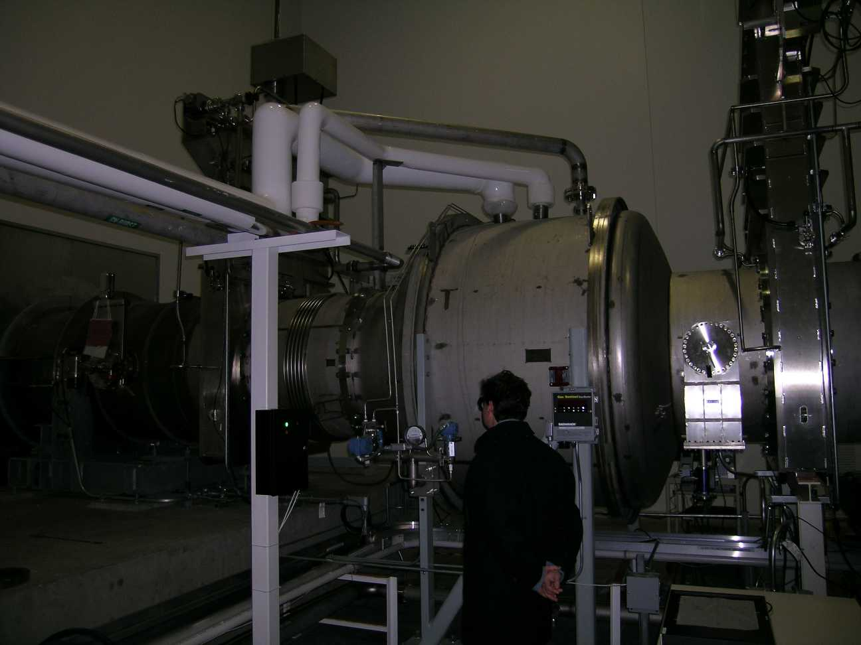
(1)
(2)
(3)
(4)
(5)
(6)
(7)
(8)
(9)
End station trap
- 3 pipes for GN2, exhaust, safety outlet ,regeneration
- liquid inlet, with a flange and a flex joint
- LN2 level measurement
- Vacuum gauge
- Large valve
- Large valve
- Vacuum gauge
- Beam tube
- pumping ducts for the double orings

