TCS TESTS REVIEW

E. Campagna

Summary

Introduction 5
Step 12 tests 7
Test at 10 mW 7
Going to higher powers 8
Turning off the TCS from 1.3 W: the etalon effect 10
Trends during the cooling down 12
Trying to balance the SBs moving locking signals 14
Trying to balance the SBs moving the ITF input power 15
Investigation on 10-11 Hz loop instabilities 17
Step 8 tests 19
Increasing the power up to 4.4 W 19
Test at 1.3 W 20
Scanning OMC temp. to measure Gaussian and Laguerre power content 21
Trying to balance the sidebands moving the locking signals or the alignment ones 22
LOCKING ACQUISITION 23
With 700 mW from the beginning 23
With 1.3 W from step 8 24
With various power from step 6 24
SINGLE SWINGING CAVITY 25
More on etalon: the Newton rings 26
Unlockable period after TCS tests 28

Introduction

Since mid April we began a series of test on the ITF using the Thermal Compensation System.

The TCS was introduced to compensate the thermal effect due to the heating of the mirrors passed-through by the YAG laser. The input mirrors of the two cavities heat up, their mean temperature increases, temperature distribution goes toward a stable configuration that produces a deformation in the radius of curvature (RoC) of the central region, either through dl/dT in the coating or dβ/dT in the bulk.
Moreover, before this process came to an equilibrium, there is a transient phase that involves strong temperature gradients in the central part of the mirror, generating other effects such as Newton rings.

Up to now the interferometer has been locked coping with these effects in a passive way. At step 6 the state (meaning the set of reference values of the locking signals) is discontinuously changed in order to maintain the locking (see J. Marque), at step 8 a 10 minutes wait is necessary for the sidebands to reach a reasonable balancing…
All of that is due to the thermal effects from laser power absorption in the input optics. TCS is then a must in the control system of the ITF, and it is expected to compensate for the transients, speeding up the locking acquisition and increasing ITF stationarity.

The system is realized using two auxiliary CO₂ lasers impinging on the front face of the input mirrors. The beams should have an annulus shape in order to compensate for the Gaussian profile of the YAG laser and bring the surface to the right RoC.

Unfortunately, in the whole test session we performed before the shutdown, only one laser was in operation. Therefore, all the tests refer to a TCS acting only on the WI mirror. That choice was done considering that the two input mirror are not equal: the WI absorption is around 3 times the NI one (14 ppm vs 5 ppm), so that WI mirror heats up more than the other. Shooting with TCS on the WI we can have the possibility to recover on the two mirrors the same RoC.

TCS apparatus is located on two similar benches out of the two input towers; the generated beam enters the tower through an optical window and, after being reflected on two mirrors, impinges on the front face of the input mirror.
A sketch of the bench is given in Fig. 1.
The 25 W laser enters a first telescope (made by L1-L2 lenses) and, after a half wave-plate, it passes through a polarizer (to tune the needed power). About 4% of the beam power is picked off with a beam splitter and is sensed on a photodiode (substituting the former power meter, a simple calorimeter). Before exiting the bench, the laser is shaped in the system constituted by a telescope (L3-L5) and an Axicone (a conical lens whose schematic action is shown in Fig. 2) to give it the desired annulus shape.
Fig. 1: Sketch of the TCS bench (by A. Rocchi)

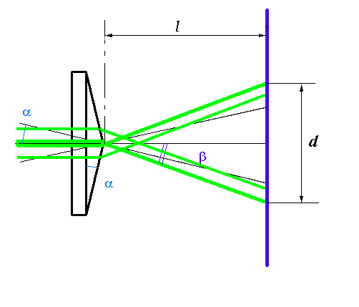
Fig. 2: Diagram showing the effect on a beam passing through a conical lens.

A lot of different tests were performed on the ITF, either with the ITF locked

- at step 12
- at step 8

or during the lock acquisition.
Some tests were also performed with a free swinging cavity.
In the following we will review all of them focusing on what we understood and what still remains unclear.

Step 12 tests

The majority of the tests were performed at step 12, i.e., starting with the ITF at the end of the lock acquisition, after waiting some minutes for a stable configuration to be reached (this is the so called “science mode” configuration used during the science runs).

Test at 10 mW

Injecting 10 mW with CO₂ laser there is a strong visible effect on the sidebands balancing (see Fig. 3). This is definitely NOT expected with such a low power. The direction of unbalancing is opposite to the one we have in the normal thermal transient during the lock acquisition. That effect can be due to an observed, but not yet clarified in its origin, spot in the central part of the annulus. Obviously, such a spot should give a neat effect that is opposite w.r.t. the annulus one. Even in subsequent similar tests that effect has been observed.
Looking at the images from the phase camera (Fig. 5 and Fig. 6) one can see a clear effect on the phase in the central area: it is going toward a flatter configuration (understand if it is in contradiction with the unbalancing?).
The servo on SBs balancing, acting on MICH offset, is enabled during this test. A decrease of MICH offset gives the usual increase of the power seen by B5 photodiode.

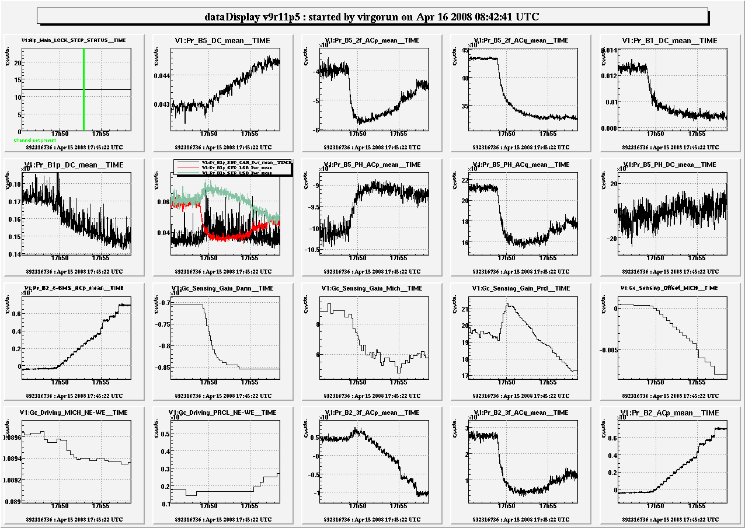
Fig. 3: A set of signals from the 10 mW TCS test at step 12.

Going to higher powers

A further increase of the power up to 100 mW seems not to give significantly different effects.

Bringing the power up to 700 mW (this time not enabling SB balancing servo) gives an encouraging result (Fig. 4). The sidebands are unbalancing in a way that resemble the time-reversal of what is happening at the beginning of the transient during the lock acquisition (in which the servo is also not enabled yet). It seems therefore that the action of the CO₂ laser is towards a reduction of the thermal lensing, as wanted.
Each laser power step generates a transient of about 5 minutes in many signals.
B5_2f_ACq (that is not in-loop) is decreasing a lot during the test, even if the mean power in the sidebands is increasing.
On the other hand B5_DC is remaining quite constant.
INVESTIGATE THIS UNLOCK( at 892312979)! (nothing particular, just Differential and Michelson going away)
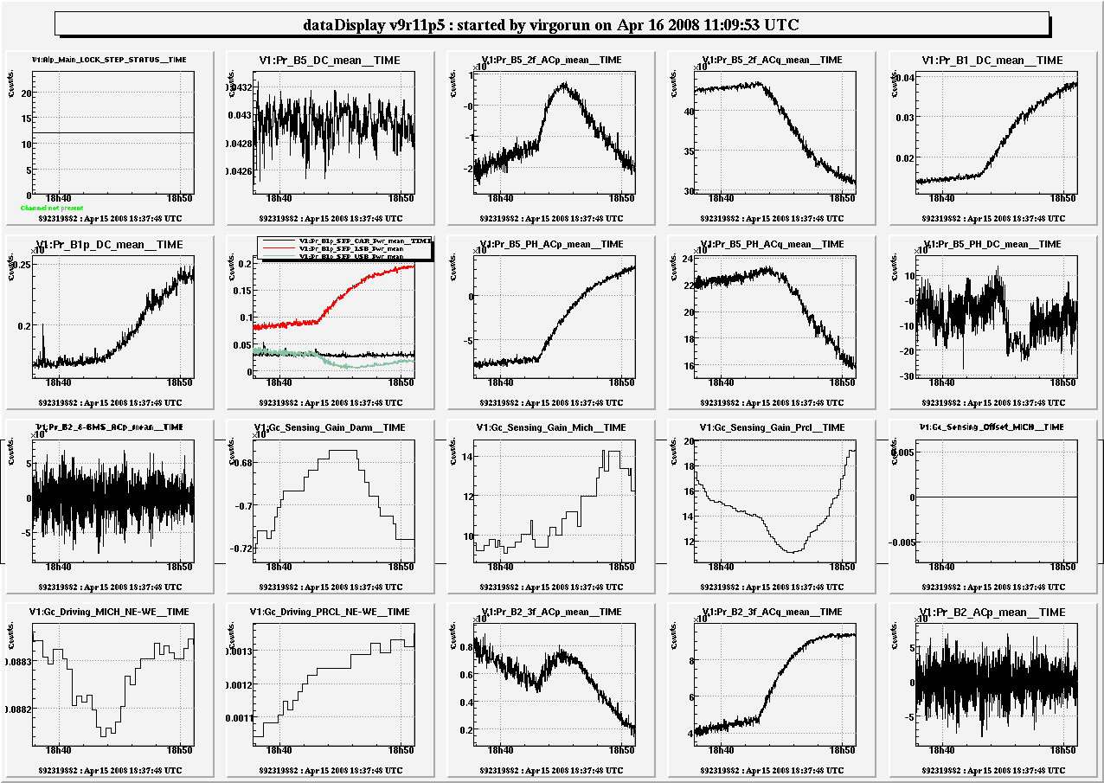
Fig. 4: Zoom on the TCS power step to 700 mW.

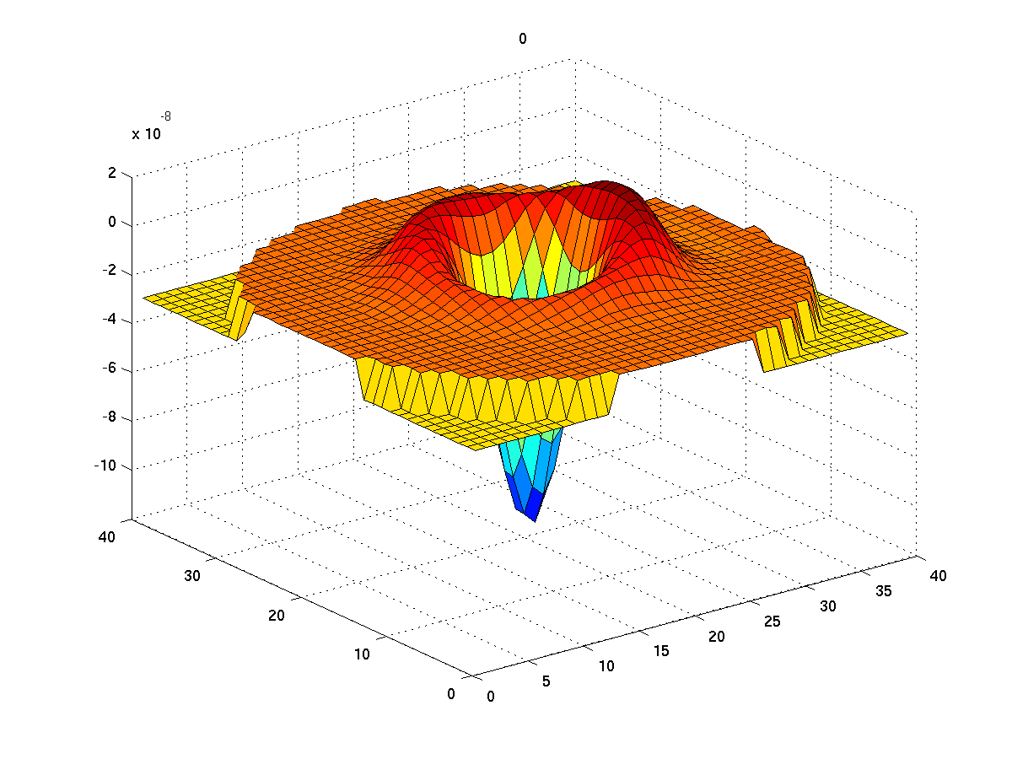
Fig. 5: Phase camera image taken at the beginning of the test.
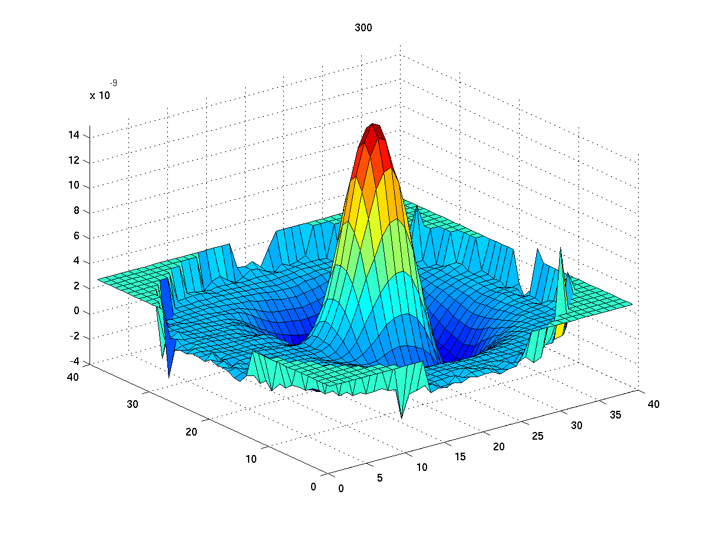
Fig. 6: Difference of the phase camera signal from the initial values taken 70 s after switching on the CO₂ laser at 10 mW.

With more than 1 W the upper SB starts increasing like the upper one but there is a 10/11 Hz loop instability that brings to unlock. This time B1_DC/B1p_DC increases indicating a cleaner matching of the SBs in the OMC, and West cavity finesse is significantly growing (see , ). All the other already discussed effects continue with the same trend.

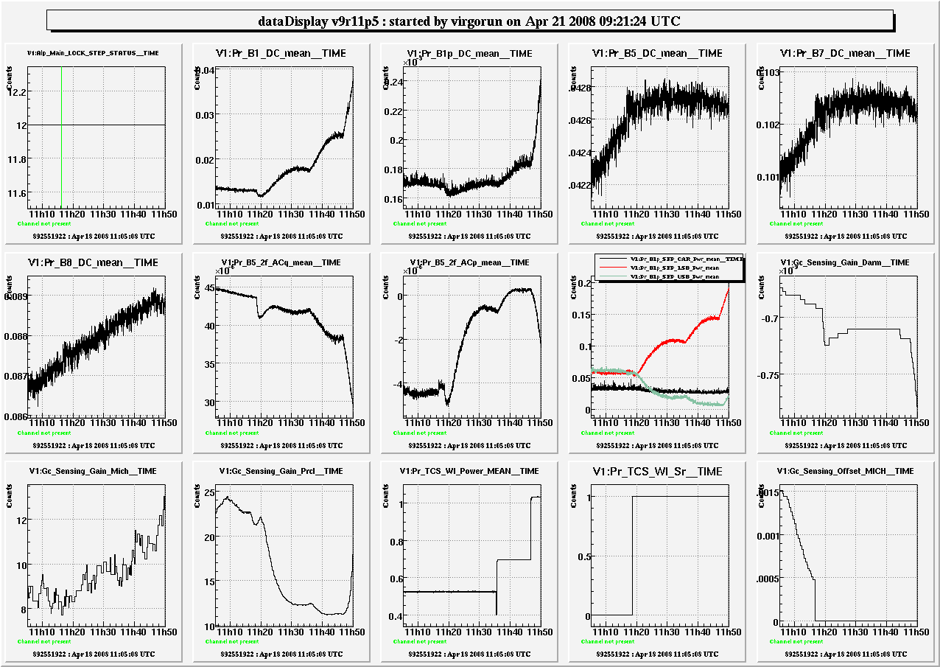
Fig. 7: Some relevant signal during the test with TCS power up to 1W.

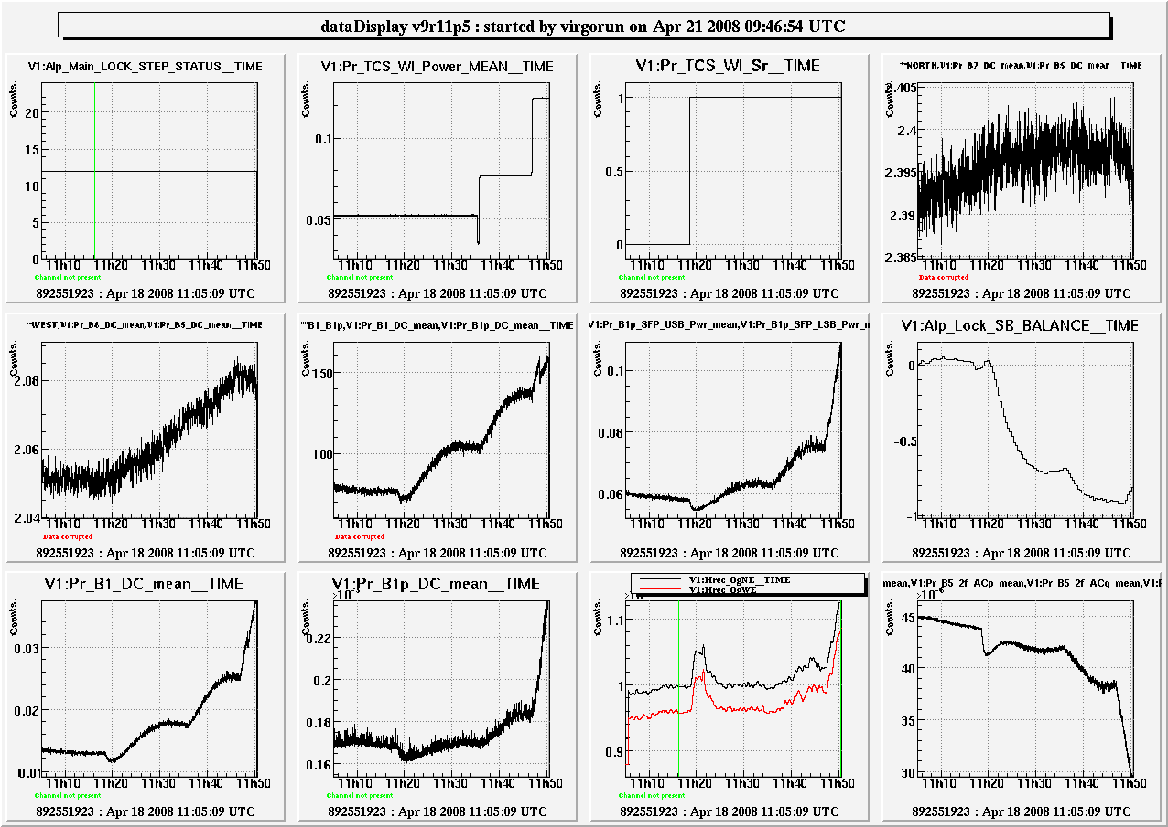
Fig. 8: Some derived quantities from the beginning of 1 W TCS test. In (1,4) and (2,1) the North and West cavity finesses, in (2,2) the ratio B1_DC/B1p_DC

Turning off the TCS from 1.3 W: the etalon effect

After a test performed reaching step 12 with 1.3 W TCS laser power, we switched off the TCS.
Looking at the signals, (Fig. 9) there are clear fast transients (~5-10 minutes) in all of them and a slower one in B5_2f_ACq. There is also a clear indication of etalon changing in the WI mirror, since beta (Gc_Driving_PRCL_NE-WE) was much larger than usual and slowly decreased after the TCS switch off. The process is the following: the WI heating changes its thickness; this varies the etalon effect bringing to a finesse asymmetry among the two cavities; therefore a pure common mode starts coupling to a differential mode, and also PRCL enters differently in the dark fringe signal.
However, even if beta was much larger than usual, PRCL noise was never limiting the sensitivity as you can see looking at the coherence among PRCL d.o.f. and the dark fringe (Fig. 10).

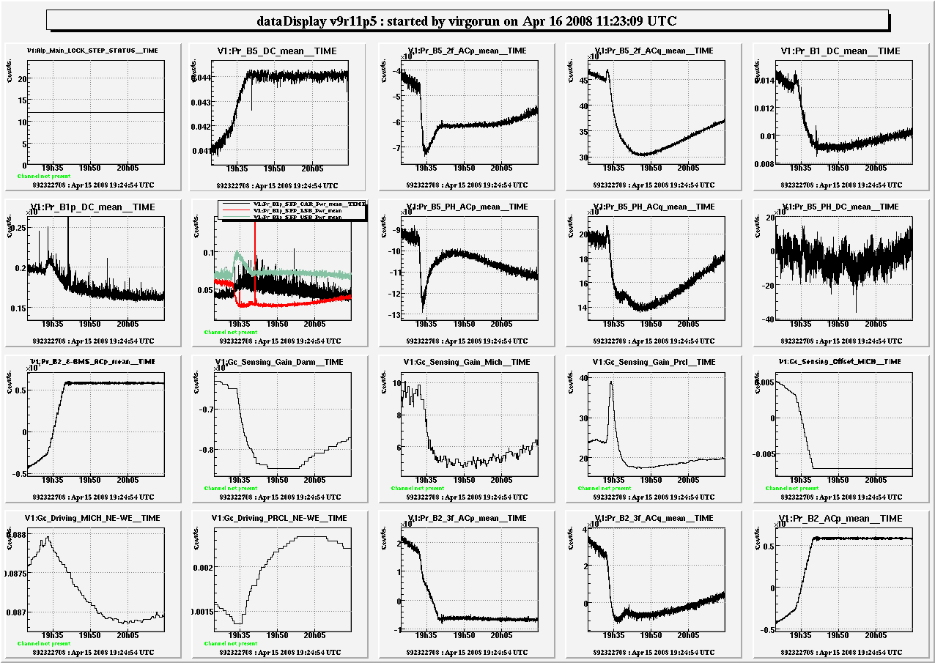
Fig. 9: Transients of the locking signal after switching of the TCS.

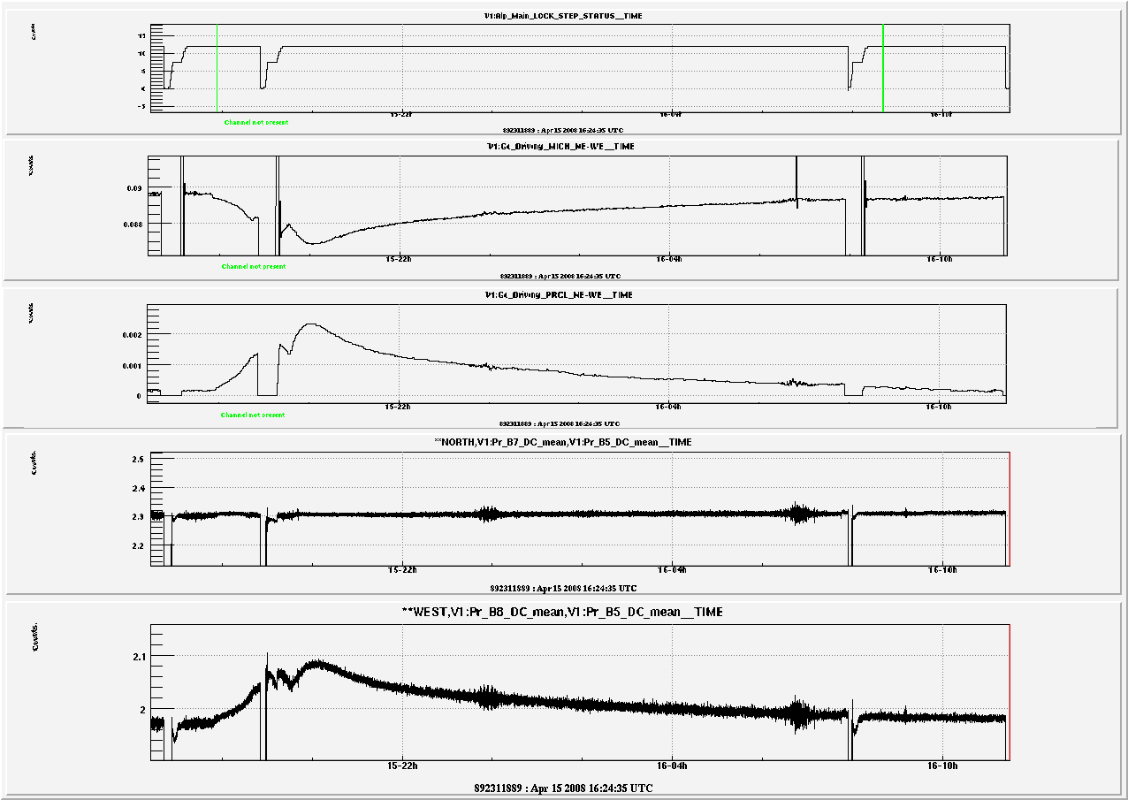
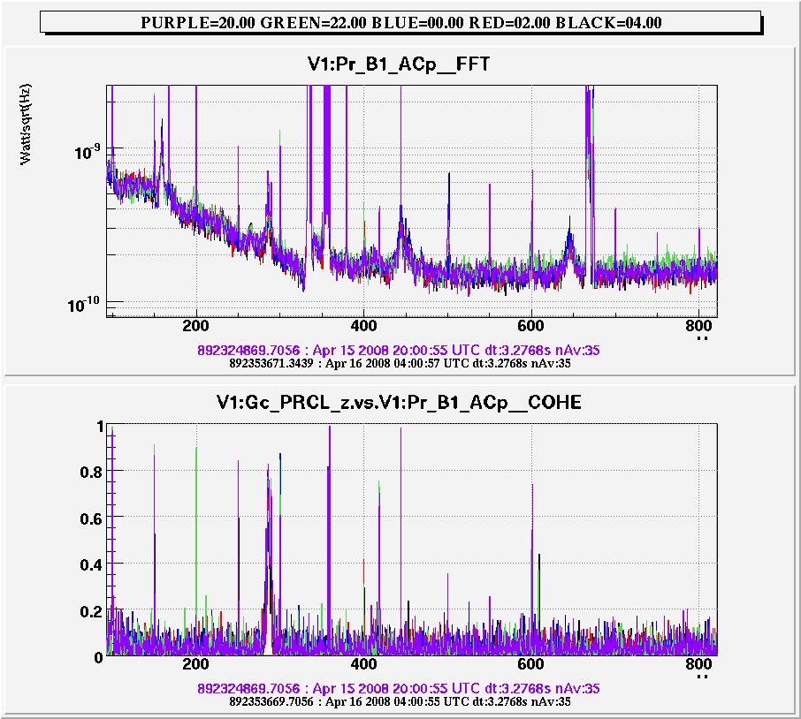
Fig. 10: Coherence among PRCL and dark fringe.
Fig. 11: Trends of alpha, beta nad the two cavity finesses.

shows the variation of alpha and beta, together with a measurement of the cavity finesses, estimated as the ratio Pr_B7_DC / Pr_B5_DC and Pr_B8_DC / Pr_B5_DC. The north cavity is not affected, while the west one changes significantly (6%).

Trends during the cooling down

After the step 12 test at 700 mW the subsequent lock (with TCS off), has clear long transients (see Fig. 12).
The sidebands start from very low values and then slowly increase (seen both on B1_2f and B5_2f signals), this generates a long trend in the optical gain of NE, WE and BS that is correlated quite well with the horizon.

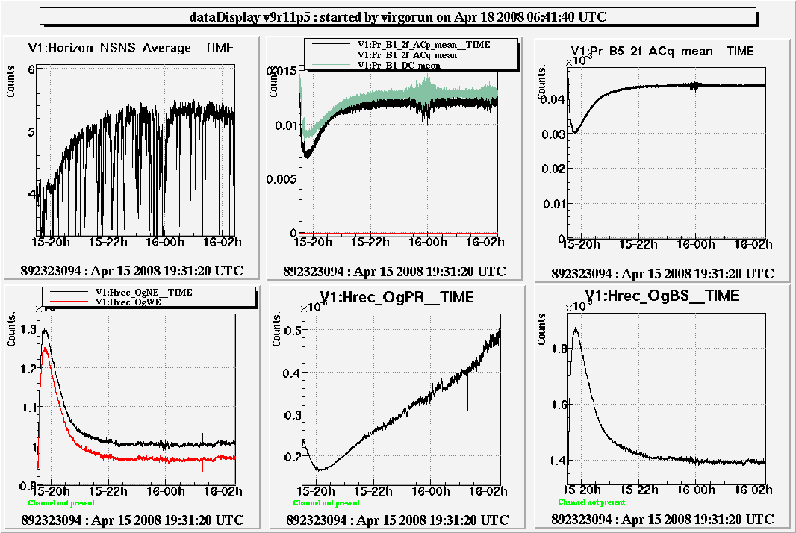
Fig. 12: Long transient in a lock with TCS off following a test a t 700 mW.

In Fig. 13 there is a comparison among the B1 spectra at the beginning and at the end of the lock, when the thermal transient is finished. There is no change in the region over 50 Hz and there is an indication of noise dependence over the optical gains in the region below 50 Hz.

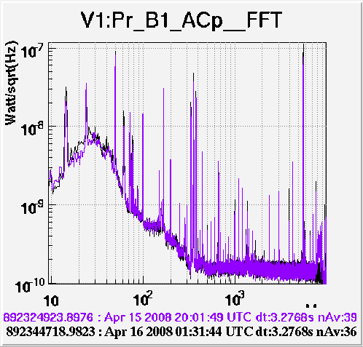
Fig. 13: Comparison of spectra at the beginning and at the end of the lock

Concerning the region above 200Hz, which is usually limited by shot noise, we probably see an effect due to etalon: the coupling of frequency noise is increased and therefore the impact of B5 shot noise (Fig. 14) is greater.
More investigations are need for explaining the increased noise in the intermediate frequencies. One should check if B5 shot noise can play a role there also.

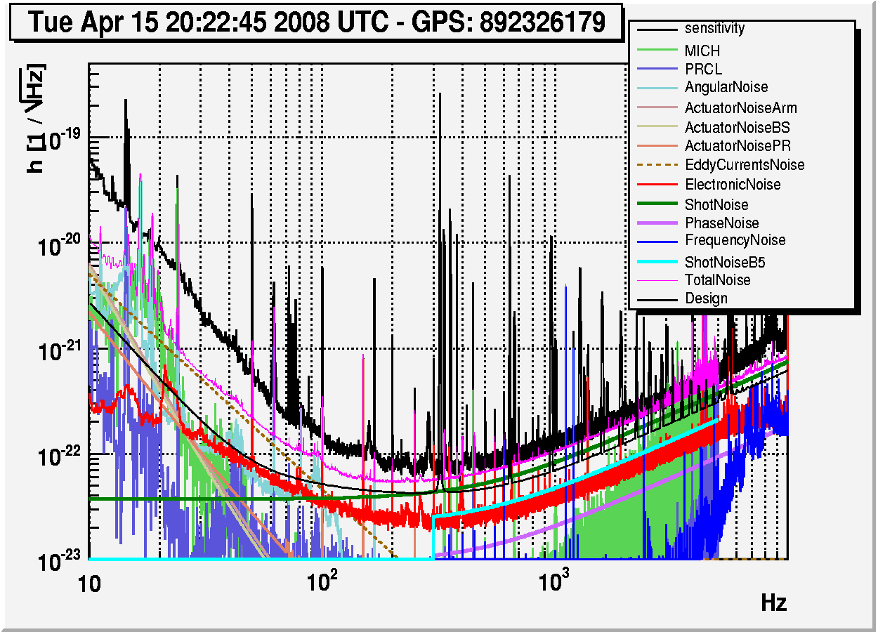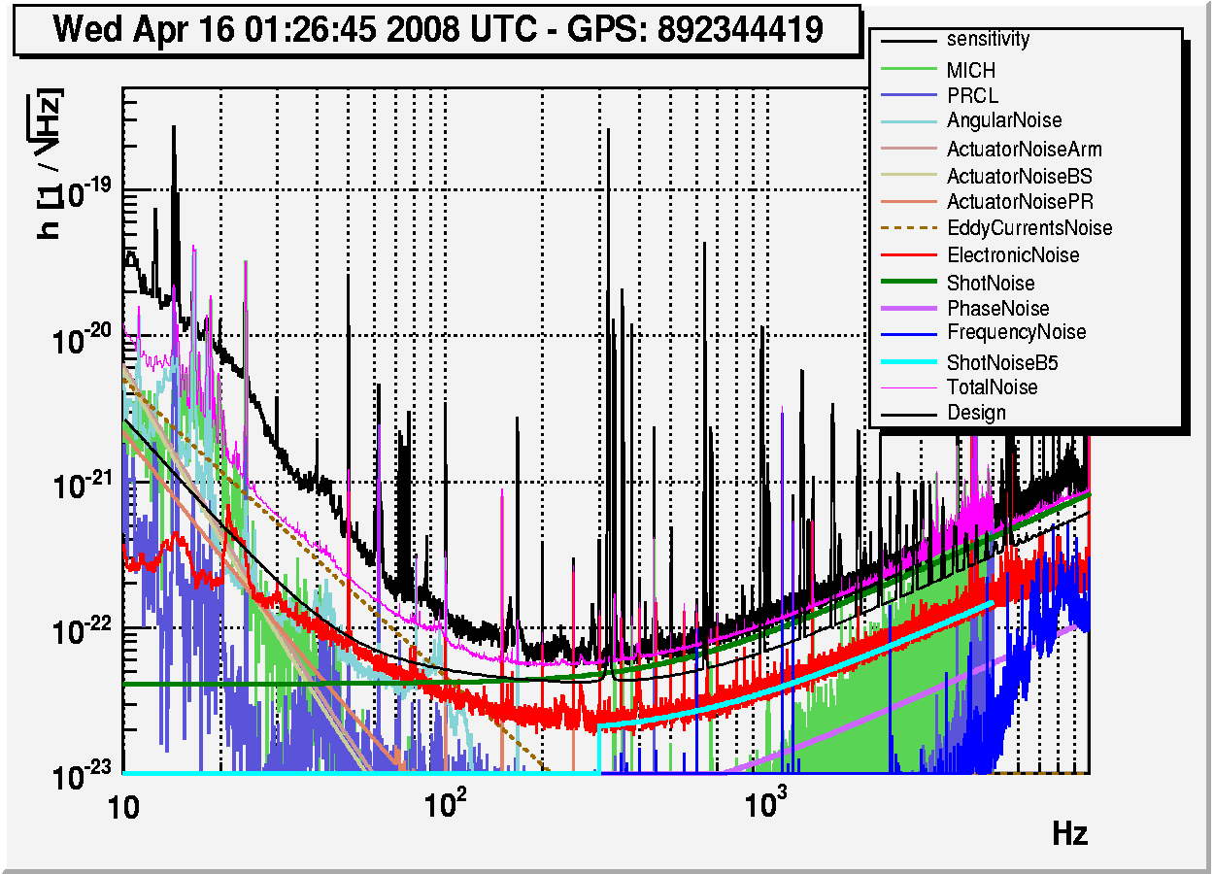
Fig. 14: Noise budget at the beginning (left) and at the end of the lock (right). The contribution of B5 shot noise is clearly higher at the beginning.

Trying to balance the SBs moving locking signals

The strong SB unbalance induced by TCS is not recoverable by the automatic servo. Also moving manually MICH offset, one rapidly come to very high values in which known instabilities start growing. B5_DC is brought to very low power.
We tried to tune the phase of B2_8MHz at step 12 with TCS off in order to bring B5_ACq to 0: the SBs unbalance, MICH offset goes towards zero and there are no effects on B5_DC or B5_2f _ACq (Fig. 15). Unfortunately, with the TCS, on nothing changes.
Lowering the PRCL offset the SBs unbalance but their power (B5_2f_ACq) goes up.

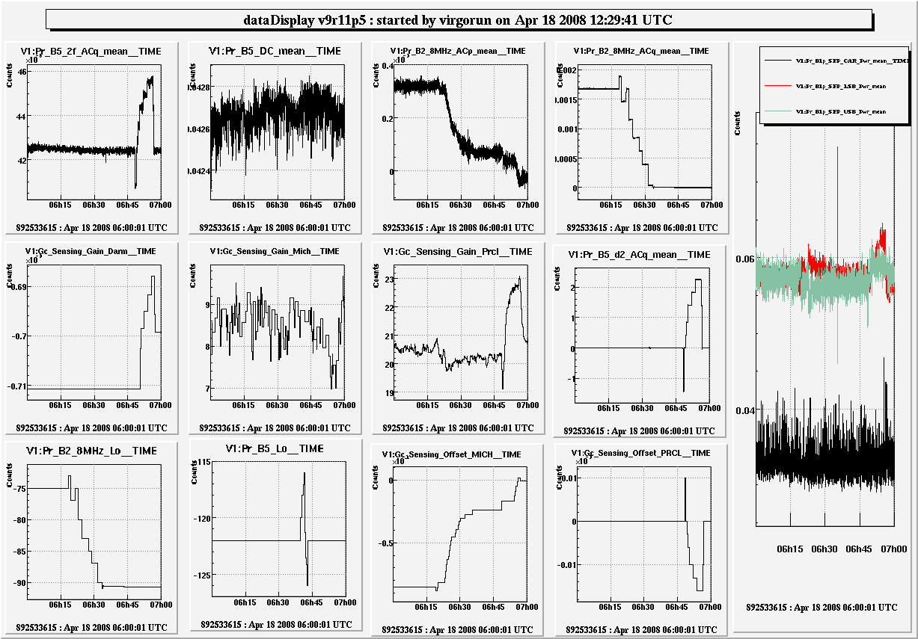
Fig. 15: Trying to move B2_8MHz phase and PRCL offset

Trying to balance the SBs moving the ITF input power

As expected an increasing of the ITF input power can follow the TCS power increasing leaving the ITF more or lass in the same state, at least for what concern the SB balancing.
That was verified injecting 0.5 W with TCS and than balancing the sidebands moving the input power. Moving the ITF power to 8.45 W (almost the current maximum allowed value) a good ITF configuration is reached. We have some non-reversible effects, probably due to etalon (Fig. 16).
With a preventive laser circuit control modification it is possible to perform a similar test reaching 9.3 W laser in input to the ITF. The results are almost the same (Fig. 17). Obviously there is a reduction of the shot noise level due to the increased input power (Fig. 18).

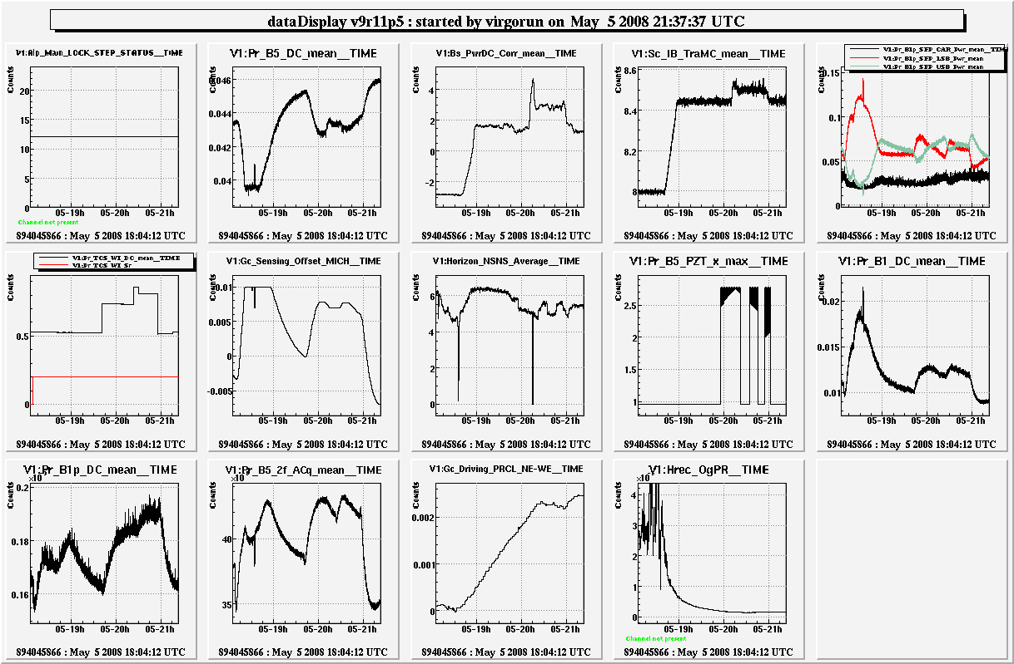
Fig. 16: TCS at 0.5 W and ITF power moved up to 8.5 W in order to balance the SBs.

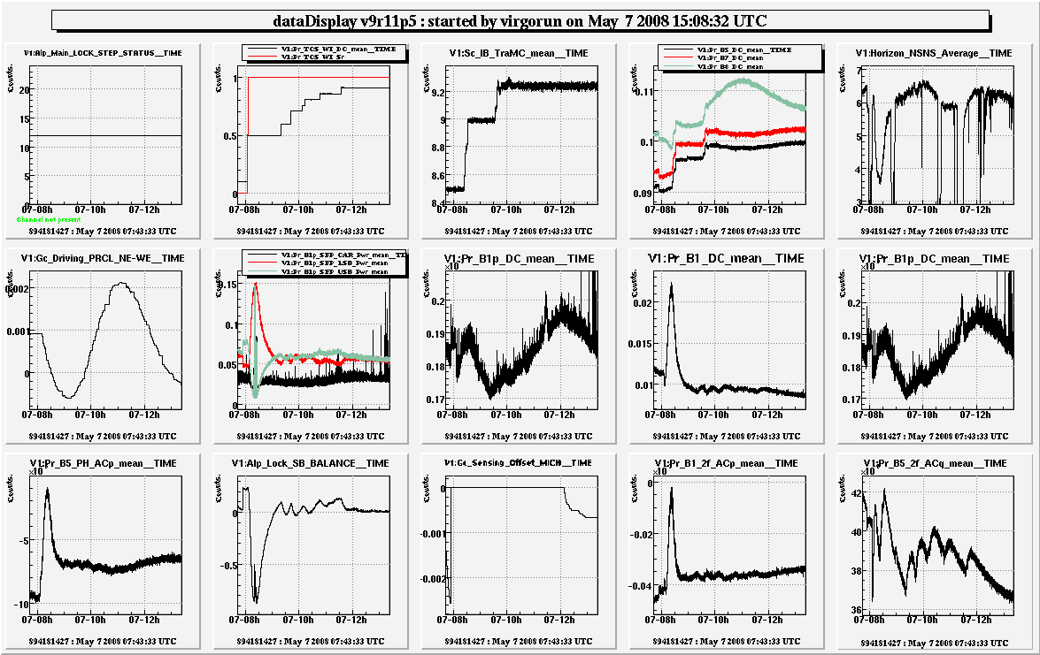
Fig. 17: TCS at 0.9 W and ITF power moved up to 9.25 W in order to balance the SBs.

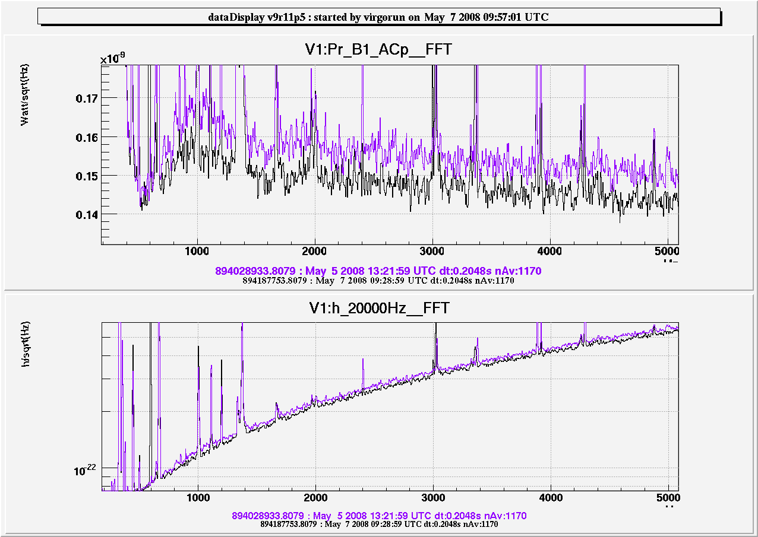
Fig. 18: Expected decrease in the shot noise due to the laser power increasing.

Investigation on 10-11 Hz loop instabilities

At step 12, increasing TCS power over 700 mW, we experience oscillations in the MICH and PRCL loops. In the PRCL open loop transfer function a sort of “resonance” is appearing.
Also acquiring the lock with TCS power at 1.5 W we have a similar instability triggered by BS marionette re-allocation (see next), moreover the servo on PRCL subtraction from the dark fringe is not working well around 10-20 Hz because the shape of the PRCL to B1 TF is largely different.
To investigate that effect we performed a test measuring the PRCL OLTF while moving the driving term from MICH d.o.f. to PR mirror. It is evident that something is happening around 10 Hz (Fig. 19).

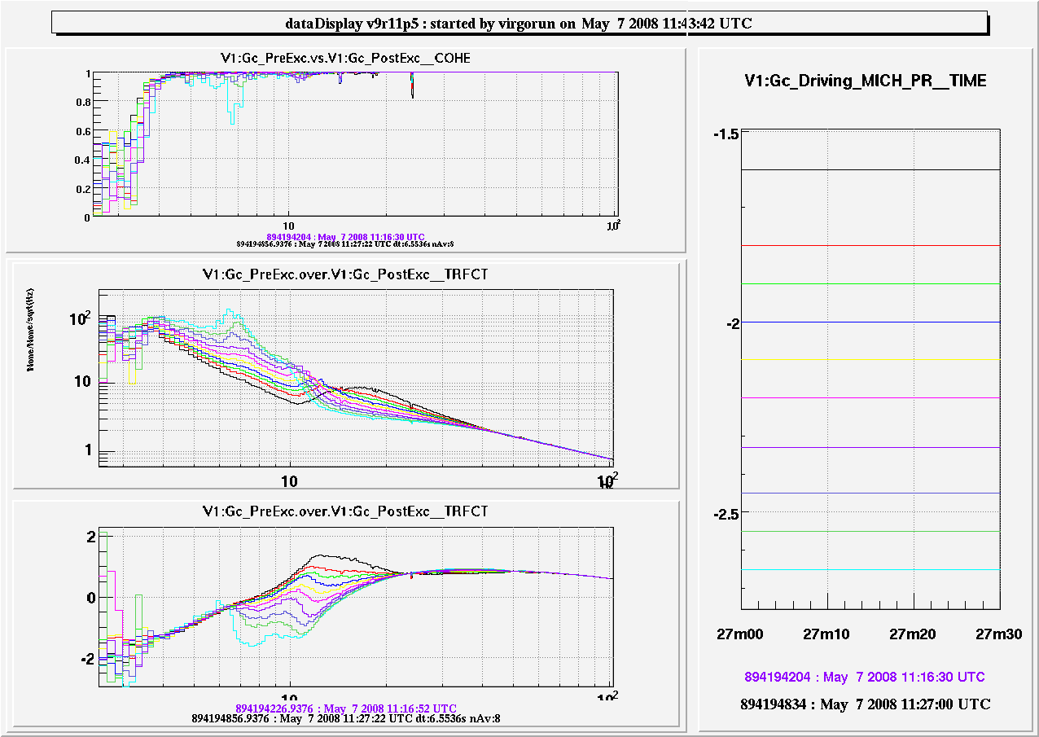
Fig. 19: PRCL OLTF for different values of the MICH to PR mirror driving term.

It is possible that such an effect is due to a not well tuned BS marionette re-allocation. We performed measurements of the BS TFs to the dark fringe at step 12 with a 9.25 ITF input power (Fig. 20) for the marionette, the reference mass and the global correction signal (we use here the following notation for the 2 TFs: Ma=Marionette to B1, RM=Reference Mass to B1, zGc=Global correction signal to B1 ). It is possible to compute the filter to be used for reallocation
(that is Ma/RM) but a fit to it reveals a pole with a negative frequency (Fig. 21); implementing it would give an instable loop. In Fig. 22 the ratio among zGc and RM actuation is shown: it represent the actuation unbalancing (whose fit has no poles with negative frequency) that can be easily compensated implementing a filter in the DSP (has to be tried in the next future).

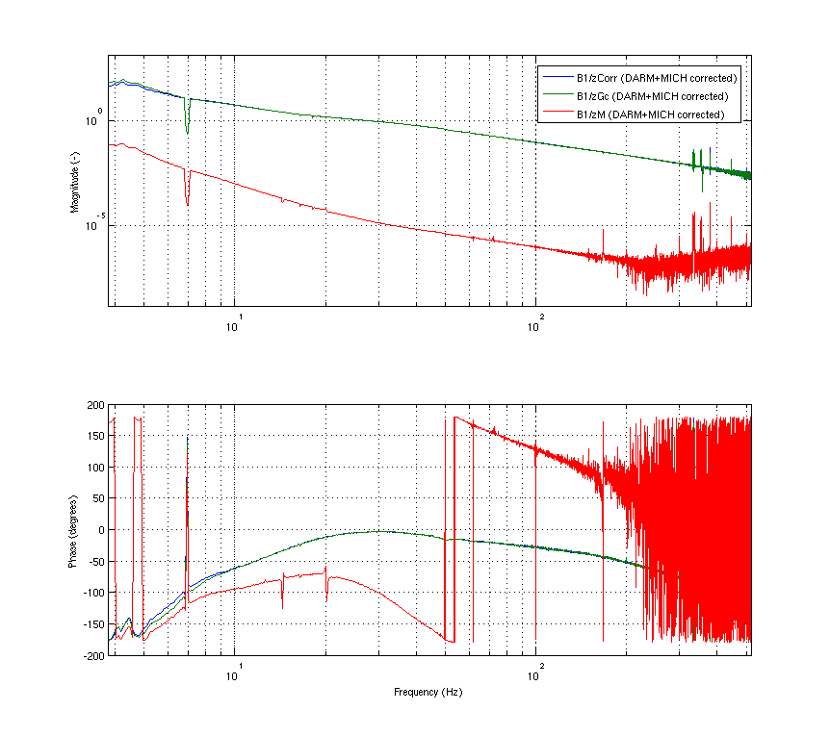
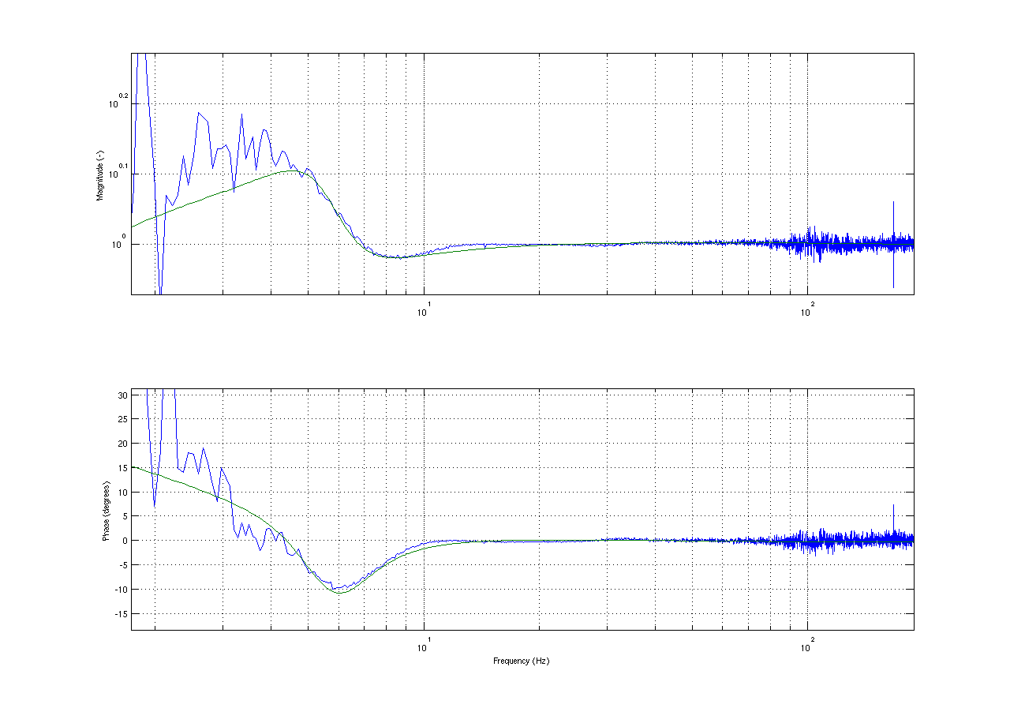
Fig. 20: Measurements of the BS TFs to the dark fringe at step 12 with a 9.25 ITF input power.

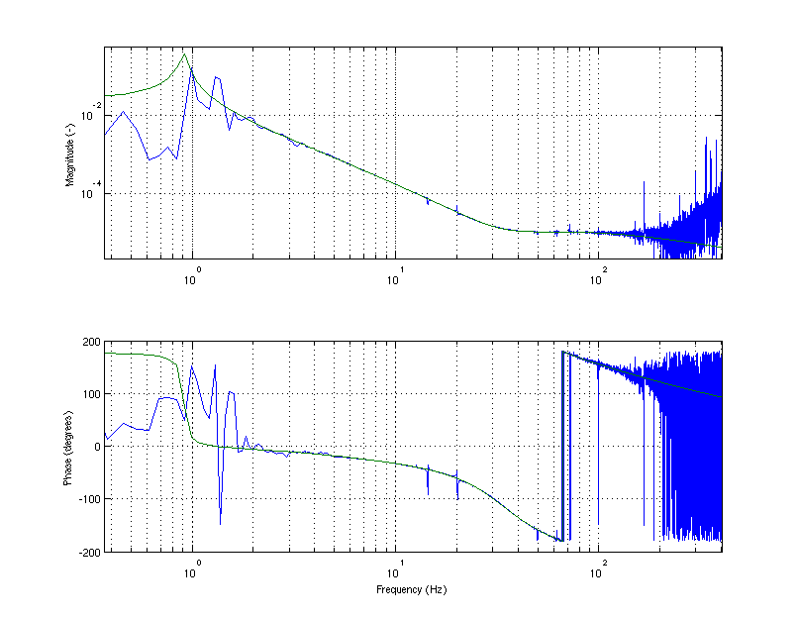
Fig. 21: Ratio of the marionette to B1 and reference mass to B1 transfer functions, measured at step 12 with a 9.25 W input power.
Fig. 22: Ratio of the global signal to B1 and reference mass to B1 transfer functions.

Step 8 tests

Increasing the power up to 4.4 W

MOVIE?
We made a first test leaving the ITF with MICH d.o.f. controlled by B5_ACq and PRCL d.o.f. on B2_3f_ACp, that is on the same configuration as during the transient of the lock acquisition. Relevant signal of the test are reported in Fig. 23; the CO₂ power was brought up to 4.4 W. It is evident that there is a strong increasing of the mean power on the sidebands even if the upper sideband goes to very low values (the scanning Fabry-Perot automatic program for the SB peaks identification starts failing).
Looking at the phase camera image during the test it seems that around 1.3 W the interferometer behaves like a “cold” one. This actually should correspond to the simulated power, for which the two input mirrors have an equal effective curvature (as it happens for a null power).

After this test a long unlockable period occurs. The time constant of the thermal transient of WI mirror is of the order of few hours.

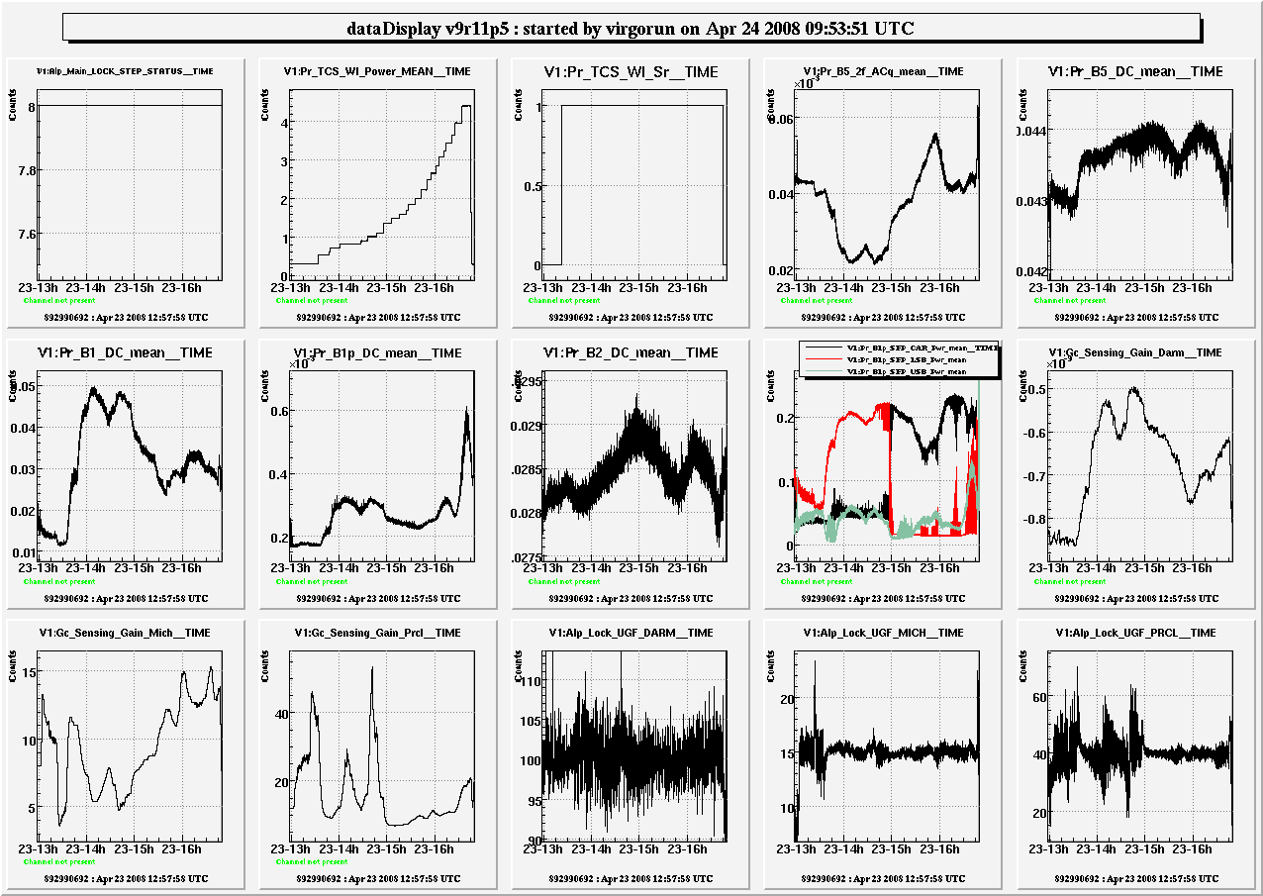
Fig. 23: Test performed at step 8 going up to a 4.5 W TCS laser power.

Test at 1.3 W

A second test was done going directly to 1.3 W in a single step (see Fig. 24). In this condition the sidebands were largely unbalanced. We then tried to rotate B2_3f phase to balance them. The "normal" phase was -102. The best one in terms of decoupling P/Q = 10 for PRCL 62Hz line was -90. The ITF unlocked when we tried to rotate further. Moreover, at the second attempt the ITF unlocked again at -90. This phase however makes B5_2f quite small. MOVIE?

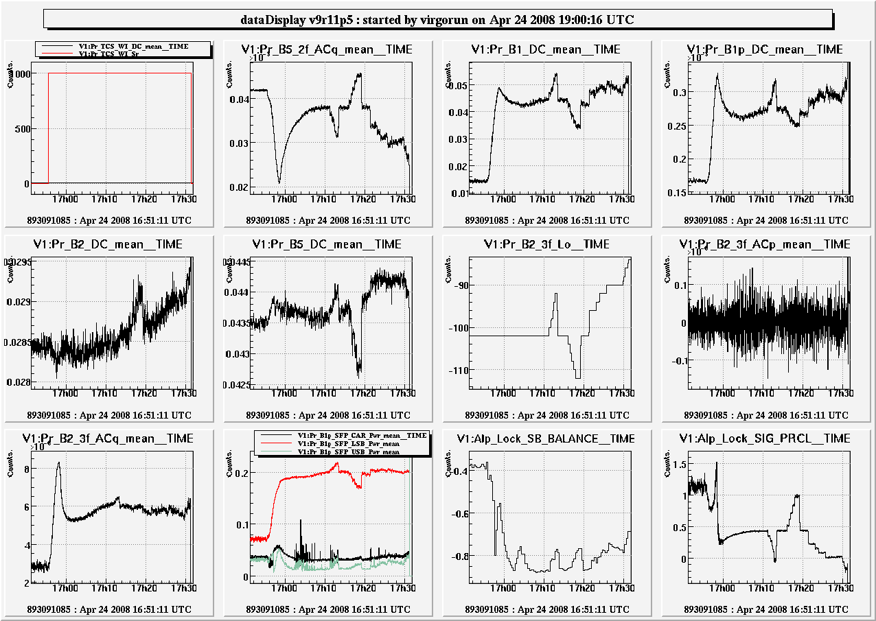
Fig. 24: Test performed at step 8 with a TCS laser power of 1.3 W

Scanning OMC temp. to measure Gaussian and Laguerre power content

We performed a test measuring the Gaussian and Laguerre power content in the dark fringe signal through the OMC with various TCS powers (Fig. 25).

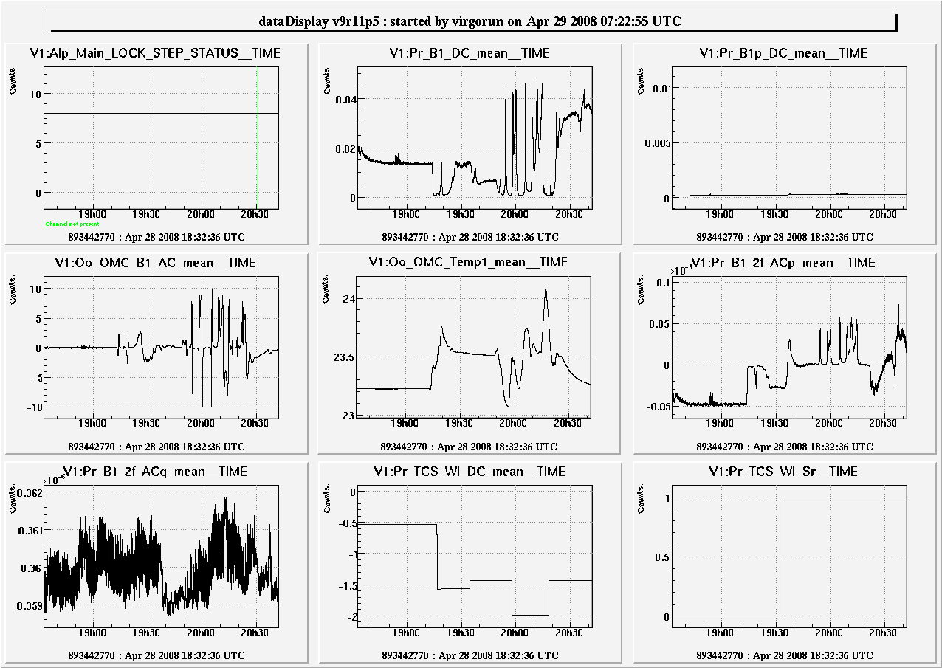
Fig. 25: Main signals during the whole OMC scanning temperature test.

In the normal hot state the sidebands reaching the dark fringe has a total power (TEM00 + Laguerre) of about 27.9 mW with 46% TEM00 and 54% Laguerre.
With 1.5W the total sideband power is doubled: 53.1 mW with a much better content: 13% Laguerre and 87% TEM00
Going to 2W slightly increases the total power (55.2 mW) with a mode content almost equal to the previous case.

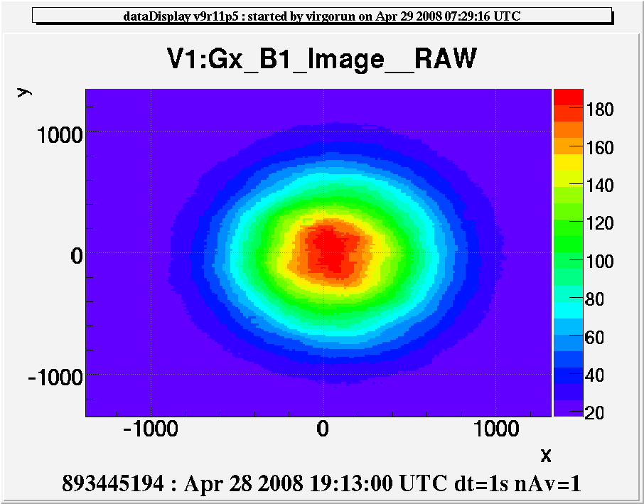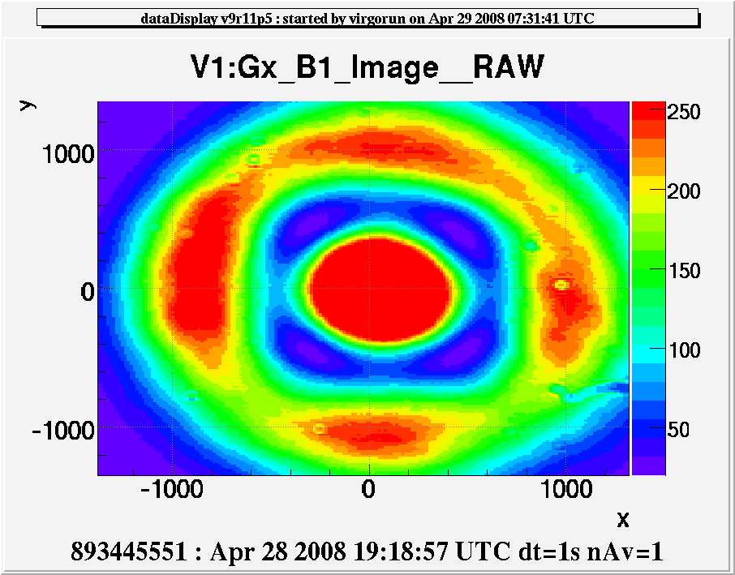
Fig. 26: Images of the B1 camera for the Gaussian mode (left) and for the first Laguerre mode (right).

In both these configurations however the sidebands were strongly unbalanced and it was difficult to balance them (see next paragraph).
An explanation of what we see can be the following: the lower sideband has a good Gaussian shape and therefore has high recycling gain, while the upper sideband has almost completely a Laguerre shape and almost no recycling gain. Probably there is no way to prove whether this is the case (at least without the new phase camera).

Trying to balance the sidebands moving the locking signals or the alignment ones

Moving the B2_3f phase or the B5 phase has no effect at all in balancing the SBs.
The effects of MICH and PRCL offsets are the same as step 12 (Fig. 27). Small effect of MICH offset, which brings towards instability, and no effect of PRLC offset. So, again, the usual way of balancing the SBs is not working

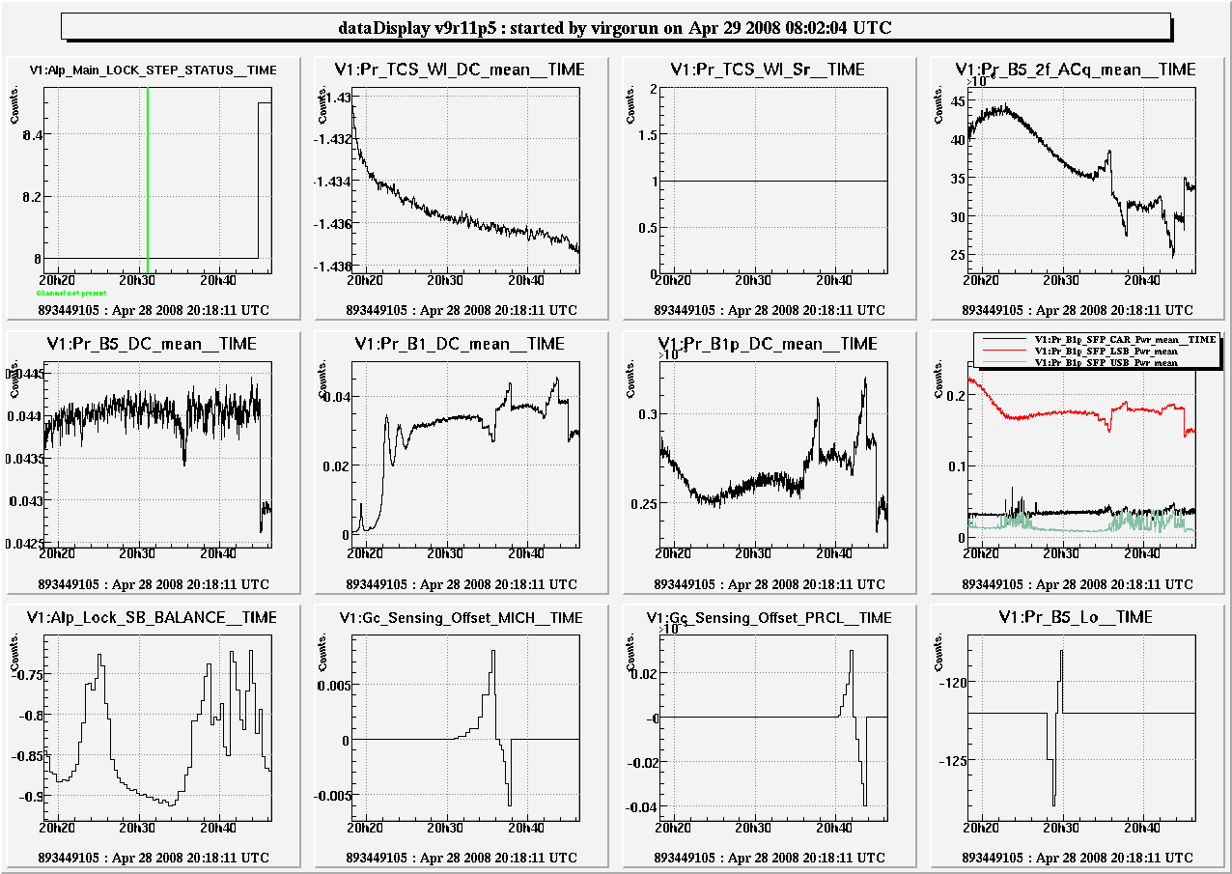
Fig. 27: Moving PRCL offset or B5 phase has no effect on SBs balancing. MICH has an effect but it is very small.

With 1.5 W TCS laser power we tried to use also some alignment signals for the SB balancing. We made a test only with the NI and WI signals but finding any effect: we unlocked for alignment instabilities.
More investigations are needed.

LOCKING ACQUISITION

With 700 mW from the beginning

We tried a relock starting with an already heated WI mirror with 700 mW TCS laser power.
In Fig. 28 the test lock acquisition, in black, is compared to a "normal" one (without TCS), in purple.
The transient is still present, but clearly different.
B5_2f power starts from higher values at the beginning of the lock acquisition and decreases slower than usual.
At a certain point of the lock acquisition, the MICH error signal is mixed by a small contribution from PRCL (see 4throw-3rdcolumn panel, Gc_Gain_Sensing_B2_MICH in the first step, at around 19^{h}08^{m}). This normally induces a step in powers, which now is not happening. This should mean that B2_3f_ACp responds in a different way to MICH displacement.
Close to the end of step 8, the control of MICH and PRCL is moved to B2_8MHz and B5_ACq. This induces now a large step in powers. Signals, indeed, seem to go back to the “normal” situation. This seems to imply that the 8MHz signal is more or less the same as before, but B2_3f is changed by the TCS.
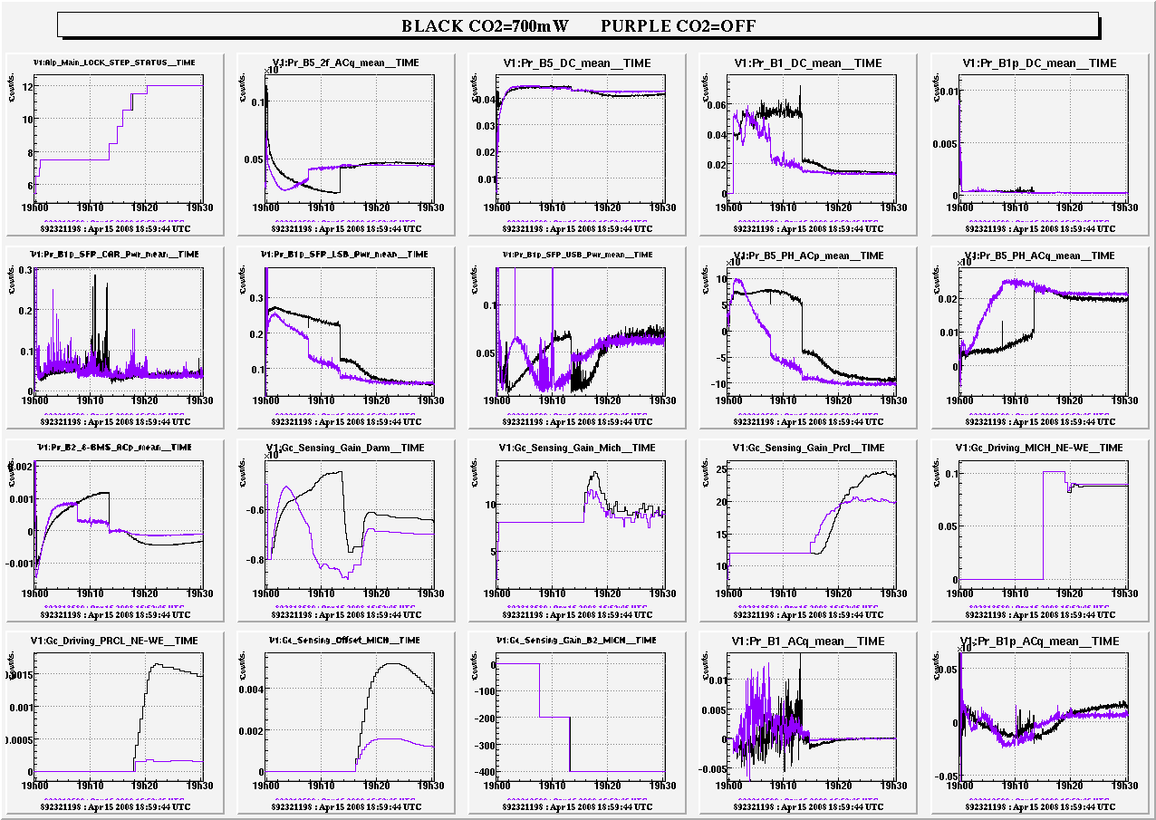
Fig. 28: Comparison among a normal lock acquisition (purple) with a lock acquisition done starting with a TCS laser power of 1.3 W.

The TCS has a clear effect on the ITF working point, even if it is not clear yet what really happens and if it is a good thing.
More investigations needed

With 1.3 W from step 8

We turned on the TCS at step 8 with a power of 1.3 W.
The strange structure around 11 Hz in the PRCL OLTF appears again and the ITF unlocks as soon as the re-allocation on the BS marionette is engaged. This is strange because if we reside on PRCL OL as culprit, at a first glance the instability should not be related to BS reallocation (PRCL loop acts only on PR). See the paragraph “Investigation on 10-11 Hz loop instabilities” for a probable explanation of that effect.

With various power from step 6

Modifying a bit the lock acquisition we managed to survive for about 1 min in the old dying-high-power-state with DARM on B1p. As soon as we were reaching the dark fringe at step 6 (on B8_ACp), in several lock acquisition, we turned on the TCS at various powers (0.5 W, 1 W, 1.5 W). The results are compared in Fig. 29, where black and blue curves refer to reference locks, with TCS off. No evident effects are present.

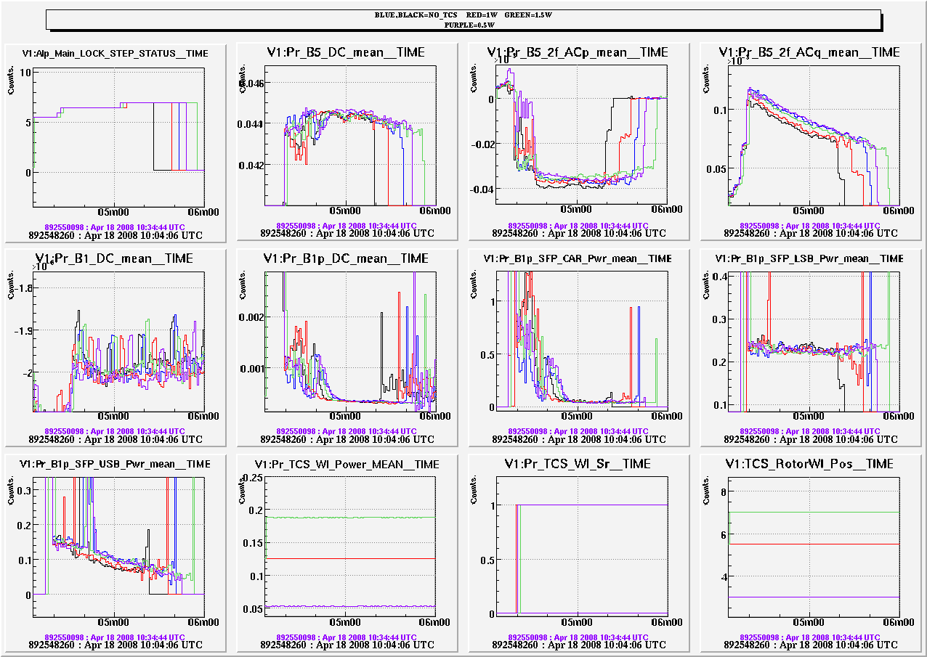
Fig. 29: Comparison among various lock acquisition switching on the TCS at step 6 with different laser power. Black and blue curves refer to reference locks, with TCS off, the othe r to 0.5 W, 1 W and 1.5 W.

SINGLE SWINGING CAVITY

We locked the two arms (step 1) and then we induced an unlock, following the behavior of the WI free swinging cavity. The idea is to estimate the elastic deformation of the WI HR-coating surface from measuring higher order mode (TEM02) frequency shift and to compare the result with what is expected. The test was repeated several times, increasing the TSC power laser up to 0.9 W (see Fig. 30)

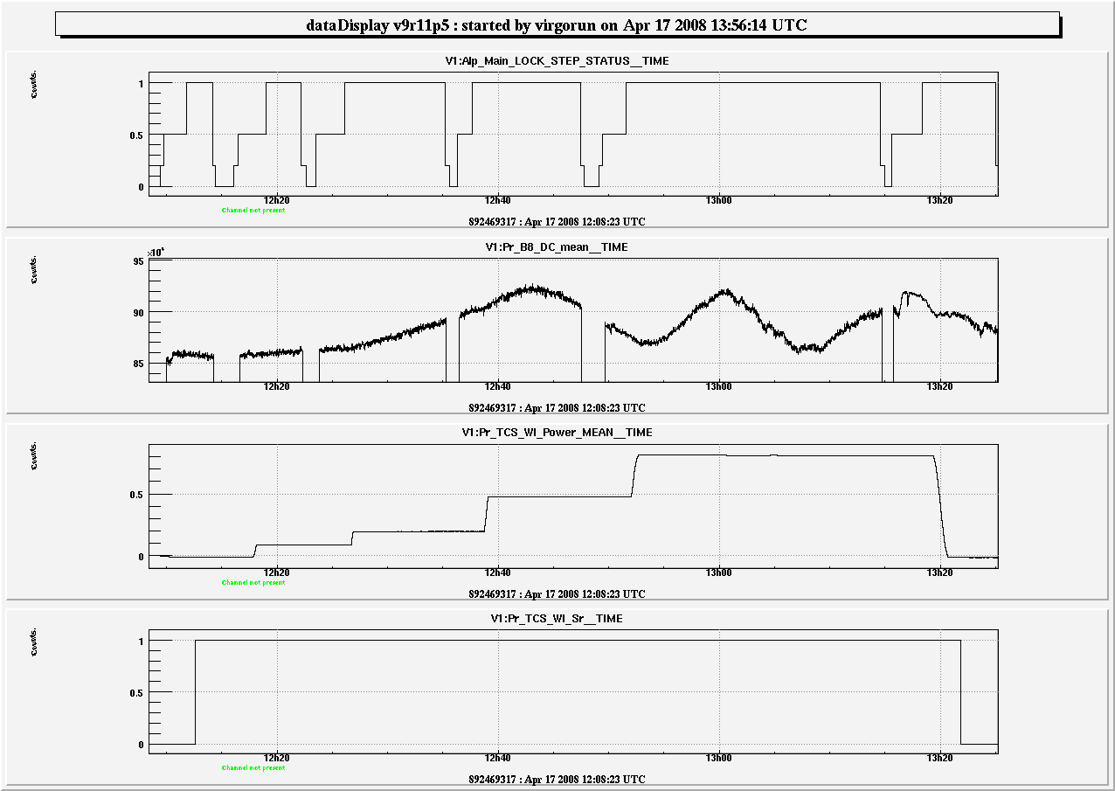
Fig. 30: Signals of the free swinging cavity tests performed at several TCS powers.

A change in the RoCs of a Fabry-Perot cavity changes the frequency position of the higher order resonant modes. The predicted effect, for the involved absorbed powers, is tiny, a shift of 30/10000 FSR, but should be measurable. We performed also some swinging test in the cooling down phase after a TCS heating. No effect is measured (see Fig. 31)!

Fig. 31: Measured TEM02 frequency shift in units of FSRx10000 from. The shift is of the order of 2 units, to be compared with the 30 expected. Also USB and LSB are plotted. (by R. Day)

More on etalon: the Newton rings

A clear evidence of the mirror heating is coming from the mirror temperature measurements through the resonant mode technique (using the internal mode frequency shift due to the change in thickness of the mirror).
An example of the extracted WI temperature values relative to a free swinging cavity test is shown in Fig. 32
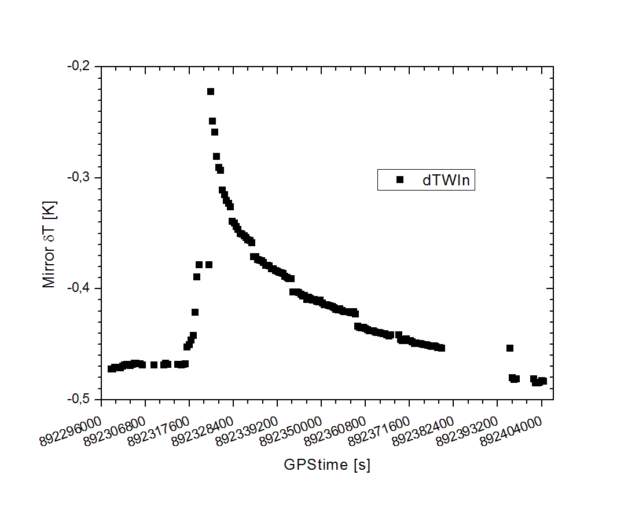
Fig. 32: Extracted WI mirror temperature after an unlock, showing the fast worming up and the slow cooling down of the mirror (by M. Punturo)

This mirror temperature change is not enough to be the cause of the observed etalon effects shown in Fig. 30. Indeed, 0.2 mean mirror temperature increase are not enough even for making half an etalon oscillation.
Making a simulation with a finite element analysis it is evident that even if the mirror mean temperature is increasing of 0.2 , on the other hand the mirror temperature in the zone of the beam spot is going up some degrees.

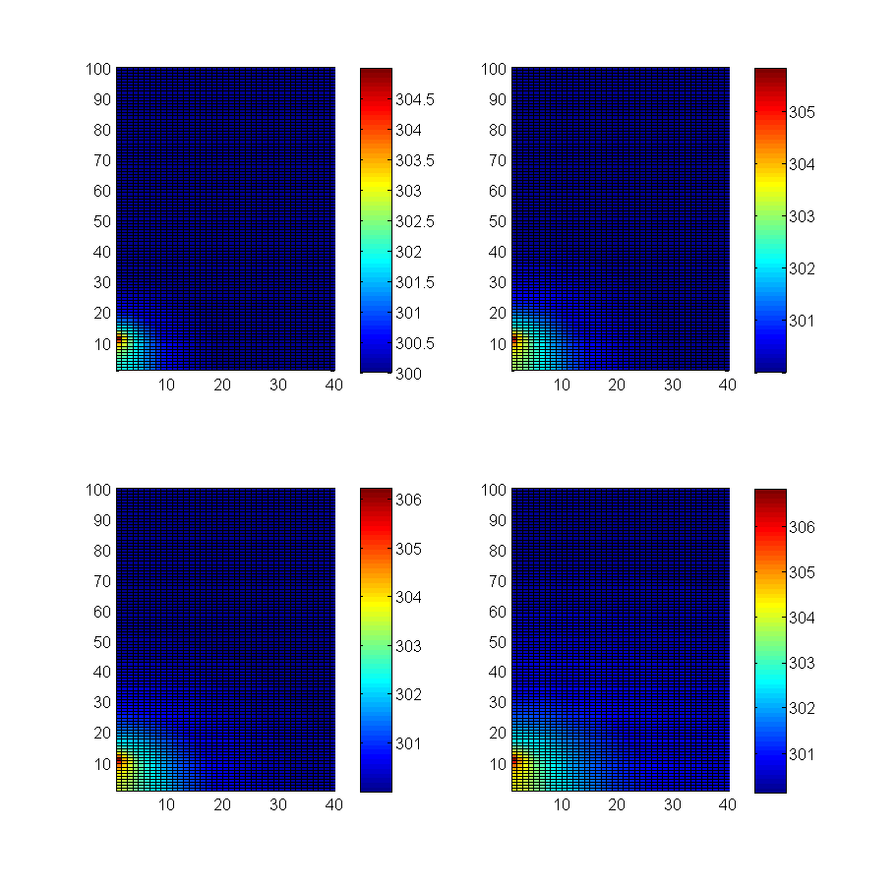
Fig. 33: FEA temperature distribution on a mirror with an impinging CO₂ laser of 770 mW of 2 mm radius (by M.Punturo)
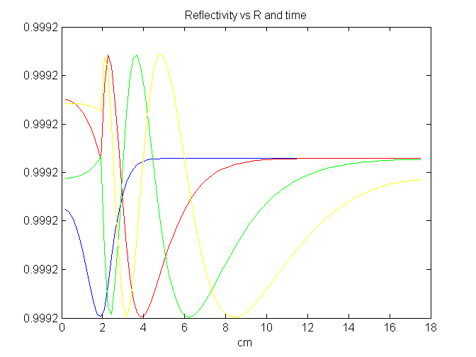
Fig. 34: Power weighted reflectivity of the interferometer vs the radial distance is shown after 1 min (blue), 10 min (red), 30 min (green), 1h (yellow). (by M.Punturo)

This local warming up is generating Newton rings that are drifting with time, as shown in , where the power weighted reflectivity of the interferometer versus the radial distance is shown for various times. This affects the power transmitted by the cavity, as shown in , where 3 power oscillations are generated although the mirror average temperature increases by only 0.4 .

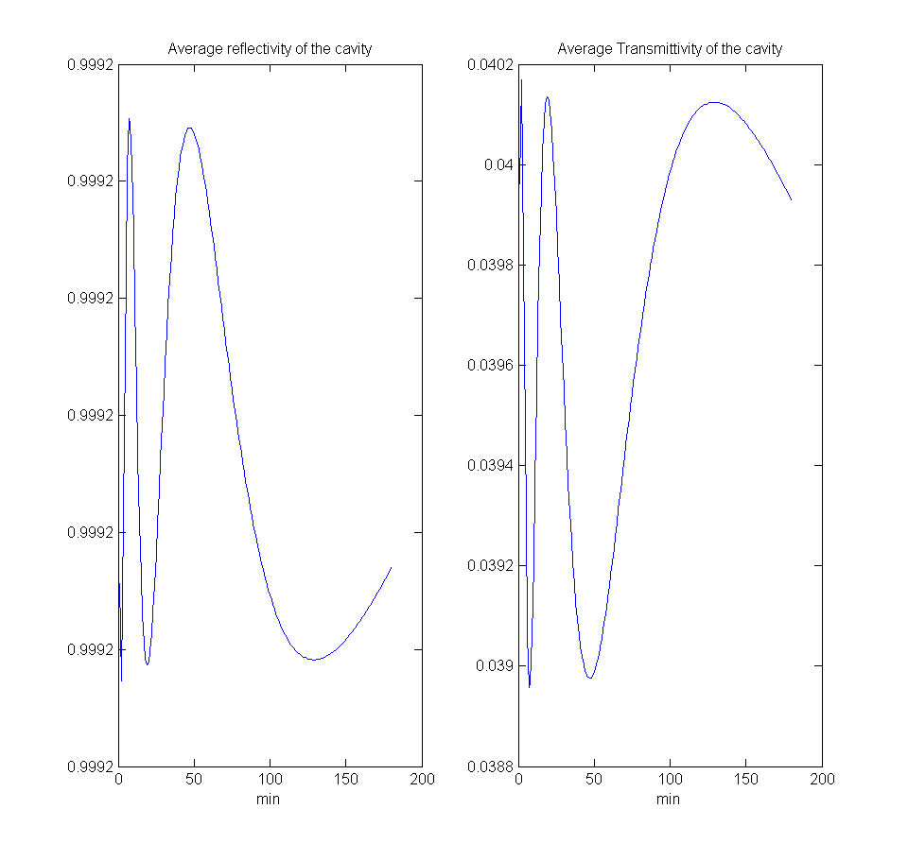
Fig. 35: Average reflectivity (left) and transmittivity (right) of the cavity for a mirror average temperature increases by 0.4 (by M. Punturo)

This effect forces to restyle the TCS as it is now. Indeed, with the current configuration we would never get rid of the local thermal transient (and therefore of the etalon effect due to Newton rings), either if we switch on the TCS at the beginning of the lock acquisition, either if we always illuminate the mirrors. What is needed is an extra CO₂ laser path with a Gaussian shape that should replace the Nd:Yag laser heating while the ITF is unlocked.

Unlockable period after TCS tests

After unlocks occurred during a TCS test with more than 0.5 W, we had some long unlockable periods of the order of hours.

After the reviewed step 8 tests we had unfortunately only two lock trials, which are not enough for having a clear idea of what is happening.
One occurred at step 6.5, triggered by a 25-30 Hz oscillation in the PRCL loop (Fig. 36), and the other happened at step 7.5 (Fig. 37) with a clear 145 Hz oscillation on all the signals.

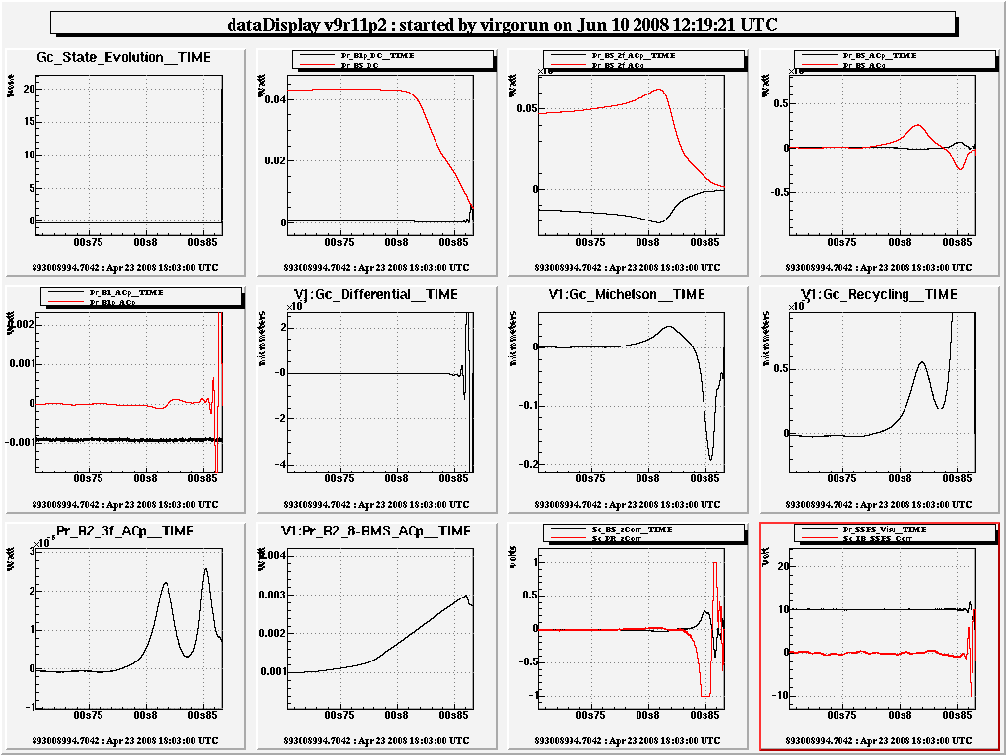
Fig. 36: Step 6.5 unlock with a 25-30 Hz PRCL loop oscillation.

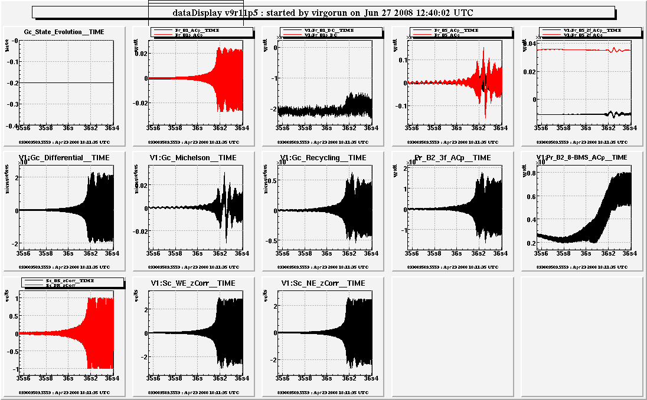
Fig. 37: Step 7.5 unlock with a clear 145 Hz oscillation on all the signals.

After the reviewed step 1 tests we had 5 unlocks at step 5.5 and 2 at step 6.5.
The ones at step 5.5 are quite similar, happening almost all at the moment, the transition to the dark fringe, with a B5_d2_ACp (the error signal of SSFS loop) getting noisier (except for unlock #2) and going under fast oscillations (Fig. 38 and Fig. 39). In the #4 there is also a very dirty DARM signal (Fig. 40).

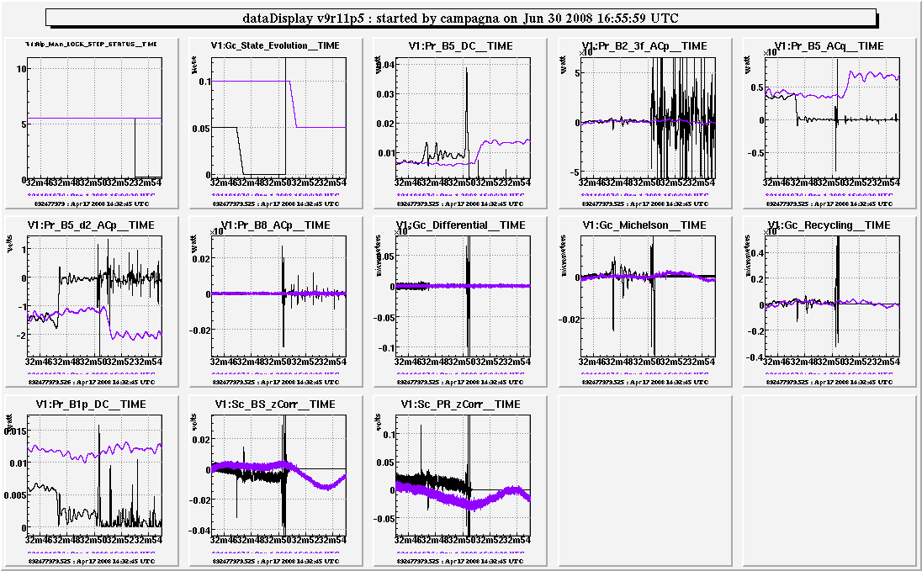
Fig. 38: Typical step 5.5 unlock; noisier B5_d2_ACp signal.
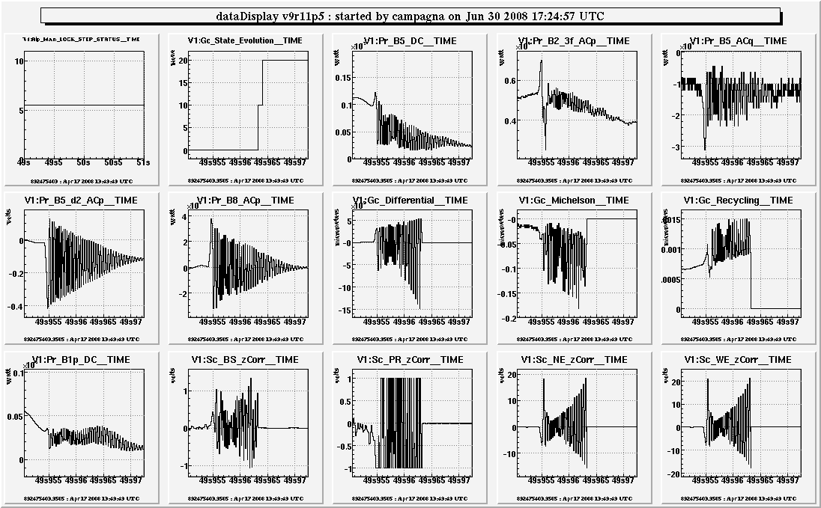
Fig. 39: Typicaltep 5.5 unlock; B5_d2_Acp going under fast oscillations.

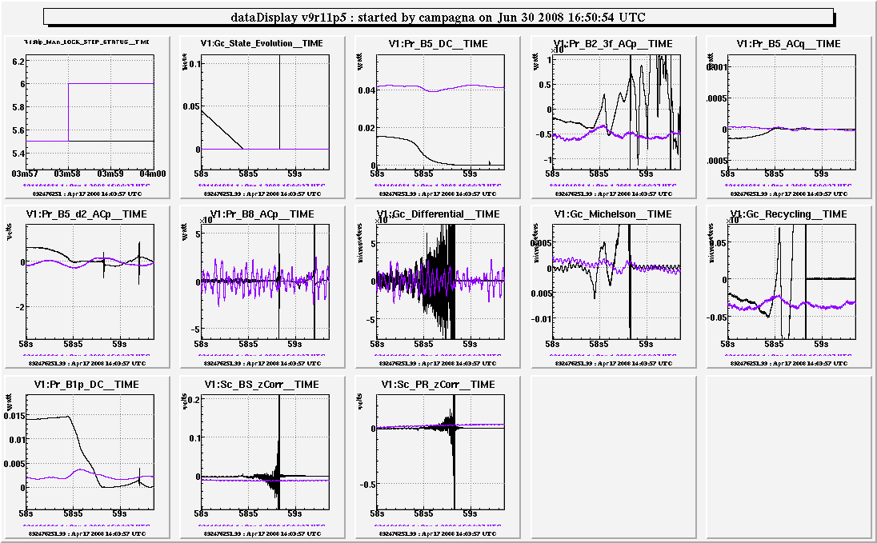
Fig. 40: The step 5.5 unlock with a very dirty DARM.

Regarding the 2 step 6.5 unlocks we cannot say too much: one has, as a precursor, a 30 Hz DARM oscillation and the other is due to a B5_d2_ACp saturation.

