- THE VIRGO EFFECTIVE SENSITIVITY AND ON-LINE STRAIN COMPUTATION

This last chapter shows how the Virgo spectral sensitivity to gravitational wave signals is obtained from the apparatus described in this paper; this needs a precise calibration of the detector considered as a whole, once each specific subsystem has been characterized.
Using the important on line computing power and data storage available on site, this sensitivity can be computed nearly in real time during the running periods, allowing to check the noise status of the instrument and to act quickly if problems are detected.
The instantaneous strain output of the detector, called “h reconstructed” is computed from the dark fringe signal and the calibration. This is the main output of Virgo; it is computed and written on each frame before final storage.

11.1 Detector calibration

The precise recording of a gravitational wave signal based on the relative elongation of the arms requires an accurate calibration of the interferometer response to mirror motion.

However, since the ITF is controlled, the mirror motion is reduced compared to the one that should have been induced by the gravitational wave. It is thus necessary to take into account the mirror displacement due to the control signals also. Therefore the calibration consists of two tasks:
- To measure the mirror displacement due to a given control signal in order to obtain the transfer function for each mirror actuator.
- To measure the effect of a differential arm elongation on the dark fringe signal to compute the detector response to gravitational waves.

11.1.1 Mirror actuator transfer function

The procedure to measure the mirror actuator transfer function (TF) is based on the distance between interferometer fringes, determined by the laser wavelength. Due to the high force required this can only be performed using coil drivers in High Power mode (HP). The Low Noise (LN) channel of the coil driver is then calibrated electronically.
First, data are taken with the ITF in free swinging Michelson configurations. Sinusoidal signals (zCorr) are sent to the mirror actuators with the coil driver set in HP mode. In such configuration, it is possible to extract the mirror movement ΔL from the uncalibrated dark fringe signal directly. The ratio ΔL /zCorr is the mirror actuator TF in HP mode at each line frequency measured in m/V. Such measurements are done from 5 Hz to 1 kHz on the beam splitter and arm mirrors.
To convert the actuator TF from HP to LN mode white noise is sent to actuator. The current flowing in the actuator coil is measured as a voltage across a resistor with the coil driver in HP and LN mode. This allows to compute the mirror actuator TF in LN mode.
Since the mirror position is partially controlled by the marionette a measurement of the related TF is required. Sinusoidal signals (zM) in the band 1-10 Hz are sent to the marionette coil driver and ΔL is directly measured using free swinging Michelson configurations Again, ΔL/zM gives the marionette actuator TF which are then extrapolated above 10 Hz using the mirror pendulum measured mechanical properties.

11.1.2 Virgo transfer function and sensitivity

The Virgo transfer function describes the effect of a differential arm elongation in meters onto the dark fringe intensity in Watt, in the range 10 Hz to 10 kHz. It is measured by injecting white noise from 10 Hz to 1 kHz on the NE or WE mirror actuator and measuring the dark fringe signal. From the mirror actuator transfer function the injected white noise in Volt can be converted into a mirror displacement in meters ΔL. The ratio between dark fringe intensity variation and ΔL is a measurement of the Virgo TF up to 1 kHz. Above that frequency the Virgo TF shape is determined by the 3 km cavity pole behaviour. The pole frequencies have been measured to be at 500 Hz within a few percent.

The strain sensitivity in Hz^{-1/2} is obtained multiplying the dark fringe noise linear power spectrum in W/Hz^{1/2} by the Virgo TF in m/W. The strain is obtained dividing the result by the arm length. The best sensitivity, obtained in April 2008 is shown in fig 11.1 , together with the design sensitivity.

11.2 ON LINE PRELIMINARY ANALYSIS

The on-line computing capability on site has been designed for several tasks to be performed on the data as soon as these are acquired. Different algorithms have been written, some of them for data conditioning, such as down sampling. The crucial task of h-reconstruction is also performed, allowing to check immediately the instrument sensitivity and identify anomalous noise. What is also computed on line is the “horizon”, defined as the largest distance at which a typical binary neutron star inspiral event could be detected by Virgo with a signal to noise ratio equal to 8. Input for this calculation is the noise spectrum and the expected waveform [11.2]. The horizon is used to monitor the time stability of the detector sensitivity for frequencies between 70 Hz and 1300 Hz (frequency of the last stable orbit for inspiralling neutron stars). Fig.11.2 shows the horizon during the full four month VSR1 run.
Finally algorithms are being designed to detect on line hints of possible event candidates by looking for transient signals from expected sources such as inspiralling binary systems and stellar core collapses (details of possible methods can be found in [11.3,11.4, ]). It is planned to send these signals as triggers to the astrophysics network of detectors.
The final data analyses, that require a huge computing power, are performed offline in the large computing centers.

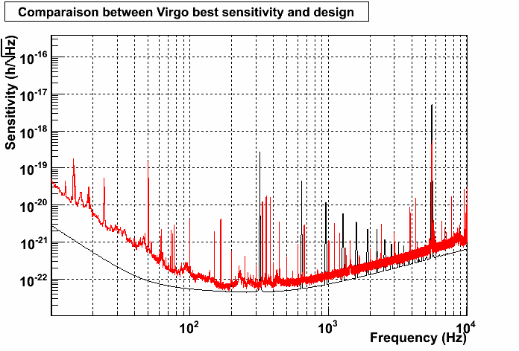
Fig. 11.1. Virgo sensitivity n April 2008 (red) and design curve (black).

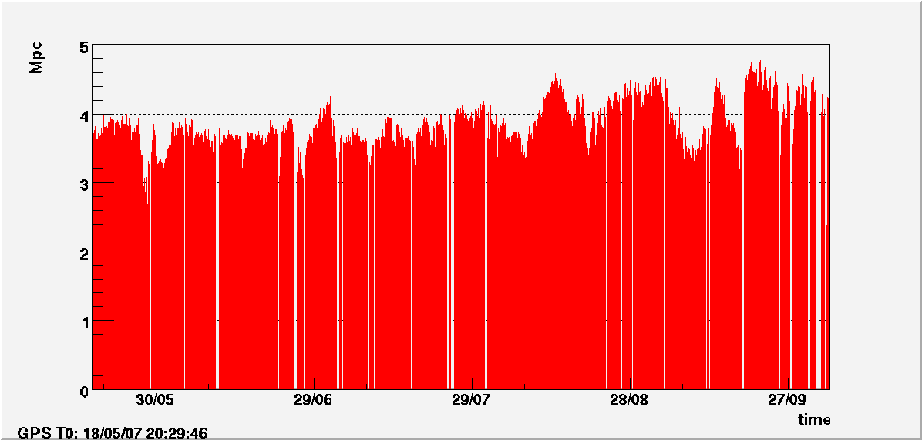

Fig 11.2. Binary neutron star horizon during the four month VSR1. The variations are mainly due to weather conditions and control noises.

References
[11.1] E. Tournefier, F. Bondu et al., Measurement of the optical parameters of the Virgo interferometer Optics, Interferometer, Applied Optics, 46 (2006) 3466-3484
[11.2] L.Blanchet et al., Class.Quant.Grav. 13.575 (1996) ;
A. Buonanno, G. B. Cook, and F. Pretorius, Phys. Rev. D 75, 124018 (2007)
[11.3] Marion F et al 2003 Multi-band search of coalescing binaries applied to Virgo CITF data Proc. ‘Rencontres deMoriond’)
[11.4] Amico P, Bosi L, Cattuto C, Gammaitoni L, Marchesoni F, Punturo M, Travasso F and Vocca H 2003 Comput. Phys. Commun. 153, 179

