9. Environmental Monitoring

The environmental monitoring system of Virgo records all the physical parameters that can contribute or alter the response of the interferometer. In fact, due to the high sensitivity of the antenna and to the weakness of the expected signals, many external perturbations can influence the performances of the interferometer. The purpose of the environmental monitoring system is to generate vetoes against false gravitational wave signals in the data analysis phase. Such vetoes are based on the understanding of the noise generated by environmental factors.
The environmental monitoring system is composed by two main subsystems: the slow monitoring, also called Building Control, and the Fast Monitoring. The first one [9-1], [9-2] records slowly changing parameters with a sampling frequency of 1 Hz. The second subsystem [9-2] records physical quantities with a sampling frequencies of the order of some kHz. The actual sampling frequency depends on the characteristics of the probe being used. Actually the slow control subsystem manages the acquisition of several outdoor and indoor parameters: weather conditions, lightning events, rain, temperature, pressure and humidity.
The meteorological conditions are monitored using a commercial station, model Vantage Pro by Davis, equipped with an anemometer, a rain rate probe, a thermometer, an hygrometer and a barometer. These sensors are integrated in a single box placed on the roof of the central building of Virgo. The lightning detector is a commercial radio frequency detector, model LD-250 from Boltek, that is able to detect events and recognize them as strikes up to a distance of 400 Km. This device is also positioned on the roof of the central building. Both the weather station and the lightning detector are connected, using a standard RS-232 link, to the VME based master Building Control CPU.
The monitoring inside the Virgo buildings of the slow varying parameters, temperature, pressure and humidity, is performed using a highly modular and distributed acquisition system. The base element of this system consists of a commercial remote acquisition board, model TRS-56 from Tecnint, equipped with 16 12-bits ADC channels. Conditioning electronic circuits adapt the signal range to the ADC input range. The standard transmission protocol used, RS485, allows to connect in cascade several boards over a distance of 300 meters. The master board is a TVM-932A VME board from Tecnint which resides in a crate together with a main CPU collecting all the data and sending them to the acquisition system. Due to the slow acquisition frequency (1 Hz), no special synchronization is required to manage these processes. There is one such system serving the central and mode cleaner buildings and two other systems for each end building. The total number of slow monitoring probes, actually operational in Virgo is: 244 temperature, 11 pressure and 11 humidity probes, 1 weather monitoring station and 1 lightning detector station.
The Fast Monitoring subsystem, records physical quantities with a broader frequency band. The system is composed by mechanical vibration sensors, acoustic sensors and magnetic field sensors as listed in Table 9.1. The location of the various sensors is shown in Figures 9.1 and 9.2. In particular vibration and acoustic sensors are located near the superattenuator base and on the optical benches.

The mechanical vibration sensors are of three kinds. The first one consists of single axis accelerometers, model 4378 from Brüel and Kjaer, with a frequency band spanning from 1 Hz to 3 kHz. The second kind includes tri-axial accelerometers, working in the frequency range 0.1 to 200 Hz, model FBA ES-T from Kinemetrics. The last one is a tri-axial broadband velocimeter, model CMG-40T from Güralp, whose frequency band spans from 30 mHz up to 50 Hz. The acoustic sensors are microphones, model 4190 from Brüel and Kjaer, with a frequency band 0.1 to 3 kHz. Finally the magnetic sensors are broadband induction coil magnetometers, model MFS-06 from Metronix, with a frequency band from 4 Hz to 10 kHz.

All the fast monitoring probes are connected to the ADC’s of the data acquisition system of Virgo [Section 10]. For microphones and single axis accelerometers a commercial amplifier, model Nexus from Brüel and Kjaer, is used, while home-made conditioning amplifiers are used for the remaining sensors.
The large number of probes used for the monitoring and their optimal positioning allows to understand several properties of the environmental noise on the site and to study its coupling with the Virgo interferometer [9-3, 9-4].

References
[9-1] A. Anastasio, F. Barone, A. Eleuteri, F. Garufi, L. Milano, “The Environment Monitoring of the Virgo Antenna for gravitational wave detection”, in “Gravitational Waves”, Proceedings of the 3rd Amaldi Conference, S.Meshkov editor, AIP Conference Proceedings 523, Pasadena, California, (USA), 17-19 July, 1999, p. 463-464.
[9-2] F. Barone, R. De Rosa, A. Eleuteri, L. Milano, K. Qipiani, “The Environmental Monitoring System of Virgo Antenna for Gravitational Waves Detection”, IEEE Trans. Nucl. Sci. 49, 2002, p. 405-410.
[9-3] F. Acernese et al., “Properties of Seismic Noise at Virgo Site”, Class. Quant. Grav. 21, S433-S440, 2004.
[9-4] F. Acernese et al., “A First Study of Environmental Noise Coupling to the Virgo Interferometer”, Class. Quant. Grav. 22, S1069-S1077, 2005.

LIST OF FIGURES

Figure 9.1 Location of the various sensors in the Central Building. M: Microphone, B: Magnetometer, E: Episensor, V: Velocimeter, A: Accelerometer, T: Temperature probe, P: Pressure probe, H: Humidity probe.
Figure 9.2 Location of the various sensors in the End Buildings. Same labels as Fig. 9.1.

LIST OF TABLES

TABLE 9.1 Environmental sensors used

Model | Physical quantity | Number of axes | Frequency band (Hz)
Kinemetrics MFS-06 | Acceleration | 3 | 0.1 – 200
Brüel and Kjaer 4378 | Acceleration | 1 | 0.1 – 3000
Güralp CMG-40T | Velocity | 3 | 0.03 - 50
Brüel and Kjaer 4190 | Pressure (Acoustic) | 1 | 0.1 - 3000
Metronics MFS-06 | Magnetic Field | 1 | 4 - 10000

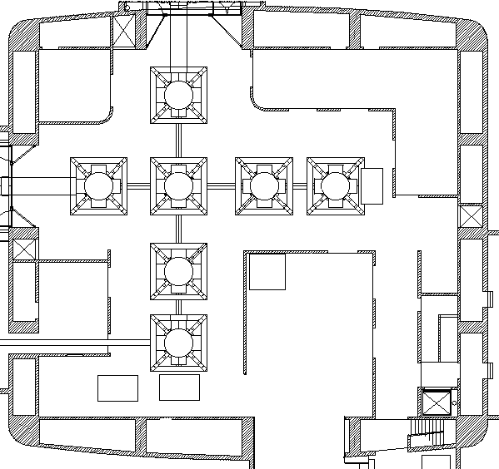
M
M
M
M
B
E
E
E
V
A
A
A
A
A
A
A
A
A
A
T
T
T
T
T
T
T
T
T
T
T
T
T
P
H
P
H
T
P
H
T
P
H
T
P
H

Figure 9.1 Location of the various sensors in the Central Building. M: Microphone, B: Magnetometer, E: Episensor, V: Velocimeter, A: Accelerometer, T: Temperature probe, P: Pressure probe, H: Humidity probe.

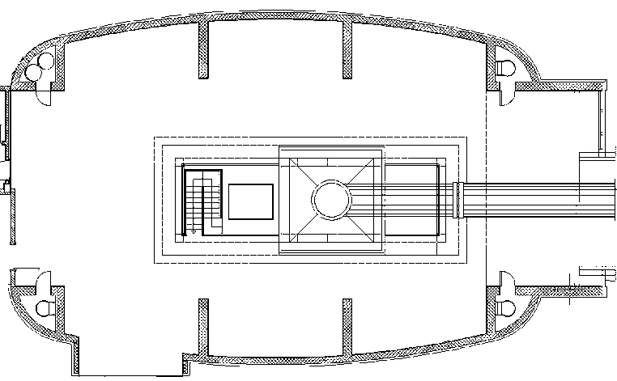
M
B
E
A
A
T
T
P
H
P
H
T
T
T

Figure 9.2 Location of the various sensors in the End Buildings. Same labels as Fig. 9.1.

