2. Description and requirements

2.1 General description
The Virgo interferometer is based on the Michelson scheme which foresees two perpendicular arms of equal length to cancel wavelength fluctuations of the light source. The passage of gravitational waves changes the geometry of space time resulting in a different apparent length of each arm. The resulting length difference δL between the two arms gives the gravitational wave signal. In terms of h

δL = h L .

For a given precision in the measurement of δL the sensitivity is proportional to L. The measurement of δL is obtained from the phase difference of the returning beams, which is deduced from the intensity of the interference figure. The best sensitivity is achieved when destructive interference occurs (dark fringe).
Sensitivity is improved by introducing Fabry-Perot resonant cavities in the arms that multiply the optical path, resulting in a larger phase variation for a given arm length change. For practical reasons the Virgo arm length was limited to 3 km while the optical path increase was chosen to be around 30 giving an effective optical length of 90 km. The sensitivity of the phase measurement is limited by photon counting statistics and can be improved by increasing the light intensity in the interferometer. By working on the dark fringe most of the light power goes back to the light source. This light can be usefully sent back to the interferometer, increasing the total circulating intensity by a factor of the order of 50. This is achieved by installing an additional semireflective mirror at the entrance of the interferometer that sends back the outgoing light in phase with the incoming beam, forming an overall resonant cavity. The resulting principle scheme is shown in Fig. 2.1 .

2.2 Required sensitivity

Due to local gravity fluctuations ground based interferometers are sensitive to gravitational waves with frequency higher than a few Hz. At lower frequency a gravitational wave detector has to operate in space. On the high side of the frequency band the gravitational wave signal strongly decreases due to source dynamics. The Virgo interferometer has been designed to cover a frequency band starting from 10 Hz up to a few kHz. Expected sources in this range are coalescing binary systems like neutron star or black hole pairs, stellar collapses, rotating neutron stars, and possibly cosmological background radiation. Estimations for gravitational wave amplitude on Earth from these sources are at the level of h = 10⁻²¹. This figure was used as a guideline to set a requirement on the spectral sensitivity $\overset{\text{\sim }}{h}$ ~ 10⁻²² to 10⁻²³/√Hz..
The Virgo sensitivity is limited by noise sources that can be grouped in different categories. The position of the test masses can fluctuate due to local perturbations like residual seismic noise, local gravity fluctuations and thermal motion. Other noise sources affect the detected signal without a real mirror displacement, the main one being photon shot noise. This is illustrated in Fig. 2.2 which shows the Virgo expected sensitivity as a function of frequency. Typical values are h = 5 10⁻²³/√Hz at 100 Hz., and h = 3 10⁻²¹/√Hz at 10 Hz where large efforts have been made to reduce the seismic noise through the use of superattenuators and so improve the sensitivity at very low frequency, where many interesting sources can be found.

2.3. General requirements

The construction of a detector of such a size is resource and time consuming in particular for what concerns the infrastructures and the vacuum tank. These items have been designed to have a lifetime of the order of 20 years. It is expected that progress in sensitivity can be achieved with improvements in optics and mirror materials, which can be done more rapidly using the same infrastructure.

The aimed sensitivity induces stringent specifications in the following domains:

2.3.1. Seismic isolation
At the Virgo site the seismic noise must be strongly reduced in the detection frequency range (10 to 10000 Hz) up to a factor of ~ 10¹² at low frequency (10–100 Hz), where it is dominant.

2.3.2. Vacuum
The arm optical length depends on the refraction index along the light beam path. That can change with pressure fluctuations of the medium. To minimize them the whole interferometer has to be located in ultra high vacuum. Moreover vacuum isolates the test masses from external acoustic noise, air turbulence and temperature fluctuations. The most stringent requirement comes from the statistical fluctuations of the molecule number along the beam path. Anticipating a factor of 10 in sensitivity improvement during the detector lifetime and keeping another factor of 10 as safety margin gives an upper limit for the contribution to the detector noise from this source of 10⁻²⁵/√Hz in h. With Hydrogen as main residual gas this translates into a pressure limit of 10⁻⁷ Pa (10⁻⁹ mbar).

2.3.3. Interferometer specifications
In a resonant optical cavity, the minimum detectable signal is proportional to 1 /Q√N , Q being the “quality factor” of the cavity, and N the number of photons entering the cavity. So both values have to be as high as possible. However a high value of Q will result in a loss of sensitivity at high frequency due to the storage time of the cavity that acts as a low pass filter.
The laser power arriving on the beam splitter mirror of the Michelson interferometer has to be at least 1 kW with a power fluctuation δP/P ≤ 10⁻⁸/√Hz. The laser frequency fluctuations due to coupling to the expected interferometer asymmetries (1%) have to be mastered in order to get a laser frequency noise spectral density not larger than 4.10⁻⁴ Hz/√Hz at 60 Hz and 3.10⁻⁴Hz/√Hz at 10 Hz.

2.3.4. Mirrors
Each mirror has to meet very stringent specifications: the total losses at 1064 nm must be less than 100 ppm. The maximum allowed absorption is 5 ppm to reduce thermal effects, giving constraints on the substrate choice, and the scattering level has to be less than 5 ppm, requiring very high quality coatings.
The mechanical dissipation of the substrate and coatings determines the level of thermal noise from the mirrors. An overall mechanical quality factor of more than 10⁶ is needed.
The wires suspending the mirror are also another source of thermal noise coming from mechanical dissipation. There too low dissipation materials like carbon steel or silica have to be used. A mechanical quality factor for the pendulum of more than 10⁶ is required.

2.3.5. Mirror position control – During the whole data taking operation the interferometer has to remain at its working point, with the two Fabry-Perot and the recycling cavities in a resonant state and the Michelson output on a dark fringe. To get and keep this situation, suspended optical components need to have their position and angles continuously controlled. The constraints are about 10⁻¹⁰ meter RMS for the length control (locking), and 10⁻⁹ rad. RMS for the angular degrees of freedom of mirrors (alignment).

Figures

Fig. 2.1. Virgo optical scheme principle.
Fig 2.2 – Design sensitivity of Virgo, as a function of frequency. The coloured curves show the main limiting noises.

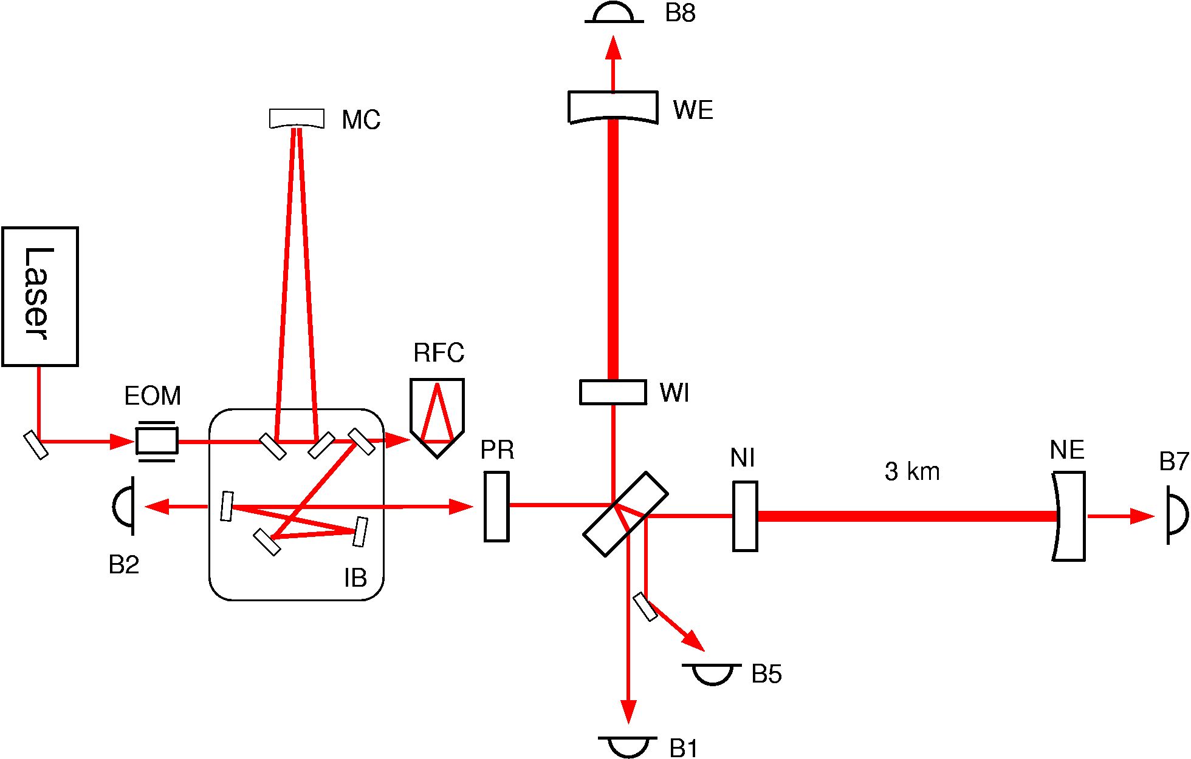
Laser
WI, NI: West, North Input Mirror
WE, NE: West, North End Mirror
PR: Power recycling Mirror

Detection

Fig. 2.1. Virgo optical scheme principle.

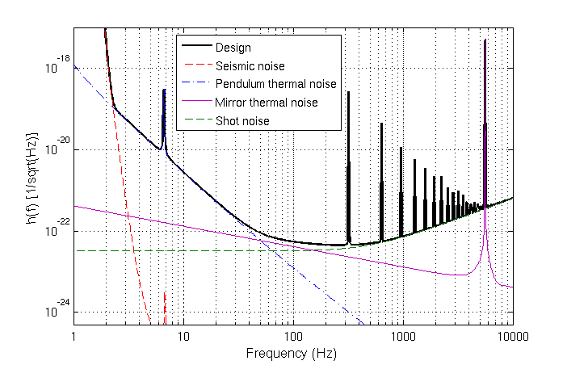

Fig 2.2 – Design sensitivity of Virgo, as a function of frequency.
The coloured curves show the main limiting noises.

