8. Overall Interferometer Control.

8.1 Overall control

An apparatus like Virgo requires several control loops to reach and stay on its working point. Initially the various systems (mainly the Injection system, the Mirror suspensions and the Detection system) are running and are being controlled in an autonomous way (see dedicated sections for details). In order to reach the interferometer working point the state of the various components will have to be steered in a global way. In its nominal running, two main feedback loops are active. The longitudinal control of the mirror positions (z degree of freedom as shown on Figure 6.6) is achieved with the Locking feedback loop.. The Alignment loop controls the transverse degrees of freedoms (θ_{x} and θ_{y} on Figure 6.6).

Figure 8.1 presents a schematic view of the different systems which are involved in the overall control of the interferometer:
- Timing system (Section 8.1.2) which distributes a time reference over the site.
- DAQ system which collects all interferometer measurements. It is involved in the control loops as data provider for the Automatic Locking Procedure (ALP), Section 8.3.
- Photodiode and Quadrant Readout (Section 7.4) which collects the photodiode and quadrant signals.
- Suspension control (Section 6.6) in charge of the actuation on the mirror.
- Laser and injection control (Section 7.2.4 ),
- Global Control (Section 8.2) which computes Locking and Alignment corrections
- ALP, which provides a set of high level commands to couple the different systems (see Section 8.3 for details).

The control system is implemented using digital servo loops. The Locking loop runs at 10 kHz and the Alignment one at 500 Hz. The overall synchronization is insured by the Timing system described in Section 8.1.2 and the communication between systems is performed using optical links (DOL) [8.4] (Section 8.1.1). Locking and Alignment loops behave in a similar way. The photodiode signals (both DC and AC) (cf. Fig. 7.1) are acquired by the Photodiode and the Quadrant Readouts (for Locking and Alignment respectively) which send them to the Global Control. Using these signals, the Global Control computes the four lengths and the fourteen angles to be controlled. After appropriate filtering the Global Control sends to each mirror Suspension the correction signal to be applied. At this level, depending on the state of the lock acquisition procedure, the corrections can be mixed with those coming from the local control system. This complex procedure is driven by the ALP which has access to the data collected by the DAQ system, allowing the determination of the interferometer status. When the science mode is reached, all mirrors are controlled in a global way and almost all the local control loops are switched off as they are noisier than the global ones.

8 .1 .1 The hardware environment

Virgo decided to use the VME and VSB standard for the boards dedicated to the online system. The standard CPU for Virgo is the RIO8062 from CES [8.1], based on the PowerPC 604 chip from Motorola. This board has been chosen for its good interrupt time response and its block transfer capabilities on VME and VSB [8.2]. The Virgo operating system is LynxOS [8.3], a UNIX-compatible real-time operating system for embedded applications. The version used is v2.5.1.

The various sub-systems of Virgo (Photodiode Readouts, Suspensions, Frame Builder, Global Control) exchange only digital data through optical fibres connected to a DOL dedicated board. The DOL board is a VME/VSB slave module which is able to send a small number of data (some kBytes) in point to point mode, over long distances (up to 3.2 km), with no latency. Moreover, powering off of the Receiver DOL will not affect the Transmitter DOL which allows a decoupling between the sub-systems. It is designed with 2 channels: one to send data, one to receive data which are completely independent. On each channel, a FIFO buffer takes care of the asynchronous operation between the optical link and the local bus of the board. The chosen FIFO buffer depth is 512 32-bit words for the Transmitter channel and 512 or 16K words for the Receiver channel.

8.1.2
The Timing System

In order to perform the feedback loops, to insure the coherence between acquired data all over the site, a central timing is needed to synchronize all Virgo sub-systems. This is achieved with a master clock driving a set of timing boards. The master clock is derived from a GPS system located in the control building [8.5]. Clock signals are distributed by optical fibre links to the different buildings (up to 3.2km away) where a local Timing board converts them to TTL signals and VME bus interrupts for local use. The data, sampled at a frequency of up to 20 kHz, receive from these signals a time stamp with an accuracy of 1μs [8.6].

8.2 Global interferometer control

Virgo needs an active control of the positions of the suspended optical components, keeping the detector on its working point. The constraints are about 10⁻¹² m RMS for the longitudinal control (‘‘Locking’’) and 10⁻⁹ rad RMS for the angular degrees of freedom (‘‘Alignment’’). The dedicated hardware and software system named Global Control [8.7] is in charge of the Locking and the Alignment feedback loops. This system has been designed to provide a flexible tool for the integration of the various algorithms needed for the control of Virgo.
The Locking feedback loop runs at 10 kHz and one of its major constraints is to be perfectly synchronized at this frequency. Any uncontrolled jitter or delay can introduce instability in the feedback loop. The Global Control receives through the DOLs the digitized photodiode signals and computes the mirror position deviation from their optimal working point. The associated corrections are sent to each suspension control system to bring the mirrors back to the right position. The Alignment feedback loop runs at 500 Hz and is similar to the Locking one.
In order to fulfill the timing constraints and insure a perfect synchronization, two dedicated boards have been built. The first one, the Transparent Memory Board (TMB), allows a fast access to the optical fiber boards in write and read mode. It also avoids the use of interrupts for the synchronization, which are a source of uncontrolled delays. The second board, the Spy Data Board (SDB), is dedicated to the supervision of the processor running at 10 kHz. It gets a copy of all data exchanged at 10 kHz and delivers them to the monitoring machine.
The Global Control hardware is divided in three parts as shown in Fig. 8.2: a crate housing the hardware dedicated to the Locking feedback loops, a second crate for the Alignment control loop and a workstation monitoring the system.

The first crate is dedicated to the Locking activities and the distribution of the correction signals. The second crate handles the Alignment loop. In order to send the Alignment corrections to the suspensions, a DOL connects the Locking and Alignment crate. The two components of the Locking part are the ‘‘Working’’ CPU synchronized at the Locking frequency and the ‘‘Master’’. The latter steers the Working part and transfers data for monitoring purposes. When synchronized at 10 kHz, the CPU housing the Locking process is isolated from the network and communications go through a dual port VME/VSB Shared Memory Board (SMB).
The Alignment CPU uses the VME bus to access the DOL boards. The synchronization is performed using a VME interrupt generated by the Timing board.

A general purpose CPU has been chosen for the implementation of the control algorithms: this solution gives the best flexibility for the design of the feedback loops. In particular, the length reconstruction needs powerful algorithms requiring many mathematical operations that change during the lock acquisition process. The algorithms are split in three parts: Sensing, Filtering and Driving. The Sensing part converts the photodiode signals in lengths and angles, the Filtering part applies in the time domain the correction filters to the quantities computed by the Sensing. In the Driving part for Locking, the various feedback signals are distributed to the relevant mirrors according to the driving matrix given by the user. This algorithm division has been chosen to allow switches between different versions of a given task without modifying the others. For example, it allows to change on the fly the length reconstruction procedure (from a lock acquisition to a lock maintaining algorithm for example) while keeping the same filtering.
All free parameters of the algorithms (optical gains, filter characteristics, trigger thresholds, etc.) are stored in the Virgo on-line DataBase. This allows the user to easily change the behaviour of the algorithms without modifying the C++ code. In addition, the full history of parameter changes is stored in the DataBase leading to an efficient recovery of previous configurations. Some parameters can also be modified on the fly without stopping the 10 kHz loop.
For both Locking and Alignment, the algorithm part of the code has been isolated in dedicated libraries which can also be used offline on recorded data or connected to SIESTA [8.8], the simulation program in the time domain developed for Virgo. This feature allows the complete development and test of an algorithm on an offline workstation without perturbing the current version running in the online chain. In this case, the developer is not limited by real-time constraints and can use powerful tools to debug its code. It should be underlined that the connection with SIESTA is a major improvement of the algorithm reliability as the algorithm runs offline in conditions as close as possible to the real ones. This feature really improved the efficiency of the Locking activities.

8.3 The Automatic Locking Procedure (ALP)

The working point of the detector is reached and maintained using elaborate procedures, built on two levels:
- a real time and fast automation layer directly implemented at sub-system level, involving local and global control, with a bandwidth up to 10 kHz;
- a control and monitoring automation layer using the data coming from the DAQ channels to drive the different phases of the locking procedure.
The interaction between the two levels is implemented via the Virgo inter-process communication protocol Cm using DAQ channels.
The software developed for the control and monitoring level has a server architecture.
The basic concept is to use the data acquired by the DAQ and to compute on a standard workstation the state of any subsystem by processing the data from the relevant channels. According to the subsystem state, actions can be performed using system calls or directly with messages in Cm format (Fig. 8.3).
The ALP server uses the DAQ framework to access the data and to report on the performed actions. It uses a script programming language. It is possible for example to create internal variables, compute signal statistical properties in the time domain (mean, min, max, rms, range) or in frequency domain (FFT, RMS in a frequency band, coherence, …) to perform the lock acquisition.
In order to better distribute the computational load and to provide a clean hierarchical organization (subsystem-linked) to the different automation tasks, an automation architecture based on a Master and several ALP servers has been developed.
The overall automated procedure consists of two main sequences:
- Pre-alignment sequence. In this procedure the alignment of the beam in the N and W cavities is performed and the long optical cavities are tuned to resonance
- Alignment/Locking/Noise Reduction sequence. This procedure allows to fully lock the interferometer along the longitudinal degree of freedom and introduces all controls for low noise operations. After having applied the main lock acquisition algorithm (called Variable Finesse[8.9]) it activates the angular drift control and the Alignment control loop. It then tunes the Output Mode Cleaner, Next it undertakes actions aimed at lowering the control noise and finally it adds permanent sinusoidal signals to the different mirror corrections for calibration.
During the sequence execution and after its completion, a special macro, working in background, watches for any unlock event. In case of unlock, it brings the ITF to the lock acquisition pre-conditions, while avoiding further excitation of suspension motion.
This automation effort has been an important element in achieving a duty-cycle higher than 80 % during data taking. A typical locking sequence is shown in Figures 8.4 a, b. The risk of human error has been considerably reduced and the daily commissioning activities, where unlocking/relocking the ITF is often required, have been greatly simplified.

References:

[8.1] RIO2 8062: PowerPC based RISC I/O Boards, DOC 8062/UM, CES (1998)
[8.2] Bellachia, F., Virgo Note VIR-TRE-LAP-5200-101 (1996)
[8.3] http://www.lynxos.com
[8.4] Boget, D., Bellachia, F., Mours, B. & Verkindt, D., Virgo Note VIR-SPE-LAP-5200-105 (1998)
[8.5] Boget, D., Bellachia, F. & Mours, B., Virgo Note VIR-SPE-LAP-5200-103 (1997)
[8.6] F. Acernese et al., The Virgo Data Acquisition System, XIIIth IEEE-NPSS Conference on Real Time Systems, http://wwwlapp.in2p3.fr/virgo/daqManual/VirgoDAQ-RT2003.pdf .
[8.7] The Global Control of the Virgo experiment, Arnaud. N. et al, NIM A 550 (2005) 467–489
[8.8] B. Caron, et al., Astropart. Phys. 10/4 (1999) 369.
[8.9] Acernese, F. et al., The variable finesse locking technique, Class. Quant. Gravity 23 (2006) S85
Figure Captions

Figure 8.1: Overview of the systems involved in the overall control of the interferometer
Figure 8.2: Schematic view of the Global Control crates
Figure 8.3 ALP simplified architecture
Figure 8.4 a) Locking status value transitions during the full sequence. Values correspond to the sequence step numbers. b) Power into the recycling cavity during the sequence evolution.

Figure 8.1: Overview of the systems involved in the overall control of the interferometer

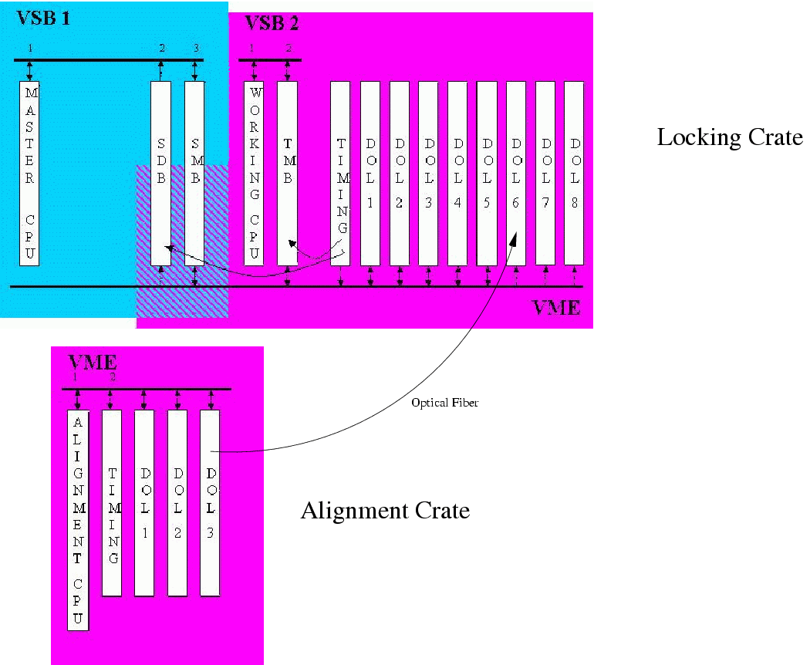
Figure 8.2: Schematic view of the Global Control crates

ALP Master

Alp server

DAQ

DAQ
ALP server
DAQ
DataDisplay

Alp server
DAQ
DataDisplay
Frame Frame
Frame Frame

Action

Action

Sub-system servers
ALP servers
Global Control

Fig.8.3 ALP simplified architecture

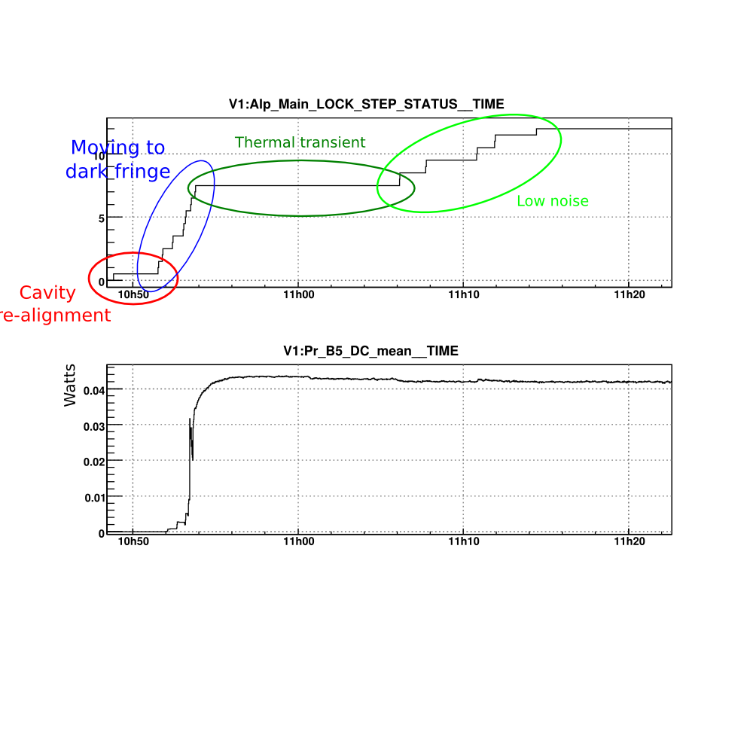
Fig.8.4 a) Locking status value transitions during the full sequence. Values correspond to the sequence step numbers. b) Power into the recycling cavity during the sequence evolution.

