Ultra-pure water (DI) production system

Authors | M.Ciardelli, N. Menzione
Date | 21/11/08
Version | v0r2
Document No. | EGO-REP-OPE-101

EGO - European Gravitational Observatory
Via E.Amaldi - Santo Stefano a Macerata, -56021 Cascina, Italia.
Secretariat: Telephone (+39) 050 752 521 FAX (+39) 050 752 550

Contents
1 Introduction 3
1.1 Purpose 3
1.2 Scope 3
1.3 Overview 3
2 General Description 4
2.1 Utra-Pure water distribution Scheme 4
2.2 Prefilter & Demineralizer 5
2.3 Millipore Elix-70 6
2.4 PP Collection tank 7
2.5 Distribution pipe line 8
2.6 Millipore Super-Q 9
2.7 PVDF Collection tank 10

Introduction

1.1 Purpose

This document is the final report of the Ultra-Pure water production system.

Scope

The scope of this document is to give some details about Ultra-Pure water
production system facility.

Overview

In the VIRGO experiment, particular care is dedicated to the cleaning of optical, mechanical and electronic components installed within the vacuum towers. This is pursued ensuring a tank with Ultra High Vacuum (UHV) compartment.
In addition to the standard cleaning procedures (ultrasonic detergent and isopropyl alcohol baths, CO2 and ionized nitrogen gun) an ultra-pure water system is used in the final process of the mechanical elements (washing tunnel). This last facility is also used in the delicate silicate bonding process.
DI water is neutral (Ph 7) and un-stable (equilibrium between H+ and OH- ions), this means that it is good solvent, able to completely remove ionic or polar compounds.
Unfortunately, being a substance that is extremely eager for ions, it must be conserved in plastic tanks (Teflon, PP, PE), as, when it is exposed to air, the CO2 parts are rapidly absorbed into the substance.

General Description

The system is quite well-defined and follows successive stages, in order to guarantee a constant water quality, and to provide the capability of ca. 5 l/min in the final phase (normal capability of analysis laboratories is a few liters per day).

Utra-Pure water distribution Scheme

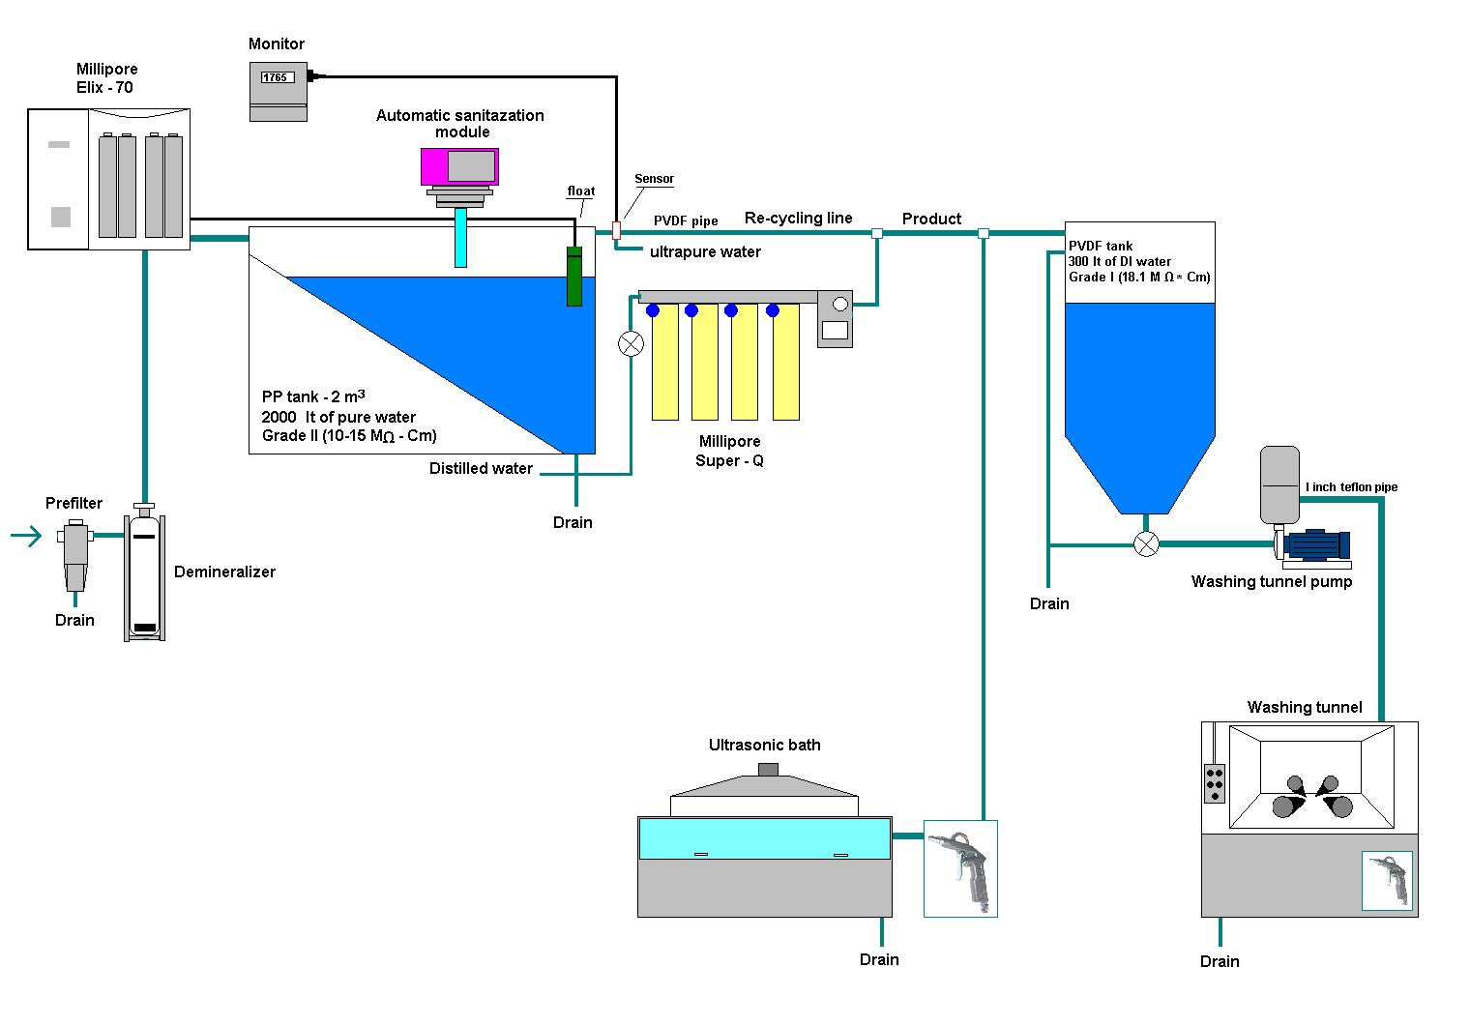

Prefilter & Demineralizer

They are necessary to bring the water characteristics to the specifications required by the main system (Millipore Elix-70):

- Elimination of encrusting elements (sand, insoluble salts)

- Reduction of water conductivity (from 1400 to 1000 μS/cm)

N.B. The recently installed (2008) OMICRON demineralizer, has taken the place of the water softener (in operation since 2001), which is now out of use.

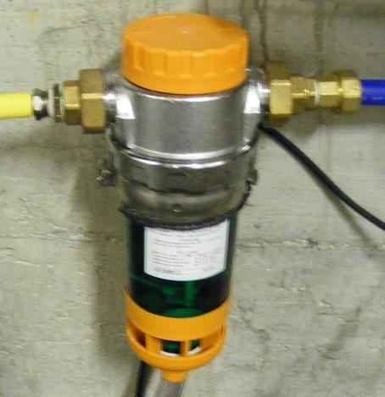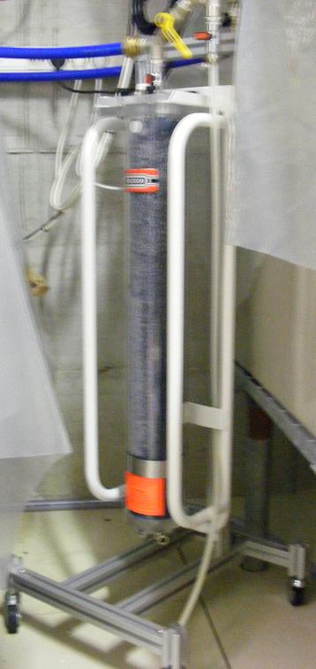

Millipore Elix-70

During the trial period (2008), the main system did not meet our specifications [pure water resistivity (ϱ ) > 5 MΩ.cm], thus a technical intervention was scheduled.The treatment module (Elix) was substituted, and a post-filter was added.Thanks to this, It is now within our specifications or better, producing up to 70 l/h of DI water with ϱ > 15 MΩ.cm.

N.B. This system has been adopted to substitute the Millipore RX-75, out of use both for aging problem (2001) and for very long inactivity period (cleanroom shut down during data taking).

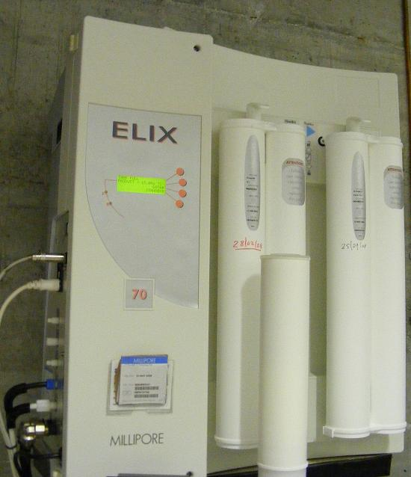

PP Collection tank

A storage tank in polypropylene (PP) meeting the EN 10204 2m3 standard, equipped with a CO2 filter, UV lamp (sterilization) and level interrupter (in Hypalon and PP) for automatic re-filling.

N.B. There have been no modifications since its installation (2001), apart from the substitution of a defective floating cock (2008).

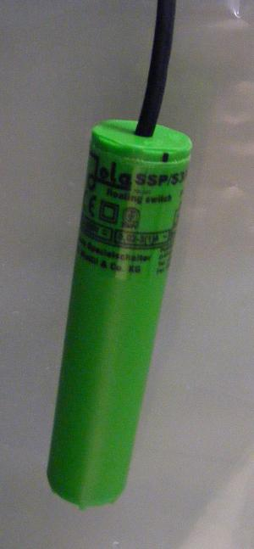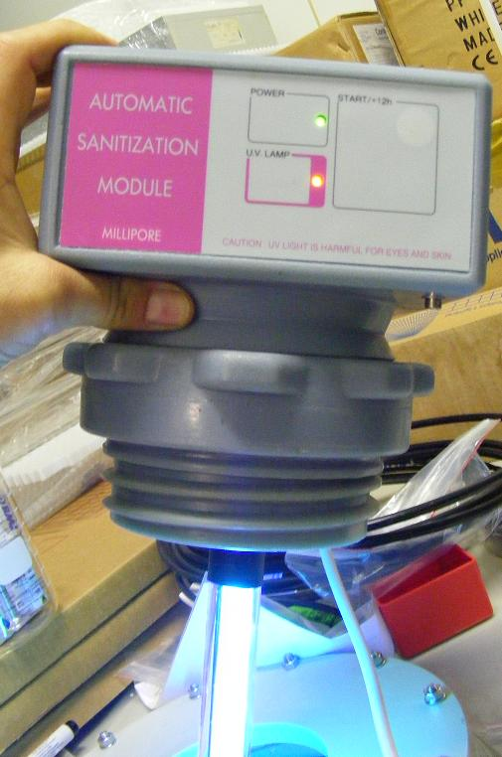
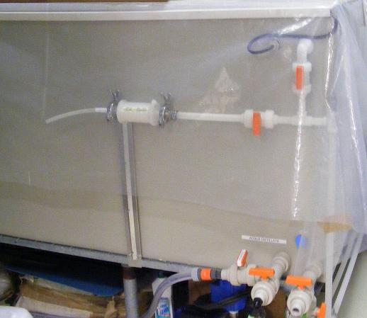

Distribution pipe line

The distribution pipe line was up-graded (2003), making use of high quality material (PVDF), to that previously used (PE) which gave rise to contamination problems.

Up-grade included also a re-cycling line in the collection tank, improving water quality and avoiding wastage (drain for 5 min. every hour of stand-by).

N.B. The monitoring system of DI water (meter-resistor 0-20 MΩ, calibration module, connectors etc.), was installed (2005) due to the DI water Quality Control (QC).

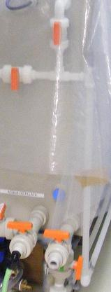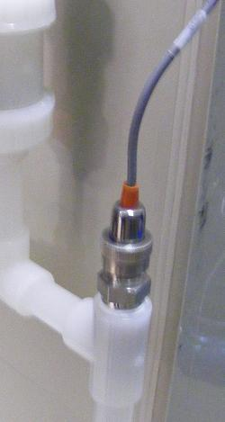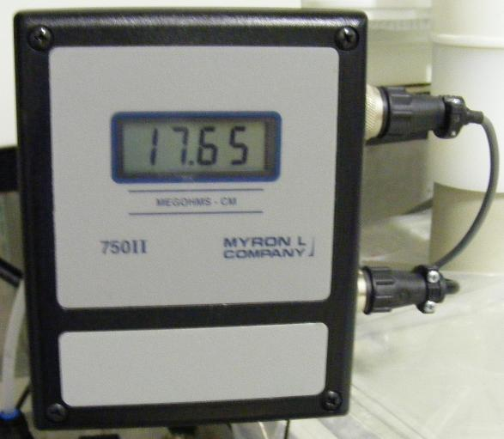

Millipore Super-Q

Final phase of the system, it produces until 5 l/min of DI water grade 1 (ϱ =18 MΩ.cm). Recent replacing of the principal system (Elix 70), has reduced the consumables use (cartridges), which are very expansive.

N.B. The gears of the system pump are in plastic material (PEEK) and require regular maintenance (service kit).The pump was replaced (2003) while the old one was repaired and kept as a spare.

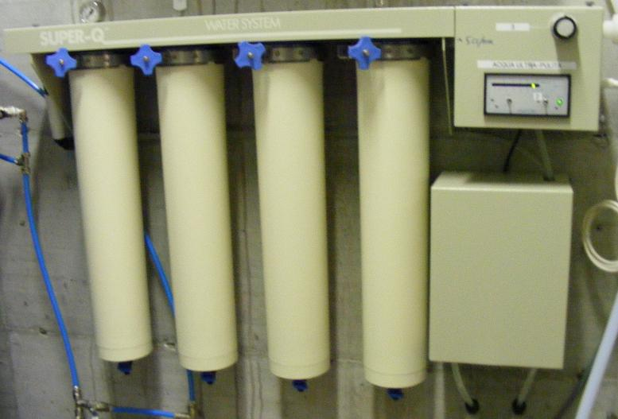

PVDF Collection tank

The Collection tank, connected directly to the washing tunnel pump, is able to store of ca. 300 lt. of DI water (produced by the Super-Q).It feeds the washing tunnel in the washing phase of each mechanical component.

N.B. It is made (2002) following our specifications (internal PVDF, external PRFV), it has substituted the pre-cursor (2001), which was insufficient in volume and of low quality (PE).

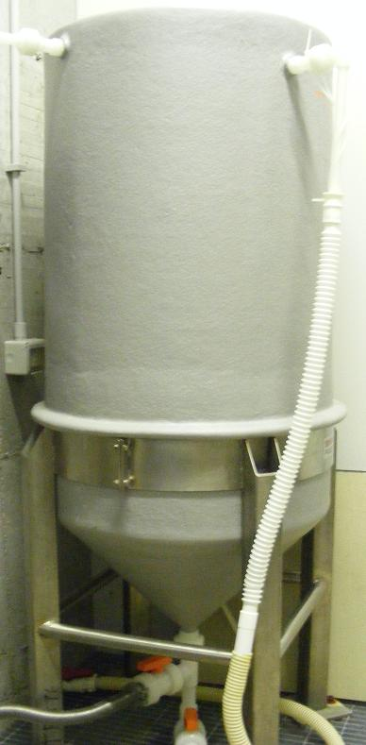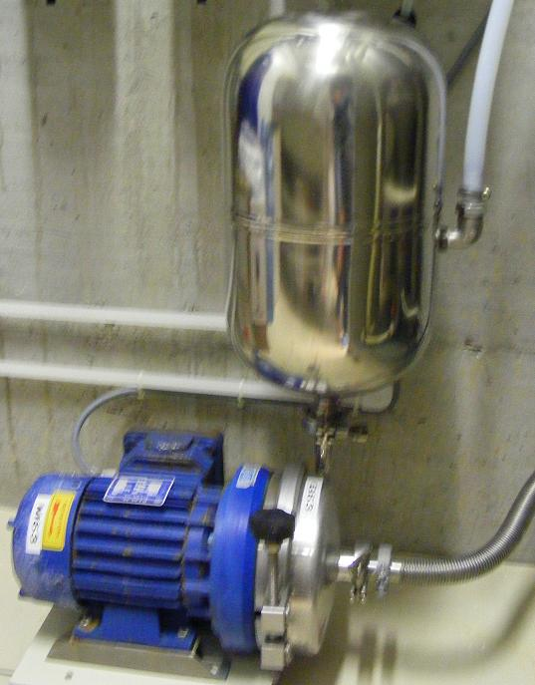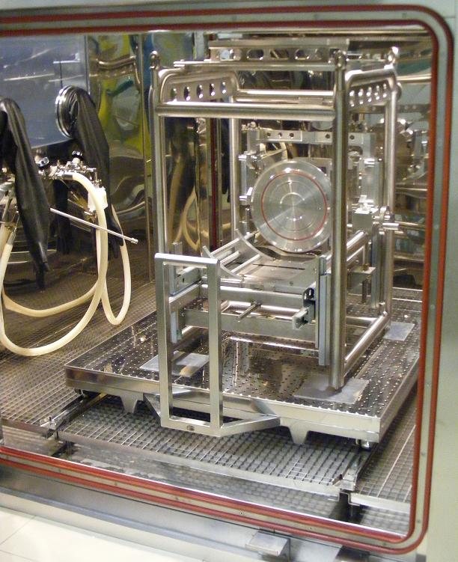

___oOo___

