ABSTRACT

The purpose of this document is to describe the operational practices that have been implemented so that it can serve as a reference for Virgo staff. It is expected that this document will be continuously updated as practices evolve as we gain experience with the interferometer hardware.

APPLICABLE DOCUMENTS

Listed below are all of the applicable and referenced documents for this procedure.

VIR-MAN-CAS-2200-113 | Contamination control Plan
VIR-PRO-CAS-2200-114 | Procedure for using clean room

PRE-REQUISITES

All preparation must be in accordance with the Contamination Control Plan and the Procedure for using a clean room.
- The carriage elevator must be installed using the system has air cushion.
- Containment of the zone. The curtains all round the tower, which must be opened, are drew and tied between them, in order to delimit the clean zone.
- To make sure that the zone is clean. To pass a rag soaks with isopropyl alcohol on the plate of carriage elevator: Hymo. Clean the floor; particulate and dust should be removed by mopping (wipe or mop) with clean water mixed with isopropyl alcohol.
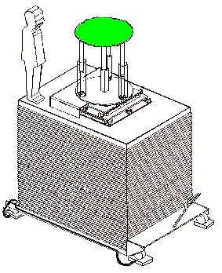

PREPARATION OF THE TOWER

- Opening of the tower (2 wrenches of 24, clean), 2 people of the vacuum team are necessary.
- To make sure that the outside spot gives in the interior of the tower some light.
- Startup of the conditioning of this tower. To make sure that there is clean air which circulates in the tower, and which air circulates by HEPA filter in its base.
- Stabilization of cleanliness, class 100 must be obtained in the zone delimited by the curtains, checking made with the portable particles counter METOne.

INTRODUCTION OF THE OPERATOR

The operator, equips with a white overall tyvek overall which it covered in the lock chamber class 10.000 air (room1003), must cover a synthetic overall (green or white), a mask, over-shoes, a mask, gloves. All these items are available in various sizes in the entrance lock-chamber of clean rooms.
- He must make sure that all that it has needed, for work in the tower, is on the plate of the hymo.
- He goes up on the plate of the hymo,
- He dresses itself in the synthetic overall (over the overall of tyvek)
- He puts a facemask.
- He sits down on the circular plate (green area), and threads synthetic over shoes.
- Slip on new gloves over those put in the hopper of the clean room.

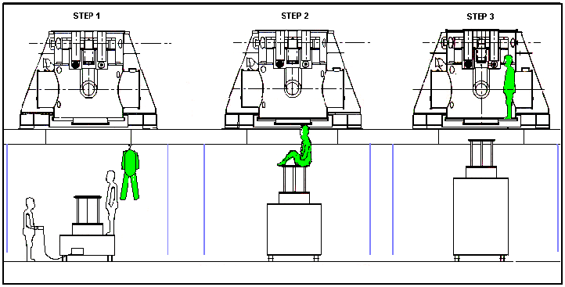

EXIT OF THE OPERATOR.

If the operator intends to turn over in the day in the tower, it was undressed according to the opposite procedure
- Remove its synthetic overshoes, sited on the circular plate (green area) of the hymo, and leaves them there.
- Remove its synthetic overall, and hangs it to a clothes hanger, for leaves in the clean area of the bottom of turn.
- It throws its gloves and its mask at the exit of the clean room.

If the operator does not hope to turn over in the day in the tower, it can from go away without being undressed.

In both cases, it must make sure that it leaves the clean place, and makes sure that it does not forget anything. The consumable ones are thrown (gloves, masks, rags) in the garbage and the synthetic overall, the synthetic overshoes put in the tank to be decontaminate at the entrance of the lock chamber.

