

TOWER CHAMBER - ISO 5 (CL. 100)

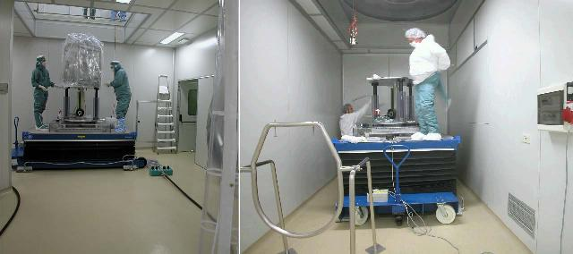

SOPRA L’ELEVATORE E OBBLIGATORIO INDOSSARE OLTRE LA TUTA IN TYVEK (BIANCA) UNA IN TESSUTO ANTISTATICO
DELLE SOVRASCARPE IN TESSUTO ANTISTATICO, UNA MASCHERINA E DEI GUANTI.

WHEN ON THE ELEVATOR BELOW THE TOWER IT IS OBLIGATORY TO WEAR – IN ADDITION TO THE WHITE TYVEK OVERALLS – ANTI-STATIC MATERIAL OVERALLS, ANTI-STATIC MATERIALS SHOE-COVER, A MASK AND GLOVES.

SUR ‘’ELEVATEUR, IL EST OBLIGATOIRE DE PORTER, EN PLUS DE LA COMBINAISON EN TYVEK (BLANCHE), UNE COMBINAISON ET DES SURCHAUSSURES EN TISSU ANTISTATIQUE, UN MASQUE ET DES GANTS.

Note 2 operators only in the tower chamber

Read the safety rules EGO-PRO-SEC-29
(before available) before going up to the elevators (Hymo)

