+24V IN
KEY_General Power
To Temperature Controller power supply
0V
Lamp +24V_IN

+24VDC
+24VDC
S
X
Trap Nitro. Level HI contact
Trap Nitro. Level LO contact
V3 Status (relayed)
Lamp V1
Chain_OK
0V

Temp relay (5s)
Rt1 (see p2)
Rlevel: powered if something is wrong
Trap Nitro. Level
0V
Temp. Control. I6
V3 Status

Trap Nitro. Temp (T1 + T2 + T3 + T4)

+24VDC
Temp. Control. I7
Air Pressure
Air pressure (relayed)

0V
0V
Temp. Control. H2

0V
KEY_V2
MANUAL KEY
MaxiGauge P1_2
MaxiGauge P1_1
MaxiGauge P2_2
Temp. Control. H1
MaxiGauge P2_1
MaxiGauge P3_2
Lamp Maxigauge-2
Temp. Control. I8
0V
MaxiGauge P3_1
Lamp Maxigauge-1

0V
KEY_V1
MANUAL KEY
R21.1
R10.1
R20.1
0V
OPEN V1
OPEN V2

(Electrovalve powered)
R11.1
(Electrovalve powered)
CLOSE V2
R20

V1_Powered
V1
V2_Powered
V2

R10.2
R20.2
(Electrovalve released)
CLOSE V1
R10
R11
R21

R11.2
R21.2

(Electrovalve released)

- Schematic Design

+24V IN

KEY_General Power
+24VDC

Lamp +24V_IN
0V

0V
Contacts
Relay Command V1
Contacts
Relay Command V1
(Electrovalve powered)
(Electrovalve released)
(Electrovalve powered)
OPEN V1
Lamp
V1_Powered
0V
V1
OPEN V2
Lamp Maxigauge-1
Maxigauge Contacts:
3 pressures monitored
Contacts
Relay Command V2
Contacts
Relay Command V2
Lamp
V2_Powered
V2

Security Contacts V1Chain_OK:
- liquid Level LO and HI
- Temperatures (4 probes)
- Air Pressure
- V3 valve closed

Lamp V1
Chain_OK
0V

Maxigauge Contacts:
3 pressures monitored

KEY_V1
Lamp Maxigauge-2
KEY_V2

0V

Relay Command V2
Relay Command V1

CLOSE V1
CLOSE V2

(Electrovalve released)

By software the sensors and the outputs of the Maxigauge are linked as following:

Schematic | Maxigauge | Sensor
MaxiGauge P1_1 | MaxiGauge relay A | Sensor 1
MaxiGauge P2_1 | MaxiGauge relay B | Sensor 2
MaxiGauge P3_1 | MaxiGauge relay C | Sensor 3
MaxiGauge P1_2 | MaxiGauge relay D | Sensor 1
MaxiGauge P2_2 | MaxiGauge relay E | Sensor 2
MaxiGauge P3_2 | MaxiGauge relay F | Sensor 3

Rev G
- Add the Rlevel relay in order to reverse the information from Liquid Level Controller.

. If the power of the Controller is off: HI and LO contacts are closed => Rlevel is powered and the contact is opened.

. If one of the levels of the Controller is out of setpoint: HI or LO contact is closed => Rlevel is powered and the contact is opened.

. If both levels of the Controller are in the setpoint: HI and LO contacts are opened => Rlevel released and the contact is closed.

- Cabling of Rt1 (temporized relay): coil on the +24VDC and contact chain (V3status – Trap Nitro Temp - Trap Nitro Level – Air Pressure) between X and S (Set).

In order to have a temporization on Rt1 release, following switch configuration has been put :
 |  | Temporization : from 1 to 10 seconds (to be precised on the relay)
  █ |  | 6
   | █ | 5
   | █ | 4
  █ |  | 3
   | █ | 2
  █ |  | 1
 |  | Mode : delay on release
Rev H
- Add two relays (on V3 status and Air Pressure to allow the use of one contact for V1 Chain_ok and the information +24DC for acquisition by the temperature controller.
Cabling of the HE-XE102 Temperature Controller I/O (see annex A):

V1 opened | DI1 | J1.1 | J2.1 | C6
V1 closed | DI2 | J1.2 | J2.2 | R6
V2 opened | DI3 | J1.3 | J2.3 | C5
V2 closed | DI4 | J1.4 | J2.4 | R5
V3 opened | DI5 | J1.5 | J2.5 | C4 | Trap Nitro Temp. Contact 2
V3 closed | DI6 | J1.6 | J2.6 | R4 | J2.7  Link
Air Pressure OK | DI7 | J1.7 | J2.7 | C3 | J2.6
MaxiGauge1 OK | DI8 | J1.8 | J2.8 | R3 | J2.9  Link
MaxiGauge2 OK | H1 | J1.9 | J2.9 | C2 | J2.8
GND | 0V | J1.10 | J2.10 | R2 | J2.11  Link
Temp Probe #1 | AI1 | J1.11 | J2.11 | C1 | J2.10
Temp Probe #2 | AI2 | J1.12 | J2.12 | R1 | Trap Nitro Temp. Contact 1
Temp Probe #3 | AI3 | J1.13 | J2.13 | H4
Temp Probe #4 | AI4 | J1.14 | J2.14 | H3
Temp Probe Com | Com | J1.15 | J2.15 | H2 | V1 Chain_OK
Annex A: Temperature Controller

V1 opened  V1 closed  V2 opened  V2 closed  V3 opened  V3 closed  Air pressure  MaxiGauge1  Maxigauge2  GND  Temp probe 1  Temp probe 2  Temp probe 3  Temp probe 4  Temp probe Com | 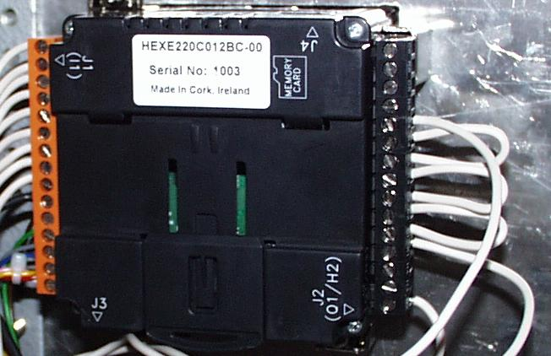 | V1 Chain_OK  Contact probe 1  Contact probe 2  Contact probe 3  Contact probe 4  4 temperature probes from the trap :

Annex B: Cryo Trap

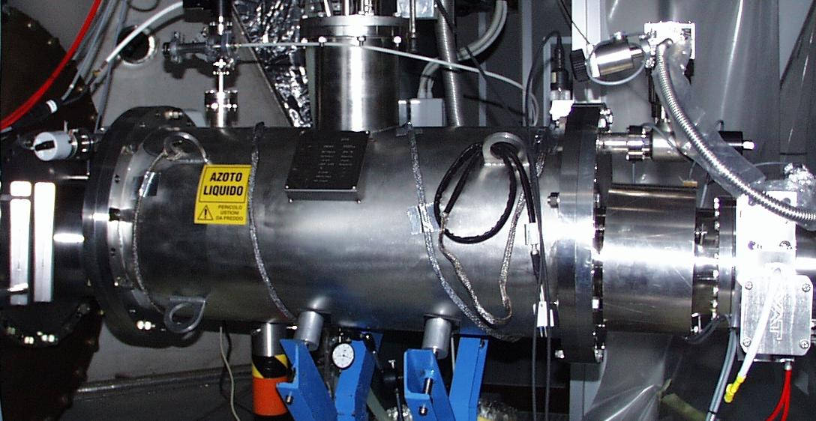
Valve V1
Valve V2
Valve V3
Air for open/close the valve
Valve status cable

